Annex A: PGCE Appeals and Complaints: Guidance for Applicants
This document describes how to appeal a PGCE admission decision or complain about an aspect of the admissions process. To ensure that we have the information we need and can handle your appeal or complaint appropriately, please read this guidance carefully.
What is an admissions appeal or complaint?
An admissions complaint is about the admissions process but seeks some other remedy than changing its outcome.
An admissions appeal seeks to change an outcome of the admissions process. Most often this will be an appeal to reverse the rejection of an application and have it reconsidered. However, it might also be against, for example, the imposition of a specific admission condition.
A PGCE admissions appeal can be made only in relation to one or more of the following three grounds and cannot be made on any other. Appeals that are ineligible will be dismissed.
- a serious procedural error (such as the provision of inaccurate information or the failure to make an admissions decision based on the admissions criteria);
- bias, or the perception of bias, in the decision-making process, defined as treating someone less favourably than another because of belonging to a protected group, as set out in the University’s Equal Opportunities Policy;
- extenuating circumstances affecting your prior academic or non-academic achievements which, for good reason, you did not inform the University of in your application, and which would have had a material impact on the admission decision.
Note that evidence of procedural error, bias or extenuating circumstances is required. If no substantive evidence is offered an appeal will be withdrawn. Please also note the following points.
- Neither an admissions appeal nor complaint can be made about a matter of academic judgement, that is a judgment where only the opinion of an academic expert is sufficient to decide on the issue. More information and examples of academic judgement can be found here: https://www.studentcomplaints.admin.cam.ac.uk/home/academic-judgment .
- The rejection of a candidate who appears to meet all entry or admissions criteria (see Annex E) does not in itself represent evidence. Entry to our courses is extremely competitive and meeting minimum requirements does not guarantee admission.
- The speed of a decision does not in itself provide evidence of a procedural error. The University aims to make quick decisions where possible, to help candidates plan their futures.
- An appeal made on the grounds of extenuating circumstances will be withdrawn if there is no good reason why these were not declared at application, regardless of the circumstances themselves.
Before you submit an appeal or complaint
It may be that your issue is out of scope for the PGCE admissions appeals and complaints process and is better dealt with elsewhere. An appeal or complaint which is out of scope will be dismissed. Please read the following guidance carefully.

Feedback
The PGCE Office will provide feedback upon admissions decisions upon request, and to the extent required by the Initial Teacher Training: Criteria and Supporting Advice:
https://www.gov.uk/government/publications/initial-teacher-training-criteria
Additional information
The appeals and complaints process should not be used to restate the qualifications and achievements that make you suitable for a course. Nor should it be used to provide additional information about your qualifications and achievements, including any gained after your application. Such information does not constitute a legitimate ground for appeal. You are welcome to apply to the University in future years if you have additional achievements to report.
Fee status
Any candidate who thinks they have been wrongly assessed for fee status may seek a review by submitting a self-assessment questionnaire. This questionnaire can be downloaded from the Fee Reassessment page:
https://www.postgraduate.study.cam.ac.uk/finance/fees/what-my-fee-status
This process has its own appeal route, with details provided to relevant applicants. Do not use the appeal process described here to request fee status reassessment or for a fee status reassessment appeal.
Exam grades and academic conditions
In general, we will not consider an admissions appeal that is based on mitigating circumstances affecting your grades in an exam. Instead, you should use the exam mitigation process in place at the institution where you took your exams (including at Cambridge) prior to your application to the PGCE, so that these circumstances are taken into account in awarding your grade.
Other procedures
- a separate appeals and complaints process for admission to Master of Studies programmes is available at the Institute for Continuing Education website;
- a separate appeals and complaints process for admission to Higher Degree programmes, including MEd, MPhil, EdD and PhD, is available through the Postgraduate Admissions Office;
- a separate appeals and complaints process for all undergraduate courses is available here:
https://www.undergraduate.study.cam.ac.uk/apply/after/complaints
Stage 1: local informal resolution
Before completing an admissions appeal or complaint form you should seek an informal resolution with the Head of the PGCE Office (aw2030@cam.ac.uk). If you have a query or concern about your College allocation, you should contact the Senior Tutor or Postgraduate Tutor within the College in the first instance. College contacts are available here:
https://map.cam.ac.uk/colleges/
In relevant cases, if you have not attempted local resolution before submitting a Stage 2 form, your appeal or complaint may be withdrawn.
Stage 2: submitting an appeal or complaint
You must submit your Stage 2 admissions appeal (see the definition of appeal above) using the form in Annex C of the PGCE Admissions Appeals and Complaints Policy (attached).
You must submit your Stage 2 admissions complaint (see the definition of complaint above) using the form in Annex D of the Admissions Appeals and Complaints Policy (attached).
If the relevant form is unavailable, email the Head of the PGCE Office (aw2030@cam.ac.uk). You must submit an admissions appeal or complaint within 28 calendar days of receiving your formal admission decision via DfE Apply. Submissions outside this timeframe may be dismissed. At their discretion, the Head of the PGCE Office may accept an appeal or complaint beyond this deadline but only in exceptional cases where a valid reason for delay is evidenced. You can withdraw an appeal or complaint at any time by emailing the same address, but once withdrawn the appeal or complaint cannot be reinstated. You will not be disadvantaged for submitting an appeal or complaint made in good faith, and this will not affect any offer of study already issued or prevent you from being able to re-apply to the University in the future.
Responding to your appeal or complaint
We will acknowledge your Stage 2 appeal or complaint within 5 working days of its receipt, dated from the working day on which the form is first received.
An admissions appeal or complaint can be dismissed if it is trivial, vexing, or malicious, or if it repeats a case that has already been made. An admissions appeal or complaint can be dismissed if no substantive evidence is offered (and for an appeal, this must relate to one of the eligible grounds for appeal from the list above). The rejection of a candidate who appears to meet all entry or admissions criteria (see Annex E of the PGCE Admissions Appeals and Complaints Policy (attached)) does not in itself represent evidence. Entry to our courses is extremely competitive and meeting minimum requirements does not guarantee admission.
If your appeal or complaint is accepted as within scope it will be investigated and a decision will be made by the PGCE Admissions Appeals and Complaints Panel, which is independent of the PGCE programme to which you applied. The investigation is likely to include requesting responses from the member(s) of academic staff that considered your application. Though information will only be shared where necessary for the investigation, this is likely to involve sharing your identity and your appeal or complaint with that member(s) of staff. All parties involved in an appeal or complaint are expected to act reasonably, fairly and courteously toward each other and to respect the University’s written documentation and legal obligations.
You will normally receive a decision within 20 working days of receiving the appeal or complaint acknowledgement. If a decision will take longer than 20 working days, you will receive an update regarding the investigation. The appeal or complaint decision notification will include the decision, the reason for the decision, and any actions being taken as a result. The appeal or complaint decision confirms the University’s final position in relation to a PGCE appeal or complaint and ends the process. The decision may be communicated to any staff or department involved in the investigation.

Annex B: Appeals and complaints flow chart for applicants
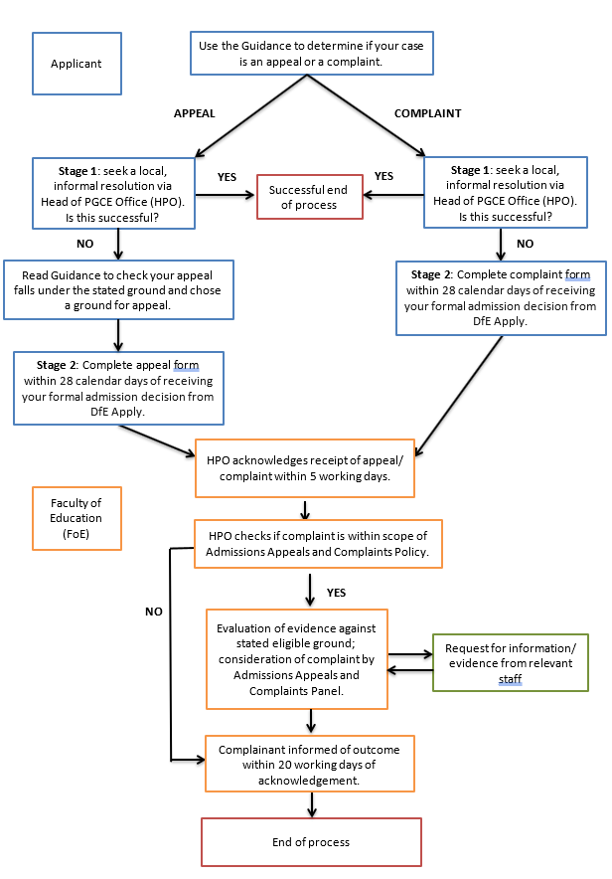
Annex C
PGCE Admissions
Stage 2 Appeal Form
PGCE Office
Your details
Applicant USN (9 digits):
Surname/ Family name:
Forename/given name(s):
Email:
Contact telephone number:

Application with which your admissions complaint is connected

Application ID Number (if known):

Course of study applied for:

early primary / primary / secondary (delete as applicable):
for secondary PGCE applicants only, indicate subject:

Date of the decision via DfE Apply which you are appealing (note an appeal must usually be received within 28 days of that decision):
________________________________________________________________________

This form is only for use in PGCE admission appeals as defined within the Faculty of Education’s PGCE Admissions Appeals and Complaints: Guidance for Applicants. It is important that you read that guidance and the following information before completing this form.

Your appeal must be based on one of the three grounds set out in the guidance and cannot be based on any other ground. If your appeal is judged not to address one of these grounds it will be rejected without further investigation.

You should not use the PGCE admission appeal process to:
- provide additional information about yourself or your application, including recent achievements; you are welcome to apply in future years if you have additional information to provide;
- request advice on how to improve your application;
- request feedback on an admissions decision;
- seek a review of your fee status;
- query your college allocations.

See the guidance for more information on feedback, fee status and college allocations.

Before submitting an admissions appeal, you should seek local resolution (Stage 1) by contacting the Head of the PGCE Office (aw2030@cam.ac.uk). Your appeal will not be taken forward if other avenues of redress are still in progress. If you wish to appeal once these are complete, you will need to complete a new form. Note that an admissions appeal cannot be made about a matter of academic judgement; that is a judgment where only the opinion of an academic expert is sufficient to decide on the issue.

☐ Please tick to confirm you have read and complied with the information above, including the document entitled PGCE Admissions Appeals and Complaints: Guidance for Applicants.
- Please identify the admission decision or issue that you are appealing, and the outcome sought.

Maximum 50 words

- Are you appealing on the grounds of a serious procedural error? Yes/ No

- If yes, please state your case precisely using the following headings. Note, an incomplete entry may not be considered. Note also that the rejection of a candidate who appears to meet the admissions criteria does not, in and of itself, represent evidence of procedural error.

Maximum 700 words

- What occurred during the admissions process?

- Why do you believe this represents a serious procedural error?

- What were the consequences?

- Please provide a numbered list of any supporting evidence you are submitting in evidence for your appeal on this ground. Any such evidence should be provided in the order set out in this list.

Maximum 500 words

- Are you appealing on the grounds of bias in the decision-making process defined as treating someone less favourably than another because of belonging to a protected group, as set out in the University’s Equal Opportunities Policy? Yes/ No

- If yes, please state your case precisely using the following headings. Note an incomplete entry may not be considered.

Maximum 700 words

- What occurred during the admissions process?

- Why do you believe this represents bias in the decision-making process?

- What were the consequences?

- Please provide a numbered list of any supporting evidence you are submitting in evidence for your appeal on this ground. Any such evidence should be provided in the order set out in this list.

Maximum 500 words

- Are you appealing on the grounds of extenuating circumstances affecting your prior academic or non-academic achievements which, for good reason, you did not inform the University of in your application, and which would have had a material impact on the admission decision? Yes/ No

- If yes, please state your case precisely using the following headings. Note an incomplete entry may not be considered.

Maximum 700 words

- What were the extenuating circumstances affecting your prior achievements?

- Why do you believe this would have had a material impact on the relevant admission decision?

- Why did you not disclose this previously?

- Please provide a numbered list of any supporting evidence you are submitting in evidence for your appeal on this ground. Any such evidence should be provided in the order set out in this list.

Maximum 500 words

- Please state what steps you have taken to resolve the issue at Stage One (i.e. via the Head of the PGCE Office), as set out in PGCE Admissions Appeals and Complaints: Guidance for Applicants.

Maximum 250 words

Applicant Declaration

I confirm that:

- I understand that the University may need to process personal details about me, which could include sensitive information, in order to investigate my admission appeal.
- I understand that the University may need to exchange information about my admission appeal within the University and Colleges in order to resolve the matters under appeal.
- The information I have given on this form is true, correct and complete to the best of my knowledge.

By signing this document, I am agreeing to the above conditions.

Signed: _______________________________________________

Date: _______________________________________________

Print Name: _______________________________________________

Annex D:
PGCE Admissions
Stage 2 Complaint Form

PGCE Office
Your details

Applicant USN (9 digits):
Surname/ Family name:
Forename/given name(s):
Email:
Contact telephone number:

Application with which your admissions complaint is connected

Application ID Number (if known):

Course of study applied for:

early primary / primary / secondary (delete as applicable):
for secondary PGCE applicants only, indicate subject:
___________________________________________________________________

This form is only for use in PGCE admissions complaints as defined within the Faculty of Education’s PGCE Admissions Appeals and Complaints: Guidance for Applicants. It is important that you read that guidance and the following information before completing this form.

You should not use the postgraduate admission complaint form to:
- appeal an admission decision; please use the appeal form instead;
- make a complaint about an issue not related to postgraduate admission;
- request advice on how to improve your application;
- request feedback on an admissions decision;
- seek a review of your fee status;
- query your college allocations.

See the guidance for more information on feedback, fee status and college allocations.

Before submitting an admissions complaint, you should seek local resolution (Stage 1) by contacting the Head of the PGCE Office (aw2030@cam.ac.uk). Your complaint will not be taken forward if other avenues of redress are still in progress. If you wish to complain once these are complete, you will need to complete a new form.

Note that an admission complaint cannot be made about a matter of academic judgement; that is a judgment where only the opinion of an academic expert is sufficient to
decide on the issue.

☐ Please tick to confirm you have read and complied with the information above, including the document entitled PGCE Admissions Appeals and Complaints: Guidance for Applicants.

- Please identify the issue(s) that is the subject of your admission complaint.

Maximum 50 words

- Please state the key points of your complaint precisely using the following headings. Note an incomplete entry may not be considered.

Maximum 700 words

- What are the underlying facts, including key dates?

- What happened that has led you to complain?

- What were the consequences?

- Please provide a summary of evidence which supports your complaint. Please also provide a numbered list of any supporting documents you are submitting in evidence. Any such documents should be provided in the order set out in this list.

Maximum 500 words

- Please state what steps you have taken to resolve the issue at Stage 1 (i.e. via the Head of the PGCE Office, as set out in PGCE Admissions Appeals and Complaints: Guidance for Applicants).

Maximum 250 words

- Please state the outcome(s) you are seeking.

Maximum 200 words

Applicant Declaration

I confirm that:

- I understand that the University may need to process personal details about me, which could include sensitive information, in order to investigate my admission complaint.
- I understand that the University may need to exchange information about my admission complaint within the University and Colleges in order to resolve the matters under complaint.
- The information I have given on this form is true, correct and complete to the best of my knowledge.

By signing this document, I am agreeing to the above conditions.

Signed: _______________________________________________

Date: _______________________________________________

Print Name: _______________________________________________

Annex E: Entry criteria and Admissions Criteria
Admission to teacher education courses is regulated via the Initial Teacher Training Criteria:
https://www.gov.uk/government/publications/initial-teacher-training-criteria
The Initial Teacher Training Criteria define Entry Criteria for any course offering initial teacher education accredited by the UK Government. The Faculty of Education also applies Admissions Criteria for the PGCE course. The application guidance on the Faculty of Education website helps applicants to understand how these criteria are applied when making admissions decisions.
Entry Criteria
- all entrants have achieved a standard equivalent to a grade 4 in the GCSE examinations in English and mathematics; and those who intend to train to teach pupils aged 3 to 11 additionally must have achieved a standard equivalent to a grade 4 in the GCSE examination in a science subject.
- all entrants must hold a first degree from a United Kingdom higher education institution or equivalent qualification.
- all entrants, as part of the accredited ITT provider’s selection procedures, have taken part in a rigorous selection process designed to assess their suitability to train to teach. Applicants must have the health and physical capacity to train to teach. Their admission to the course is also subject to appropriate suitability checks, which include a) obtaining and considering Disclosure and Barring Service (DBS) criminal records checks and children’s barred list information, and b) other appropriate background checks.
Admissions Criteria
- Candidates should be able to express themselves orally and in writing and should possess basic numerical skills.
- Candidates should have sound and appropriate subject knowledge at degree level.
- Candidates should have strong academic qualifications and/or intellectual qualities.
- Candidates should normally have recent experience of and enjoyment in working with students in the age range appropriate for the course they are applying for.
- Candidates should have an articulate view about the reasons for becoming a teacher, and flexibility of ideas about teaching.
- Candidates should have positive personal qualities, including an ability to relate to others and to work collaboratively.

