TEACHER SCHEME FOR EDUCATIONAL DIALOGUE ANALYSIS

(T-SEDA)

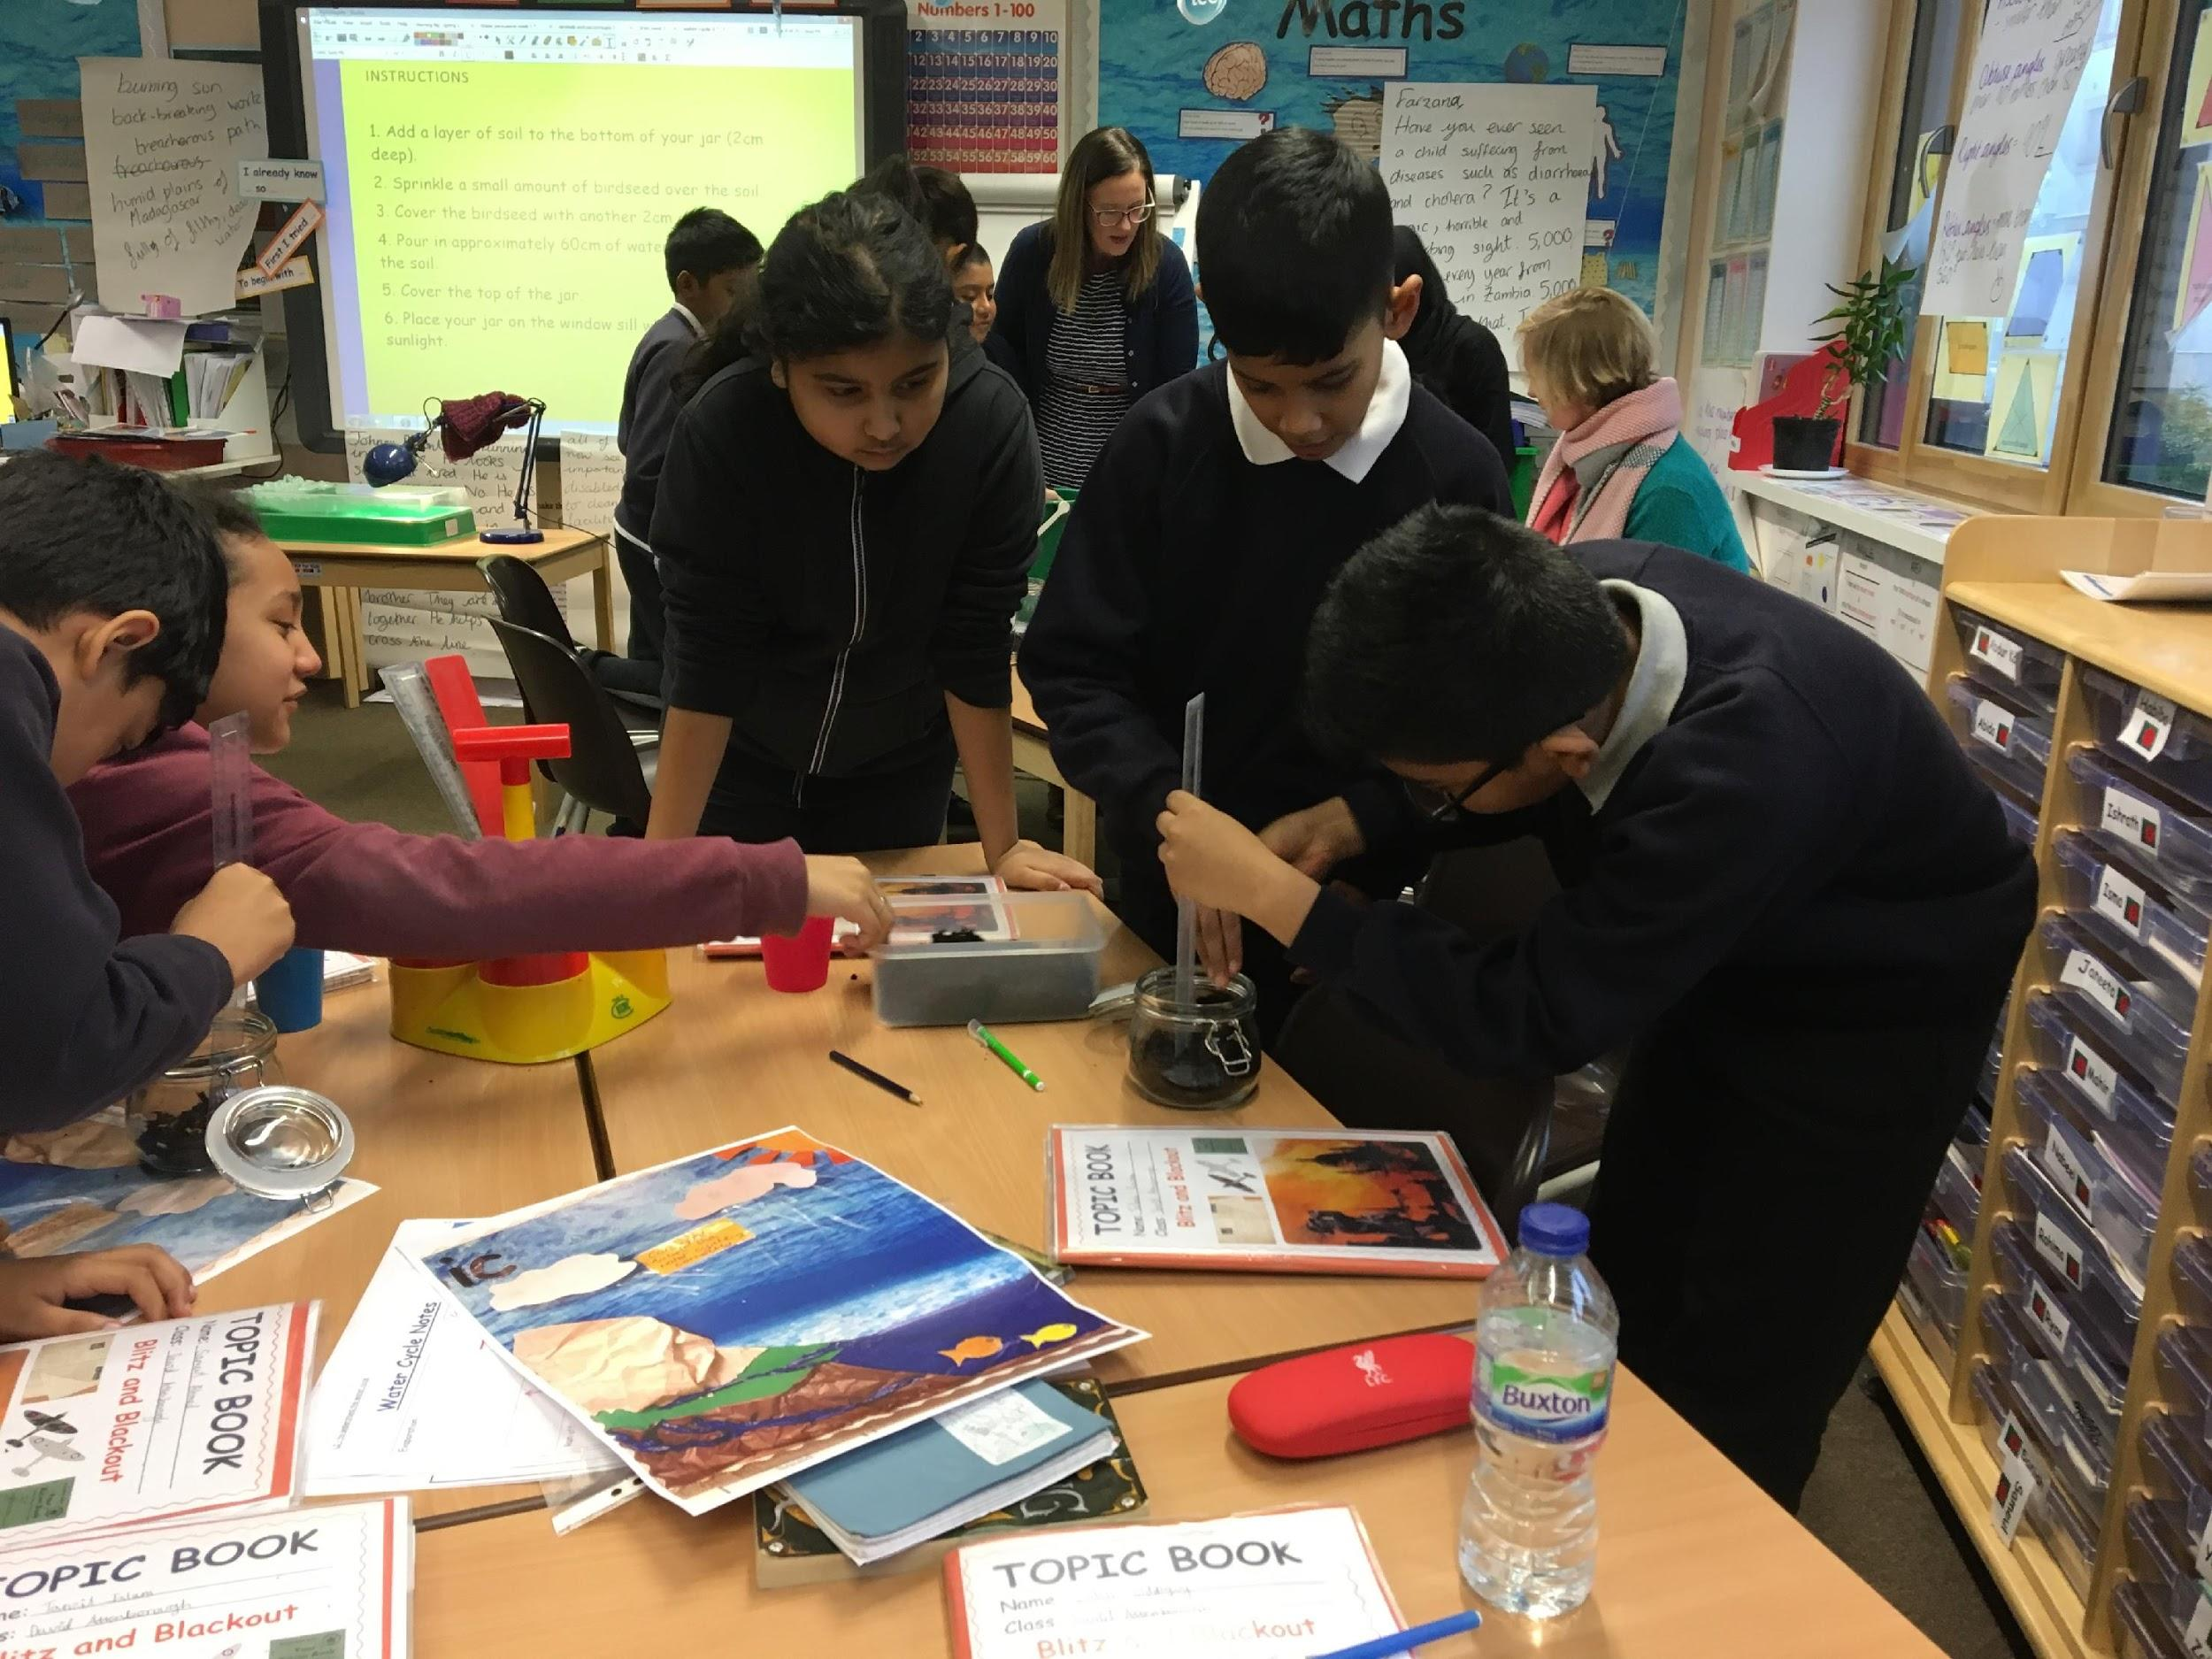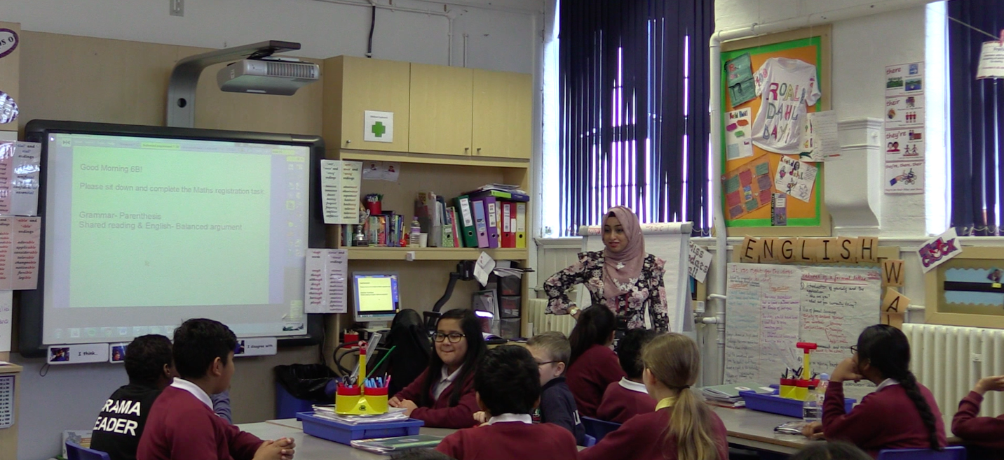

T-SEDA@educ.cam.ac.uk http://bit.ly/T-SEDA

Ruth Kershner, Sara Hennessy, Elisa Calcagni, Farah Ahmed

Contributors: Victoria Cook, Nube Estrada, Flora Hernández, Laura Kerslake, Lisa Lee, Maria Vrikki
University of Cambridge Faculty of Education and National Autonomous University of Mexico

Acknowledgements

Development of T-SEDA (and its precursor SEDA) was supported by the British Academy (International Partnership and Mobility Scheme) through the 3-year project entitled “A Tool for Analysing Dialogic Interactions in Classrooms” (2013-2015), led by Sara Hennessy and Sylvia Rojas-Drummond at the University of Cambridge, UK, and the National Autonomous University of Mexico: http://tinyurl.com/BAdialogue. The Mexican work was supported by the Dirección General de Asuntos del Personal Académico of the National Autonomous University of Mexico (DGAPA-UNAM) (PAPIIT Project Number: IN303313 and PAPIME Number: PE305814). We appreciate the support of the Economic and Social Research Council (RES063270081; RES000230825), sponsor of most of the UK team's preceding work in this area. Our most recent ESRC project (ES/M007103/1) entitled ‘Classroom Dialogue: Does it Make a Difference for Student Learning? (Christine Howe, Sara Hennessy, Neil Mercer, Maria Vrikki & Lisa Wheatley, 2015-17: http://tinyurl.com/ESRCdialogue) drew on SEDA to develop a new 12-category scheme and rating scales, testing them extensively with a large sample of 72 teachers of children aged 10-11; statistical analyses of the relationships between dialogic teaching and student attainment and attitudes produced the findings that have shaped this version of the pack. An ERSC Impact Acceleration grant supported our trials in 2018-19. Finally, we thank all of the facilitators, teachers and students who participated in our previous research and impact trials across several countries from which examples in this pack have been taken.

Development of T-SEDA has been very much a team effort; the main authors of the pack are currently listed in reverse alphabetical order simply because an order had to be selected! We are very grateful to the numerous colleagues who have contributed in some way or other to T-SEDA development over the last few years. Apart from those mentioned on the cover page, this includes those who assisted with translation into Spanish, Mandarin and Hebrew (Ana Laura Trigo Clapes, Elisa de Padua, Elisa Izquierdo, Qian Liu, Ji Ying, Chih Ching Chang and Benzi Slakmon).

How does the T-SEDA pack work in practice?

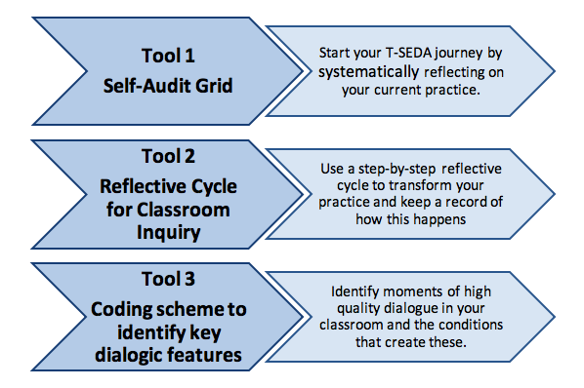

This pack is designed to be flexible for conducting an inquiry on whatever interests you in relation to educational dialogue. Try out T-SEDA in your classroom and send us feedback (T-SEDA@educ.cam.ac.uk). We would love to hear from you!
Gary’s Inquiry:
Building dialogue in role play

I’m a reception teacher, and the role play area is an important part of the EYFS (Early Years Foundation Stage) classroom because we always link the activities in the role play area to the EYFS development framework. When I used the self-audit tool, I realised that because the class is in free-flow, I needed to find out exactly how the children were using the area, particularly how they responded to each other.

I decided to observe children playing in the role play area to see how they built on each other’s ideas, as the foundation of dialogue between them. I used templates 2C and 2D to live code, and discovered that some children developed their creative expression in their talk with others, incorporating new ideas into their play. However, other children mostly played on their own and didn’t listen or respond to other children.

After this, I decided to ask children if they wanted to play in the role play area in pairs, and to share ideas about how to play. I found that children would only respond to each other’s ideas if they were excited about them – but also that children did become aware of a wider circle of play partners than their usual few friends, which meant that they were hearing a range of different ideas.

Kiran’s Inquiry:
Interrogating each other’s ideas in history

I’m a secondary history teacher and, using the self-audit tool, I wondered if my students understood how to interrogate each other’s ideas about sources. I decided to observe how much challenging of each other’s ideas was happening when the students were looking at sources in pairs. Not only this, I wanted the students themselves to become aware of how important it is to challenge each other’s ideas – because some sources can be deliberately misleading.

While some students were working in pairs, I asked others to make a tally of how many times each student in the pair queried or challenged over a period of 10 minutes. Afterwards, these students gave feedback to the class about their observations. This led to a really productive class discussion about challenging each other ideas and the source itself, so that the students were reflecting on their learning as well as gaining a deeper understanding of using sources in history.

Lily’s Inquiry:
Developing reasoning in science group work

I’m a year 5 teacher and I was concerned that there wasn’t enough reasoning happening in my classroom, after using the self-audit tool. I felt that this was particularly the case in science, where not all children were demonstrating their reasoning, for example by applying their knowledge to make predictions, etc.
I decided to use the T-SEDA coding scheme to find out how often reasoning took place in children’s group work during a unit of science lessons. I did live observations of certain groups using the time sampling tool, template 2B, and recorded instances of reasoning. I found that some children contributed their reasoning quite often, but others didn’t reason at all (or at least not verbally).
Having completed these observations, I realised that I needed to structure group work activities so that all children were encouraged and given the opportunity to share their reasoning within the group.
PACK CONTENTS

This pack contains:
T-SEDA: a user’s guide
Parts a-i (listed overleaf) contain the T-SEDA essentials

T-SEDA Core Resources
- SECTION 1: Coding framework A list and explanation of dialogue categories illustrated with sample prompts and contributions, plus more general dialogic classroom practices.
- SECTION 2: Templates for observing and coding Includes lesson observation (time-sampling; checklist; rating scales).

These additional resources are available online at http://bit.ly/T-SEDA:
- SECTION 3: Technical guidance for recording and transcribing
- SECTION 4: Case studies Illustrates teachers’ coding and interpretation of dialogue in different contexts; includes teachers’ findings and next steps.
- SECTION 5: Ideas to implement dialogue in your classroom and references to other research on dialogue and links to related resources
- BLANK TEMPLATES: reflective cycle, observation templates, self-reflection, inquiry reporting template
The entire pack is available online, including separately downloadable templates for printing or editing; look out for the icon.

T-SEDA: A user’s guide
Contents
a. Introduction | p.3
b. What is educational dialogue? | p.4
c. Educational dialogue and student learning | p.6
d. How productive is the dialogue in my classroom? A self-audit | p.9
e. Reflective cycle of classroom inquiry | p.11
f. Choosing an inquiry focus | p.13
g. Research ethics | p.19
h. Analysing classroom talk: systematic observation and coding | p.20
i. Possible uses of the T-SEDA pack | p.22
SECTION 1: Coding Framework | p.25
SECTION 2: Templates for observing and coding | p.32
Part a. Introduction

The Teacher Scheme for Educational Dialogue (T-SEDA) resource pack has been designed to support you in generating high quality educational dialogue in your classrooms, in whole class discussion and between students working in groups. It is for primary (elementary) and secondary school practitioners to use in any subject area for professional development or as a research instrument. It may also be useful for students to monitor their own participation in dialogue, and it could be extended to apply to other dialogues in schools, such as teacher meetings. You can adapt the materials to the specific needs of your own setting and students.

Teachers continuously reflect on classroom events, however they rarely have the opportunity for fine-grained systematic observation.
The T-SEDA pack offers you three tools that have been designed to support systematic observation and detailed reflection. They are based on the latest research findings about the importance of generating high quality educational dialogue to have an impact on children’s thinking and attainment.

Tool 1 - A Self -Audit Grid (See Part d)
Tool 2 - A Reflective Cycle of Classroom Inquiry (Part e)
Tool 3 - A Coding Scheme that is specifically designed for investigating classroom dialogue (Section 1)

The team that is developing T-SEDA includes practising teachers who are involved in trialling the materials in their schools. It is hoped that developing and using T-SEDA will support sharing of alternative ways of collecting evidence about the nature and outcomes of classroom dialogue. This may include its potential uses for many educational purposes, including the development of knowledge and understanding across the curriculum, the enhancement of classroom relationships and equity, and the assessment of, and for, student oracy and learning.

Teachers in several countries and working with different age groups have now tried out the pack and their feedback has helped to refine it.

Further feedback, classroom examples and suggestions from any teachers interested in trying out the materials are greatly welcomed.
(Contact us at: T-SEDA@educ.cam.ac.uk)

NOTE: The pack can be used across educational settings and student age groups, including higher education. Throughout the pack, the term ‘teacher’ is used to refer to educators in all contexts.
Part b. What is educational dialogue?

Educational dialogue grows from people’s active involvement in developing ideas together in talk. Educational dialogue enables teachers and students to think together and develop relationships that support collaborative learning. The aim of this pack is to help you evaluate and improve the quality of the educational dialogue in your classroom.

Are talk and dialogue the same thing?
There is an emerging consensus among researchers about the forms of classroom interaction that are productive for student learning. In particular, talk has been highlighted as the main tool that teachers and students can use to think together. Using words we can do things with others: we can coordinate and question, as well as dismiss or hurt. Thus, not all forms of talk are equally powerful for learning, and by ‘dialogue’ we don’t just mean any kind of talk.

What is educational dialogue?
In dialogue, participants listen to each other, they contribute by sharing their ideas, justifying their contributions and engaging with others’ views.
In particular they explore and evaluate different perspectives and reasons. Relevant questions and contributions are linked between speakers, allowing knowledge to be built collectively within a lesson or over a series of interconnected lessons.

Although verbal interactions are central, dialogue can be supported with non-verbal communication (e.g. gestures, facial expression and eye contact) and by using visual or technology resources. Silence, physical movement, classroom routines and ethos can also be important aspects of dialogue, framing and supporting (or sometimes hindering) the spoken conversation that is the main focus of this pack.

Educational dialogue takes different forms with students of different ages, from the youngest to oldest, and it can be developed in different areas of learning. Some features of productive educational dialogue already appear in many classrooms but sustaining productive educational dialogue takes time. It might also challenge participants, especially if they are not used to expressing their views at length or having them examined publicly.

The table overleaf indicates the sort of talk that is likely to be of interest.

Dialogue categories | Contributions and Strategies | What do we hear? (Key Words)
IB – Invite to build on ideas | Invite others to elaborate, build on, clarify, comment on or improve own or others’ ideas / contributions | ‘Can you add’, ‘What?’ ‘Tell me’, ‘Can you rephrase this?’ ‘Do you think?’ ‘Do you agree?’
B – Build on ideas | Build on, elaborate, clarify or comment on own or others’ ideas expressed in previous turns or other contributions | ‘it’s also’, ‘that makes me think’, ‘I mean’, ‘she meant’
CH - Challenge | Questioning, disagreeing with or challenging an idea | ‘I disagree’, ‘But’, ‘Are you sure…?’, ‘…different idea’
IRE – Invite reasoning | Invite others to explain, justify, and/or use possibility thinking relating to their own or another’s ideas | ‘Why?’, ‘How?, ‘Do you think?’, …‘explain further’
R – Make reasoning explicit | Explain, justify and/or use possibility thinking relating to own or another’s ideas | ‘I think’, ‘because’, ‘so’, ‘therefore’, ‘in order to’, ‘if...then’, ‘it’s like...’, ‘imagine if...’, ‘could’,
CA - Coordination of ideas and agreement | Contrast and synthesise ideas, confirm agreement and consensus; Invite coordination/synthesis | ‘agree’, ‘to sum up…’, ‘So, we all think that…’, ‘summarise’, ‘similar and different’
C – Connect | Make pathway of learning explicit by linking to contributions / knowledge / experiences beyond the immediate dialogue | ‘last lesson, ‘earlier’, ‘reminds me of’, ‘next lesson’, ‘related to’, ‘in your home’
RD – Reflect on dialogue or activity | Evaluate or reflect “metacognitively” on processes of dialogue or learning activity; Invite others to do so | ‘dialogue’, ‘talking’, ‘sharing’, ‘work together in the group/pair’, ‘task’, ‘activity’, ‘what you have learned’, ‘I changed my mind’
G – Guide direction of dialogue or activity | Take responsibility for shaping activity or focusing the dialogue in a desired direction or use other scaffolding strategies to support dialogue or learning | ‘How about’, ‘focus’, ‘concentrate on’, ‘Let’s try’, ‘no hurry’, ‘Have you thought about…?’
E – Express or invite ideas | Offer or invite relevant contributions to initiate or further a dialogue (ones not covered by other categories) | ‘What do you think about…?’, ‘Tell me’, ‘your thoughts’, ‘my opinion is…’, ‘your ideas’

Part c. Educational dialogue and student learning

Is there evidence that dialogue promotes learning?
There is a growing base of international research that supports the idea that dialogic teaching is beneficial for students’ learning and other personal development outcomes. Regarding peer groups, the quality of talk especially when different opinions are expressed, has positive effects on learning and reasoning skills.

Compelling evidence about the impact of teacher-led dialogue has recently been produced by a team at the University of Cambridge. The data came from detailed analyses of 144 lessons by 72 teachers in 48 English primary schools (http://tinyurl.com/ESRCdialogue). The main conclusion is that developing a supportive classroom ethos, with active participation ideally supported by agreed ground rules, provides the foundation for dialogue to flourish. Then, specific aspects of talk (talk moves), especially those relating to building on ideas, and questioning and challenging others’ ideas, are linked to learning. Student elaboration seems to be particularly important.

Which talk moves are strongly associated with learning gains?
· building on ideas
· invitations to build on ideas
· challenging and questioning others’ views respectfully

Which are the most supportive elements of dialogue at the classroom level?
· active student participation – multiple students give extended contributions and engage with others’ ideas
· explicit use of ground rules for talk – supporting dialogic practices, negotiated with students

These features of productive dialogue need to occur together to have a significant impact on learning.
Too much challenging without the other supportive elements can even have a negative effect!

These findings describe the quality of both teacher and student talk (in contexts where the teacher was present), which go hand in hand. We know that if teachers invite students to build on ideas more, for example, then students do so. ‘Build on ideas’ – including invitations and contributions – is very strongly linked with positive attitudes to school and to self-as-learner too.
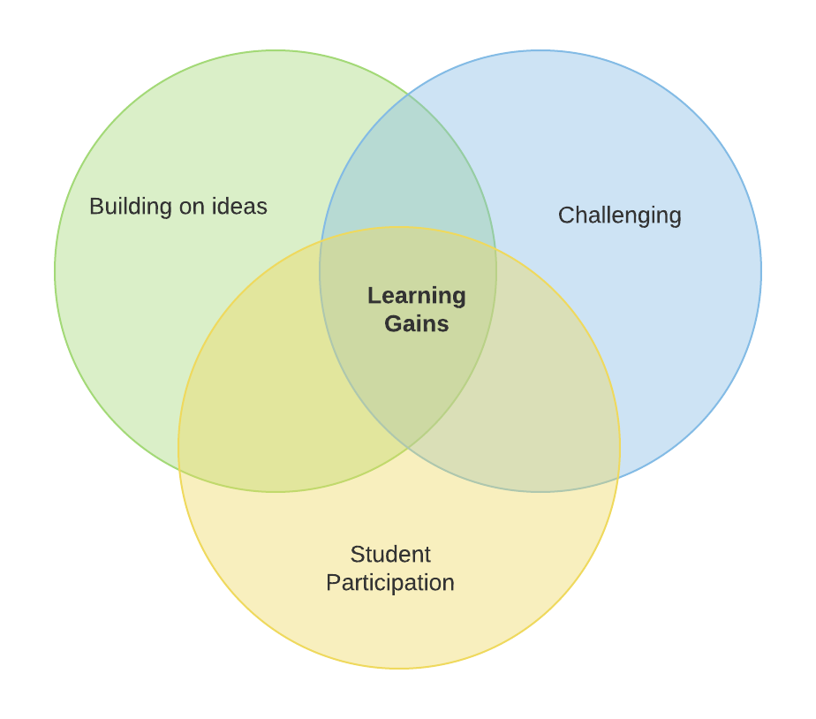

In sum, dialogue promotes learning across the curriculum, the development of reasoning skills and communication skills, and more favourable attitudes to school and learning. Also, it enhances students’ role in learning, boosting ownership and engagement. Our own study showed that very few teachers (less than 20%) introduced or referred to talk rules/ground rules for effective interaction and learning with others.
However, when talk rules were evident
- this was linked to more positive student attitudes to school.
- and when combined with a lot of elaboration, this was linked to significantly better results in mathematics.
- and when combined with challenging, they enhanced reasoning skills.
We recognise that effective teaching contains a wide repertoire of different strategies that are used appropriately and dialogue is only one of those; not all classroom interactions will (nor should) be dialogic. However, research shows that dialogic teaching is rare in many classrooms, and there are opportunities across the curriculum to develop dialogic learning and teaching. Working in professional development to promote dialogue can prove fruitful for students as well. A recent intervention study in England developed a 20-week program for teachers to promote dialogic teaching through workshops and mentoring. Standardised tests were applied to 5000 students and the intervention group outperformed the control group by two months in English, maths and science: http://bit.ly/EEFdialoguePD.

Following the outlined conception of dialogue, the coding scheme in the T-SEDA pack presents a menu of ‘talk moves’, plus features of a more general classroom ethos that support productive dialogue. This pack highlights those elements of dialogue that have been shown in our large-scale research to be strongly related to student learning gains in English and mathematics and attitudes to school and self-as-learner.

How can I engage my students in dialogue?
Some features of productive educational dialogue already appear in many classrooms and they can be promoted by deliberate questioning, practising and continuously reflecting on how talk is being used to learn. But engaging in productive educational dialogue takes time and it might challenge participants, especially if they are not used to expressing their views at length or having them examined publicly. This is why it is helpful to establish ‘ground rules’ for dialogue (talk rules). It is usually a good idea to discuss these with students and create a bespoke list that is understood and owned by each class. Here are some examples:
We listen to each other carefully and do not interrupt
A set of lesson plans for setting up talk rules/ground rules can be found at: https://thinkingtogether.educ.cam.ac.uk/resources/
We share all our ideas
We ask each other 'What do you think?' and 'Why?'
We think about what we hear
We say as much as we can, taking turns and following on

After talk rules are established they can be supported by
- negotiating target dialogic practices or goals for the lesson
- students being given or assuming responsibility for managing dialogue
- students being involved in monitoring or evaluating its effectiveness

Some ideas for learning activities to implement and support dialogue are given in Section 5.
The first task in improving dialogic practice is to look at what is already happening in your classroom. See the ‘self-audit’ in the next part.

Part d. How productive is the dialogue in my classroom? A self-audit
You may want to begin by conducting a self-audit¹. But bear in mind that sometimes we understand audit statements differently. For example, a ground rule, such as ‘we all trust and listen to each other’, has different possible meanings, such as²:
- fostering interpersonal relationships
- hearing everyone’s ideas
- learning from each other’s thinking

As a first step, consider: what is your general impression of whether these three elements of dialogue are in balance in your classroom? Is one emphasised more than others?

Secondly, go into more detail by using the self-audit table (page 8) and rating the points that apply to your classroom as:

Finally, look back at the three elements above and consider whether they need rebalancing, and why?

This self-audit can be a useful tool for reflection to focus your inquiry and to monitor what happens as you go along. It can be helpful to repeat it.

In looking at each self-audit item you may ask yourself:
- What do these mean in my practice and how do I know they are actually happening?
- Is the ethos in my classroom supportive of dialogue? When does it approach the ideal?
- What are my wider long-term purposes?
- How will enhancing the dialogue in my classroom also help to achieve my wider goals?

Your thoughts about this can feed into your Reflective Cycle of Inquiry (see Part e)

¹ This self-audit builds on an original table authored by Diane Rawlins, one of our teacher co-researchers in Cambridge. (Economic and Social Research Council grant no. RES063270081).
² This distinction between the three different layers and elements of classroom dialogue was highlighted in a large-scale mixed methods intervention study on classroom dialogue in teaching science and mathematics (www.educ.cam.ac.uk/research/projects/episteme/).

Self-Audit: Supporting development of dialogue in the classroom
Reflect on learning and teaching in your classroom and rate each statement using: (1) rarely (2) sometimes (3) usually
In my teaching, do I… ? | My rating | In our classroom, do we… ? | My rating
- value student talk in my lessons and plan for it to take place in groups and whole-class situations  - ensure that everyone participates sometimes in classroom dialogue, including myself  - take account of children’s individual needs and interests when developing dialogue  - encourage children to be responsible for their own learning (individually and collectively)  - invite children to build on their own and others’ ideas  - invite children to justify their ideas and opinions  - invite children to ask each other challenging questions about their ideas  - invite and encourage children to compare/coordinate different ideas  - support children in a range of ways to enable them to share their ideas, views and feelings  - build on children’s contributions to advance the dialogue using my own subject knowledge and understanding  - take risks and experiment by trying out new dialogic teaching approaches  - listen to students, give feedback and respond in a constructive way  - use classroom resources, including technology, in dialogic ways to help children in their learning |  | - create an inclusive classroom conversation  - trust and listen to each other  - express a range of views  - challenge each other respectfully  - explain our reasoning clearly  - ask questions to pursue inquiry  - have the willingness to sometimes change our minds  - sometimes come to agreement  - help each other to understand things in a new way /to improve ideas together  - extend and refine what we already know  - continue a dialogue over time, from lesson to lesson  - summarise what we have learned  - realise what we still need or want to learn and how we might like to do it

Part e. Reflective cycle for classroom inquiry: focusing on educational dialogue

The approaches outlined in the T-SEDA pack are grounded in the belief that reflective inquiry lies at the heart of teaching. This can involve individual self-reflection as well as collaborative professional development between teacher colleagues. Students are also part of this process and may be encouraged to discuss their own classroom communication and learning. T-SEDA is particularly suited to situations when teachers have identified a particular interest in or concern about classroom talk and learning. Focusing ‘inquiry questions’ and conducting a short classroom investigation can help to target attention, sharpen awareness and build understanding of what is actually happening in the fast-paced classroom setting. Reflecting on observational evidence and further discussion with colleagues supports subsequent decision making about setting priorities and deciding whether and how to intervene. This inquiry process resembles school-based action research, in which knowledge and understanding are developed through iterative cycles of planning, classroom trialling, observation, evaluation, and reflection and modification. This cycle should connect well with other professional practices and approaches to action research that you are already familiar with.

The reflective cycle of inquiry on the next page illustrates how T-SEDA materials may help you solve problems, develop your understanding of, and generally following up your interests in classroom dialogue.

Remember to make notes along the way. Keeping a reflective diary could be useful with informal notes or with a more systematic approach (see self-reflection template on the website: http://bit.ly/T-SEDA ).

It may also help you at this stage to look again at page 3 which provides examples of how teachers have used the T-SEDA approach.

A completed reflective cycle can be an effective way of sharing investigation findings with colleagues.

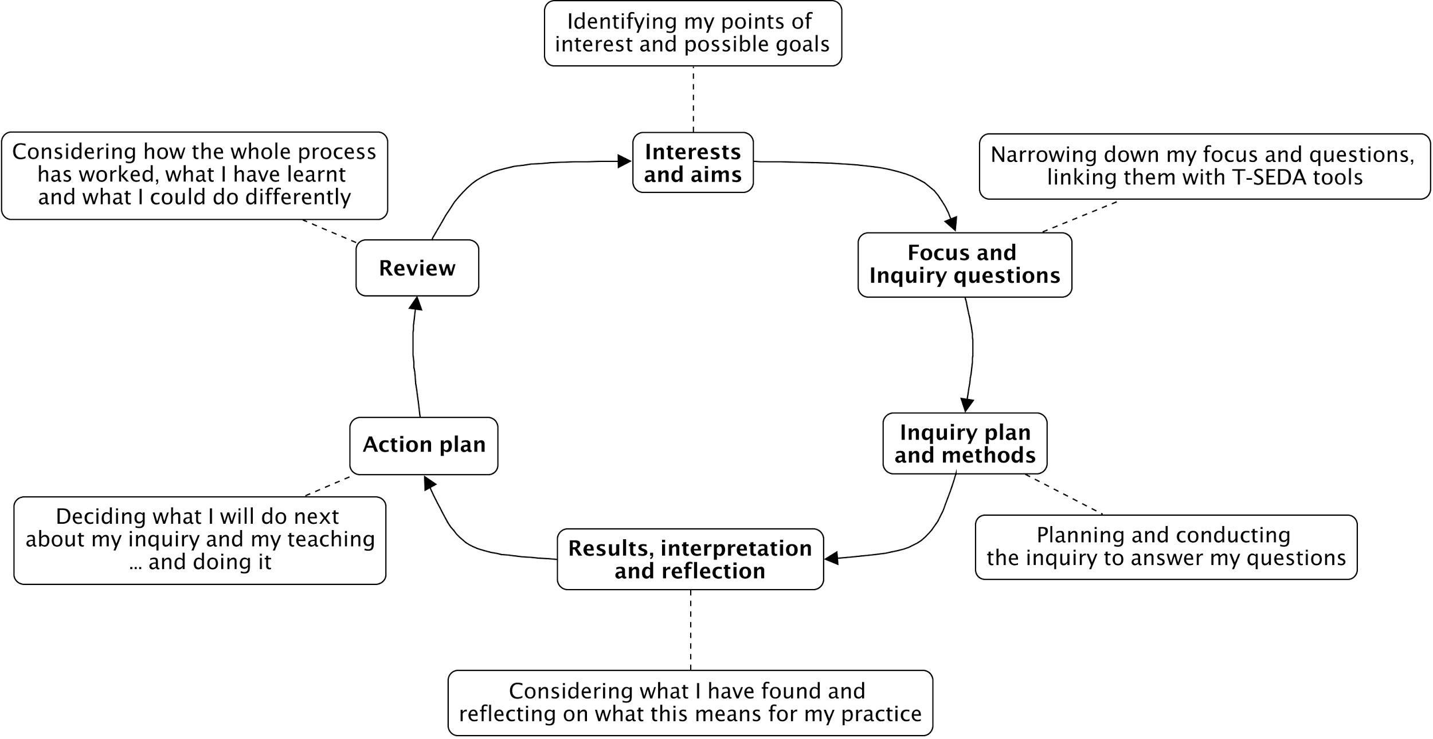

Here is blank template for developing your own cycle. An editable version can be downloaded from the website: http://bit.ly/T-SEDA
Part f. Choosing an inquiry focus
To begin your reflective inquiry cycle, you will need to determine your aims and interests; you can do this by completing the self-audit in Part d. Completing the self-audit will help you to determine what you are interested in and why. This in turn will help you to identify a focus for your inquiry. Once you have identified the focus you will be ready to begin designing your inquiry.

There is a completed reflective inquiry cycle on the next page, and the table on page 16 gives some examples of different inquiry purposes and questions.

The reflective cycle has an inquiry focus at its heart

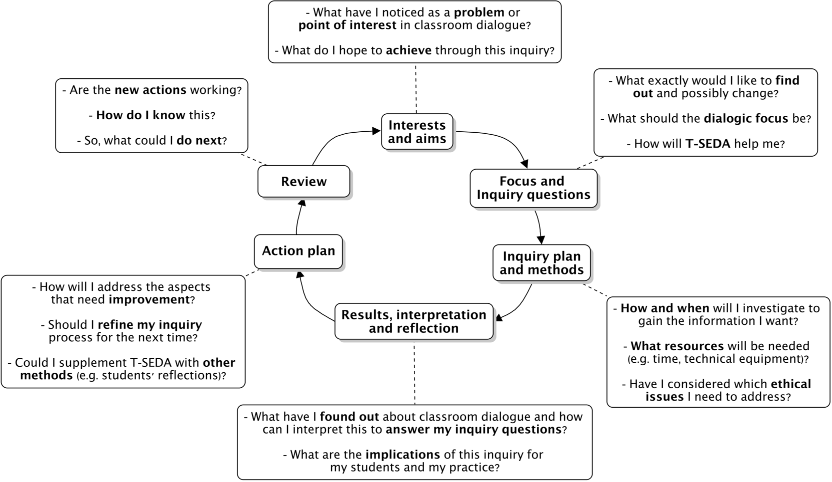

Here is an example of a reflective cycle which Gary, an Early Year teacher, used to carry out his inquiry into children’s ‘building on ideas’ in the role play area of his classroom. The following pages give further ideas about how to begin your own inquiry cycle

Action plan

Pair children for role play time
Ask them to share ideas about play
Results, interpretation and reflection
Some children appear to build on each other’s ideas but others play alone and don’t hear from their classmates
Inquiry plan and methods

Observe children playing in 4 sessions and live code using templates 2C and 2D focusing on ‘Build on ideas’
Review

Children now play with a wider range of classmates.
Are they building on ideas?
Focus and inquiry questions

Do children build on each other’s ideas when they’re playing in the role play area?
Interest and aims

I’m interested in how children use the role play area

Most investigations will focus inquiry questions on specific elements of dialogue, depending on the particular interest or concern.

We suggest that inquiries that focus on classroom dialogue and learning could take account of the research results that point to the essential combination of these elements: Student Participation and Talk Rules, IB (Invite to build on ideas) and B (Build on ideas ), and CH (Challenge).

For maximum benefit to learning, all of these would be addressed. As a starting point, you might select one (or more) element(s) for systematic inquiry. For example:

- If there is a concern about equitable participation in groupwork, then it could be a priority to focus inquiry on encouraging quality student-student dialogue through introducing Talk Rules and supporting active Student Participation.
- If students seem to be confident to contribute in class but they rarely build on others’ ideas, then an inquiry could target B.
- The inquiry focus might call for including other coding categories. If students have been working on problem solving in mathematics then a focus on the categories CH together with R (Reasoning) could be developed.

It is likely, also, that the inquiry focus will change over time. This could happen because interest shifts from one classroom concern to another, or perhaps because learning objectives change. It could also occur because there is a sequenced logic to choosing the categories for different phases of inquiry. For instance, a teacher who is concerned about the quality of whole-class dialogue in plenary sessions might start with an inquiry question focused on the overall quality of CH (Challenge) evident in the class discussion, before moving on to investigate levels of individual student participation in this context. Depending on the results, this could then be followed by close observation of how students build on each other’s ideas, how they challenge other views and how they connect their learning to wider contexts beyond the lesson.

The table overleaf gives some examples of general inquiry questions that highlight the core elements of ‘build on ideas’ and ‘challenge’ in the context of active participation and talk rules.

INQUIRY TYPE | SAMPLE PURPOSE FOR INQUIRY | SAMPLE FOCUS & INQUIRY QUESTIONS
Observation of other teachers | To see if talk rules to promote dialogue are in place  To identify how students are supported to build on ideas  To see how the teacher helps students to engage productively in challenging  To see whether there is a supportive atmosphere for trialling and evaluating ideas | Are talk rules negotiated during the lesson? If not, are talk rules mentioned? (Talk rules)  Do students and the teacher appear to observe talk rules or routines that benefit dialogue? (Talk rules)  Is the teacher asking learners to evaluate, build on or comment on others’ positions? (IB – Invite to build on ideas )  Do students feel comfortable and confident to express, query and challenge ideas? (B – Build on ideas and CH - Challenge)  Do they need a more supportive classroom ethos? Is the teacher drawing in more reticent students? (Student participation)
Observation of students | To investigate if students are building on each other’s ideas.  To observe whether ideas are being challenged productively and respectfully by students  To gauge levels of active student participation.  To see if any students are marginalised or excluded | How are students reacting to invitations to build on each other’s ideas? (B – Build on ideas)  Do students invite others to build on ideas? (IB – Invite to build on ideas))  Do students respectfully challenge or question others’ ideas? (CH - Challenge)  Do multiple students make contributions to dialogue? (B – Build on ideas)  Do students initiate interactions and speak directly to each other without always addressing the teacher? (Student Participation)  What are ‘quiet students’ and disengaged students actually doing during classroom or group discussion? (Student Participation)
INQUIRY TYPE | SAMPLE PURPOSE FOR INQUIRY | SAMPLE FOCUS & INQUIRY QUESTIONS
Teacher self-reflection & professional development | To self-assess how I am helping students to learn through dialogue  To explore how building on ideas and challenging in dialogue can be supported  To assess how talk rules are being taken up by the class and myself  To identify barriers to dialogic learning and teaching | Do I actively build on learners’ ideas? (B)  Do I explicitly encourage students to express disagreements or challenges? (CH)  Do I draw in more reticent students? (Student Participation)  In which subjects and activities do students query or challenge each other more easily? How could this be further developed? (CH)  Which talk rules are being successfully implemented? Are there areas in which we need to improve?  What strategies can I use to find a good balance between ‘build on ideas’ and ‘challenge’ in whole class dialogue?
Students’ self reflection | For students to investigate how they can better engage with their classmates’ ideas  To assist students in reflecting on their participation in classroom dialogue | Are we listening and taking account of each other's ideas? (B)  Do we develop what others have said, instead of just waiting to say what we think? (B)  When we disagree with someone else’s point of view, do we say it respectfully? (CH)  If we don’t disagree with each other publicly, why do we think this is happening? (CH)  Are our talk rules working well for different subjects and activities? Are we all sticking to them?
Lesson Study | Teachers already familiar with the Lesson Study approach to professional development may wish to use this pack to provide a focus on dialogue within a lesson study | Lesson Study doesn’t begin with inquiry questions, rather it offers a systematic approach to collaborative teacher-led professional development.  Lesson Study involves the identification by a group of teachers of an area of teaching (dialogue) that needs to be developed. The group then plans a lesson together (the research lesson) to address that area of need (with a particular focus on specific students to monitor their progress). One teacher then delivers the research lesson, whilst the other members of the group observe the lesson. They then interview the target students to gauge their progress and engagement during the lesson. The lesson is then reviewed by the group, with strengths and further areas for development identified. The process is then repeated (with somebody else teaching the research lesson) based on this review – with a view to refining the teaching strategy being looked at. More details are available in Section 5 and this free online resource: www.lessonstudy.co.uk/handbook  Example focus: Which dialogue moves do the target children make during the lesson? In what ways do these moves assist their learning?
Dialogue and Technology | To assist the effective use of technology to foster dialogue | Does the presence of technology (e.g. tablet or interactive whiteboard) facilitate dialogue? How?  Does it impact the ground rules for talk? If so, how?  How often do students refer to the technology or its contents during their dialogue?  In what ways do these references impact learning?  What talk moves emerge in dialogue using technology?  Does the presence of technology influence student participation in groupwork? If so, in what ways?
Other | e.g. multi-professional case conference or teacher team meeting / lesson study discussion...
Part g. Research ethics

The T-SEDA professional learning pack is intended to support teachers' reflective inquiry, with the aim of enhancing classroom dialogue. As in any form of professional activity there are some general ethical considerations for using T-SEDA to investigate dialogue in school. Note that educational researchers in Britain are expected to abide by ethical guidelines issued by the British Educational Research Association: http://bit.ly/BERAethics2018.
The Principles of Research Ethics
- Minimising the risk of harm and maximising benefits
- Obtaining informed consent
- Protecting anonymity and confidentiality
- Avoiding deceptive practices
- Providing the right to withdraw

What does the risk of harm mean?
- Physical harm or discomfort to participants (students and staff)
- Psychological distress and discomfort, including participants feeling pressure to participate
- Social disadvantage
- Lack of privacy and anonymity
Anyone conducting school-based investigation should make sure that they consider how to reduce these unintended harmful consequence.

To follow the principles of research ethics, it is important to consider these points before, during and after your inquiry. You might choose to discuss these issues with colleagues or to make your own notes on any of these points.

- Should the views of others (parents, students) be considered? | 6. Might any negative or embarrassing data emerge from the inquiry?
- What are the benefits of your inquiry? (e.g. to colleagues, students) | 7. How will you protect your students from harm from any negative data?
- How will you protect your participants’ data? (e.g. written or recorded) | 8. Do you need signed consent forms from students or their parents?
- How will you explain the inquiry to your students and others in the school? | 9. How will you protect the privacy of others involved in the inquiry?
- When sharing findings, how can you ensure anonymity and confidentiality? | 10. Do you need to give credit to colleagues for any of your data?

Part h. Analysing classroom talk: systematic observation and coding

To effectively understand what is happening in any talk situation, it helps to break down individual contributions and consider what functions they serve. A coding scheme can be an invaluable way of understanding real examples of classroom interactions and dialogue. This professional development pack has been developed from research on effectively coding classroom talk to look for evidence of ‘dialogic moves’ (see Part c).

Systematic coding: what is it?
How do we know high quality classroom dialogue when we see it? How can we be sure our impressions are grounded in actual instances of productive forms of interaction?

A common way to tackle this is to categorise interaction systematically, or ‘code’ it, chunk by chunk, often coding each speaker’s turn separately. This means looking at the functions of each contribution to the conversation made by teachers and students (e.g. inviting someone to offer an opinion; asking a question; or stating a point). Researchers may develop their own set of categories (scheme) for this analysis, or they may re-use or adapt one. Then they systematically apply the scheme across a lesson or particular episodes to see what features of the interaction are commonly occurring. Lessons might be coded live, from video or audio recordings, or from transcripts of those recordings (see guidance and examples in Sections 4 and 5).

Systematic coding: why use it?
Some benefits of coding:

- Coding shows up what the casual observer might not easily see, especially patterns emerging across lessons or episodes; for example who is participating more often and in more depth?
- Lots of lesson data can be handled and boiled down to show the frequencies of key characteristics of the dialogue
- Change (e.g. in teacher practice, student participation or learning) can be charted over time or student groups/lessons/classrooms can be compared using a consistent measure

Systematic coding: what will I need to be careful about?

Coding also has its limitations:

- Meanings and intentions can be ambiguous and categories may not be straightforward to apply; using particular categories diverts attention away from other features.
- Coding treats spoken turns separately and out of context, ignoring how codes work in combination and how one person’s communications influences others (e.g. how are questions and suggestions taken up in the dialogue? Are student contributions self-initiated or prompted by teachers and/or peers?)
- Coding gives us limited information about the dialogic ethos in the classroom – how confident are learners to participate freely? Is there mutual trust and respect?

What can we do about these limitations of coding? We can seek rigour and use complementary methods in order to strengthen the approach:

- For example, we can rate the student participation level across a whole lesson using a simple rating scale (see Section 2).

- We can explore how a dialogue progresses over time (during or across lessons) through reading it carefully and interpreting the interactions in light of the coding pattern emerging. Then we can write a narrative about these, taking account of different factors, such as

  - how participants stimulate further contributions by others
  - significant features of the context including pedagogical objectives and strategies

Part i. Possible uses of the T-SEDA pack

You might use the pack in different ways, according to purpose and opportunity. Teachers, other adults (e.g. teaching assistants) and students could use T-SEDA as a tool for self-reflection and for observation of peers. Students' use of T-SEDA may in most cases be initiated and guided by the teacher, although the teacher may not be physically present on every occasion. Specific dialogue categories (see Section 1) can be chosen according to inquiry aims, interests and needs.

Teachers, other adults (e.g. teaching assistants) and students themselves might use the T-SEDA pack in different ways, according to purpose and opportunity. Possibilities include (see examples in Part f):
• videoing own lesson and analysing own teaching to audit current practice, or chart change over time
• observing teacher colleagues and giving feedback – including as part of a Research Lesson Study (see Resources Section 5)
• analysing students’ collaboration or reasoning skills and supporting their development
• self-assessment of teacher discussions (e.g. during ‘lesson study’ conversations)
• engaging in school-based inquiry and in wider research networks with school/university colleagues

Teachers who have worked with T-SEDA have inquired into different aspects of dialogue. Areas of interest include:
- students’ reasoning in secondary school historical investigation;
- young learners’ group roles in ‘thinking together’ activities;
- students’ equitable participation in primary science groupwork;
- teachers’ ‘lesson study’ discussions;
- teachers’ peer lesson observations and professional development

Various resources you will need to support your inquiry are available in Sections 1-5.

Please send us feedback if you trial T-SEDA in your classroom (T-SEDA@educ.cam.ac.uk). We would love to hear from you!

TEACHER SCHEME FOR EDUCATIONAL DIALOGUE ANALYSIS
(T-SEDA): Supporting Resources

- SECTION 1: Coding framework A list and explanation of dialogue categories illustrated with sample prompts and contributions, plus more general dialogic classroom practices.

- SECTION 2: Templates for observing and coding Includes lesson observation (time-sampling; checklist; rating scales).

The following resources are available online, including separately downloadable templates for printing or editing; look out for the icon.

- SECTION 3: Technical guidance for recording and transcribing

- SECTION 4: Case studies Illustrates teachers’ coding and interpretation of dialogue in different contexts; includes teachers’ findings and next steps.

- SECTION 5: Resources and activities: Ideas to implement dialogue in your classroom, references to other research on dialogue and links to related resources

SECTION 1: Coding framework
How can the T-SEDA coding framework help me to evaluate the quality of dialogue in my classroom?

The T-SEDA coding framework focuses on turn-by-turn analysis of dialogue. The codes can be used in different ways for systematic observation, either live during a lesson or using a lesson recording. It may also be useful to capture dialogic practices across a whole lesson or episode such as the use of talk rules and levels of student participation. (See Section 2 for more details.)

The categories below can be used to analyse talk turns in order to understand the functions of each contribution to the dialogue. Sometimes, more than one code can occur within a turn or even a sentence. Guidance about how the framework can be used follows in the next sections of this resource. This framework has been adapted from the Cam-UNAM Scheme for Educational Dialogue Analysis (SEDA) collaboratively developed and tested by two large research teams in Mexico and UK (as described by Hennessy et al. 2016).

Key dialogue categories
CODING CATEGORIES | CONTRIBUTIONS AND STRATEGIES | What do we hear?
B – Build on ideas  build on, elaborate, clarify or comment on own or others’ ideas expressed on previous turns or other contributions to the learning activity (oral/written/other) | - build on own or another’s previous ideas /contributions by adding something new  - clarify, elaborate, extend, reformulate own or another’s previous ideas / contributions  - comment on previous ideas / contributions | Possible Key Words to look for:  ‘it’s also’, ‘that makes me think’, ‘I mean’, ‘she meant’  Examples:  Kate’s idea made me think about why the character would do that.  I’ve got an idea that no-one has mentioned yet…  What I meant earlier was…  Ahmed’s story had a lot of detailed description  My idea was similar to Jose, I wrote that flowers would make the best present

CODING CATEGORIES | CONTRIBUTIONS AND STRATEGIES | What do we hear?
IB – Invite to build on ideas  Invite building on, elaboration, clarifying or commenting on own or others’ ideas / contributions to learning activity (oral / written / other) | - invite others to build on own or others’ ideas  - invite others to clarify a contribution  - invite others to comment on others’ ideas or views (including invitations to agree/disagree or evaluate)  - invite others to refine/improve ideas | Possible Key Words to look for:  ‘What?’ ‘Tell me’, ‘Can you rephrase this?’ ‘Do you think?’ ‘Do you agree?’ Can you add to…?’  Examples:  What do you mean? Tell me more…  Can anyone add to that? Can you give an example of what you said?  Is your idea similar to Manuel’s? What do you think about Maria’s idea? Do you agree with what Chris just said?  What other information do we need?  How can you improve Sanjay’s group’s poster/concept map?
CH – Challenge  Questioning, disagreeing with or challenging an idea | - Stating full or partial disagreement  - Doubting an idea  - Challenging an idea  - Rejecting an idea  - Indicating that two or more ideas that have been expressed are in disagreement | Possible Key Words to look for:  ‘I disagree’, ‘No’, ‘But’, ‘Are you sure…?’ ‘…different idea’  Examples:  I’m not sure it will float actually  I don’t think that’s right, I think.... or ‘I have a different idea…’  Are you sure these angles are the same?  But then that wouldn’t happen if…  That’s partially true, but not when…  I don’t agree with that at all  It’s not Victorian London though  No, I think that other one

Some further categories to consider
CODING CATEGORIES | CONTRIBUTIONS AND STRATEGIES | What do we hear?
R – Make reasoning explicit  Explain, justify and/or use possibility thinking relating to own or another’s ideas | - explain, justify, draw on evidence, make analogies, make distinctions  - predict, hypothesise  - speculate, explore different possibilities | Possible Key Words to look for:  ‘I think’, ‘because’, ‘so’, ‘therefore’, ‘thus,’ ‘in order to’, ‘if...then’, ‘not...unless’, ‘it’s like...’, ‘imagine if...’, ‘would’, ‘could’ or ‘might’  Examples:  I think the wood will float but not the metal.  The ice caps melting by 10% supports the global warming theory.  If children don’t have to go to school, they wouldn’t learn maths properly.  If I chose the first alternative I would be safer, but if I choose the second one I could eventually have greater gains.  I think the author might be referring to feelings when he writes about water.  Our water conducts electricity because it’s contaminated with other materials.... Pure water does not conduct electricity.
IRE – Invite reasoning  Invite explaining, justifying, and/or using possibility thinking relating to their own or another’s ideas | - invite others to explain, justify, draw on evidence, make analogies, make distinctions  - invite others to predict, hypothesise  - invite others to speculate, explore different possibilities | Possible Key Words to look for:  ‘Why?’, ‘How?, ‘Do you think?’, ‘explain further’  Examples:  How did you arrive at that solution/conclusion/evaluation?  I don’t quite understand. Can you explain further?  Group X/Classmate Y said that it is because of... what do you think about their explanation?  What would/could/might happen if...?  Can you imagine that…?  Which objects do you think might float?  Why do you think that was? (in relation to a statement/observation)  Why do you think that would be? (in relation to a statement/observation)  How do you know that?  Chloe says x is 2. How do we know that she’s correct?  Who can tell me why they might agree with Joe?

CODING CATEGORIES | CONTRIBUTIONS AND STRATEGIES | What do we hear?
CA - Coordination of ideas and agreement  Contrast and synthesise ideas, express agreement and consensus, or invite others to do this | - come to a consensus view  - evaluate at least two different ideas by comparing / contrasting / critiquing them  - judge the value of an idea / artefact  - confirm agreement/consensus  - propose to resolve differences and/or agree a solution  - synthesise, generalise  - invite consensus, evaluation, summary, resolution, generalisation, etc. | Possible Key Words to look for:  ‘I agree’, ‘to sum up…’, ‘So, we all think that…’, ‘summarise’, ‘similar and different’  Examples:  So we agree with Jason… because…  Elaine came up with more evidence than Tim, she was more convincing.  ‘So, do we all agree that…?’  I think all we agree that a suspension bridge would work best.  I agree with Maria and not with Andy because the pebble is too heavy to float  We agree that these ideas can’t be reconciled.  I see what you mean, Option C is probably right, not B.  They are both saying the same thing because…  Taking together what Alan and Bonnie said, it seems that most of us now think that the government was too extreme when it required that all chickens on the farm had to be killed when only one had Avian flu.  Can someone summarise the key point of what we / your group just discussed?  Which groups’ ideas and arguments are similar?  What are the differences between your group’s arguments and the others’?
CODING CATEGORIES | CONTRIBUTIONS AND STRATEGIES | What do we hear?
RD – Reflect on dialogue or activity  Evaluate or reflect “metacognitively” on processes of dialogue or learning activity; invite others to do so | - talk about talk rules / ground rules  - reflect (or invite to reflect) about the processes/ value/ impact of dialogue  - reflect (or invite to reflect) on value/ impact of learning activity  - explicitly acknowledge a shift of position | Possible Key Words to look for:  ‘dialogue’, ‘talking’, ‘sharing’, ‘work together in the group/pair, ‘task’, ‘activity’, ‘what you have learned’, ‘I changed my mind’, changed your mind’, ‘listening’, ‘talk rules’  Examples:  I like sharing ideas because it can give us new ideas for our writing.  They (talking and listening) kind of go together, don’t they?  Can you share with the class how your group’s ideas have changed and developed?  It (dialogue) works when everyone is talking about the right thing  So, thinking about our ground rules for talking in the classroom...  In your group can you think about what makes dialogue work?  Do you think we need new talk rules for next time?  I can see you were listening to each other carefully; did that help your learning?  What have you learned in today’s lesson? Have you changed what you think?  What / whose argument helped you change your mind, and why?  How did you feel about being a group leader today?  As the ‘note-taker’ in your group did you feel you participated in the dialogue?

CODING CATEGORIES | CONTRIBUTIONS AND STRATEGIES | What do we hear?
C – Connect  Make pathway of learning explicit by linking to contributions / knowledge / experiences beyond the immediate dialogue | - refer back to earlier contributions or flag up forthcoming requests  - refer forward or back to relevant activity or artefacts  - refer to wider contexts beyond the classroom or to prior knowledge / experiences | Possible Key Words to look for:  ‘last lesson, ‘earlier’, ‘reminds me of’, ‘next lesson’ ‘related to’, ‘in your home’  Examples:  It’s like when we did/learnt…  How is today’s lesson related to last lesson?  Who remembers the experiment we did with keeping plants in the dark?  At the end of the lesson I'm going to ask you to write down what you think happened and why.  Who has visited the science museum and can tell us what they’ve seen?  I know a lot about horse riding because I have my own horse.  Do you think you might find similar creatures in the soil in your own garden?  Have you seen anything on the news that refers to weather or climate?  Is there any information in earlier chapters that is useful?
G – Guide direction of dialogue or activity  Take responsibility for shaping activity or focusing the dialogue in a desired direction or use other scaffolding strategies to support dialogue or learning  (This general category captures contributions that support the flow of dialogue and may enhance student participation) | - encourage student-student dialogue  - offer thinking time  - propose possible courses of action or inquiry  use strategies that respond to learners’ levels of understanding such as: provide informative feedback, feed in / highlight ideas, focus attention on key concepts or task elements, stimulate wider/deeper thinking, introduce authoritative perspective, e.g. technical terms or facts to clarify confused thinking | Possible Key Words to look for:  ‘How about’, ‘focus’, ‘concentrate on’, ‘Let’s try’, ‘no hurry’  Examples:  So, in answer to the question, what have you found out?  Are you thinking about...?  Don’t worry, have a go...  Let’s try adding up instead!  Take your time and let me know when you’ve thought of anything.  Why don’t you explain to Kelly what we are doing?  In pairs can you discuss which of these sources you think is the most reliable account of the battle?  What would Newton say?  Try to make more eye contact so you can engage the audience more.
CODING CATEGORIES | CONTRIBUTIONS AND STRATEGIES | What do we hear?
E – Express or invite ideas  Offer or invite relevant contributions to initiate or further a dialogue (ones not covered by other categories) | - invite opinions, ideas, beliefs or examples without referring back or building on prior contributions, typically by open, general questions, or by drawing more people into the exchange without explicitly inviting them to build/reason/coordinate/query  - make a relevant contribution, including short responses to closed questions; plenary reporting; extended ideas not explicitly linked to previous contributions | Possible Key Words to look for:  ‘What do you think about…?’, ‘Tell me’, ‘your thoughts’, ‘my opinion is…’, ‘your ideas’  Examples:  What do you think, Maria?  What do you think is really important in this text? Can you identify some key words and underline them on the board?  Are there any more ideas on that?  How many four-legged animals can you name?  What do you know about how electricity works?  Let’s brainstorm…

SECTION 2: Systematically observing and coding dialogue

This section aims to help teachers select an observation method appropriate for their purposes and situation by highlighting the advantages and disadvantages of different methods. Having become familiar with the coding framework, the next step is to decide what type of systematic observation is most helpful for the specific inquiry focus.

Systematic observation methods - potential advantages and disadvantages
The table below compares the following methods:
- Live coding (i.e. simulated ‘live’ watching a video of classroom groupwork)
- Audio-recording + selective transcribing (listening to the same video)
- Video-recording + selective transcribing (watching and listening to the same video)

LIVE CODING | AUDIO-RECORDING PLUS SELECTIVE TRANSCRIBING | VIDEO-RECORDING PLUS SELECTIVE TRANSCRIBING
Advantages
- Visual representation – being able to see body language adds to our understanding of both dialogue and classroom relationships, as does interaction with digital or physical artefacts/resources.  - It is a more practical method, which can be used more often than the other two.  - It does not change the environment for the students so it is easier to capture normal behaviour. | - Level of detail of transcript allows for more precise coding, considering dialogue codes rely on language.  - Allows revisiting previous contributions to identify connections.  - Allows pausing and thus coder thinking time.  - Allows application of more codes and repeated iterations if desired.  - Facilitates identifying opportunities for teacher intervention. | - Level of detail of transcript allows for more precise coding, considering dialogue codes rely on language.  - Allows revisiting previous contributions to identify connections.  - Allows pausing and thus coder thinking time.  - Re-enacts classroom conditions thus giving a more accurate representation of classroom events.  - Captures nonverbal participation and physical domination.
Disadvantages
- Speed of events might lead to some inaccuracies in observations/coding.  - Can be demanding and tiring (listening carefully, timing, thinking and coding).  - Only allows focusing on a maximum of two dialogue codes as a more realistic option. This might miss other elements of the discussion.  - Not possible to re-play and reflect. | - More time consuming and thus not always possible as an iterative methodology.  - Lack of visual observation means that coder should identify speakers from voices.  - Missing non-verbal participation or physical domination.  - Recording requires obtaining consent from parents and students, which may take time. | - It may take time for students and teachers to get used to being video-recorded, which means that initial recordings might not capture normal behaviour.  - Technical equipment needed - often not available in schools.  - More time consuming and thus not necessarily feasible as an everyday methodology.  - Recording requires obtaining consent from parents and students, which may take time.

SYSTEMATIC OBSERVATION METHODS: TEMPLATES FOR CODING LIVE OR RECORDED LESSONS

In this section we offer some tools for looking systematically at dialogue in both whole class and groupwork contexts. Having identified your focus and inquiry question, your methods could include structured observation techniques such as checklists, grid and rating scales. These are most efficient when you already know what types of talk you are looking for (see categories in Section 1). Parts 2A to 2E focus on analysing dialogue using the coding framework. Parts 2F and 2G focus on wider dialogic practices and participation.

These approaches can be used separately, depending on the purpose and feasibility (e.g. how much time is available). They can also be used in a combination of fine-grained and broader analysis, which can be particularly informative and powerful in showing how classroom dialogue works in practice. Editable versions can be downloaded from our website: http://bit.ly/T-SEDA.

Part 2A: Template for coding an audio/video transcript: how the dialogue develops over time
Part 2B: Time-sampling coding for groupwork (tallying): how frequently different indicators of dialogue occur in a given episode .
Part 2C: Checklist for individual students (groupwork): what the level of individual participation is in the group talk.
Part 2D: Group work quality (rating scale): summarises the quality of participation in small group dialogue in a given episode.
Part 2E: Whole-class participation overview (rating scale): what and how students are involved in dialogue during whole-class activities.
Part 2F: Student participation and Talk rules (rating scales): assessment across a whole lesson or for each activity
Part 2G: Student self-assessment (group work): students’ rating of their own involvement in group work

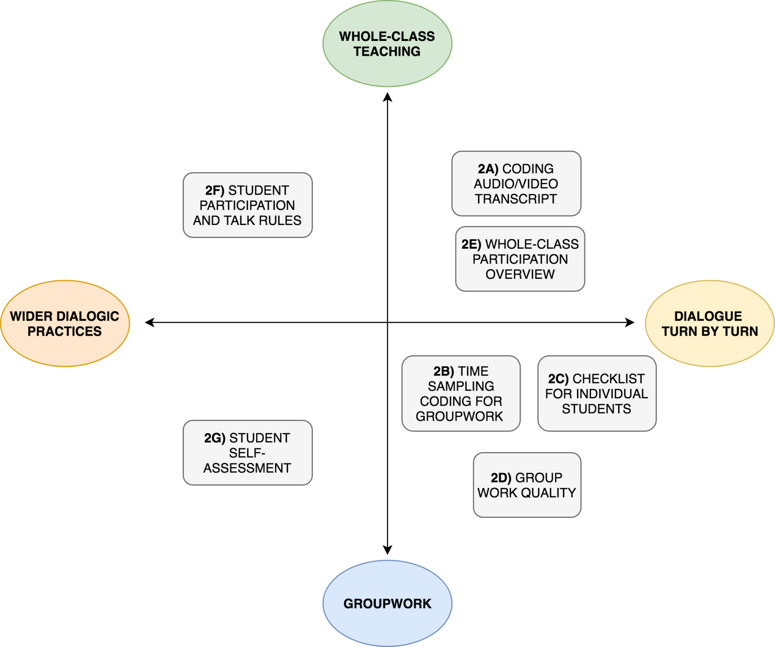

2A: Template for coding an audio/video transcript

A unique feature of T-SEDA is that it enables detailed exploration of how dialogic an interaction is, and of how specific dialogic interactions support learning. By using the T-SEDA categories to code individual speech turns, teachers can develop their understanding of whether and how learners’ thinking develops within a dialogic episode. A very useful way of conducting this type of inquiry is by coding a transcript of a recorded episode.

Guidance notes:
- Once you have created a transcript from your video or audio recording, copy and paste it onto a table like the one shown below using the “speaker” and “turn” columns (adding rows as needed). Each “turn” row should include a speaker’s contribution before the next person speaks. You may prefer to work in Microsoft Word, or Excel, or similar.
- We suggest numbering the turns (left-hand column) so that they are easily identifiable.
- You can select some of the categories from the coding scheme to do your analysis (depending on your inquiry focus), or work with the all the categories at once (noting that working with all the categories is more challenging at first).
- Read the transcript carefully and record the relevant category next to each turn.
- Bear in mind that some turns could be left uncoded (without any categories) if none of the categories is applicable. This is to be expected, even in high-quality dialogue.
- Consider also that, in some cases, more than one category will be applicable to the same turn. You can use two or three columns to list the observed categories.
- Additionally, you might find it useful to add a Comments column like the one in the table below. Here you can record any relevant observations (e.g. doubts or ideas that come up while coding, or the way in which elements in the transcription relate to your inquiry focus or questions).
A downloadable transcript coding template is available from our website.

Nº | Speaker | Turn | Code 1 | Code 2 | Comments

2B: Time-sampling coding for groupwork

This time-sampling approach is intended to be used by the teacher or another investigator for observing students working in groups. Groupwork is commonly seen to be one of the best opportunities for students to engage in productive classroom dialogue, allowing each the opportunity to participate. The ideal group size ranges from 3-6, depending on a number of factors, such as the age of the students, their experience in groupwork, and the nature of the group activity. Inquiry questions about groupwork may touch on a number of interrelated aspects of the students’ dialogue, social relationships, and learning. It is almost inevitable that, whatever the initial inquiry focus, other elements will become relevant to drawing conclusions. For instance, should non-verbal communication be taken into account? What about the particular influences of technology use? In order to prepare for and handle this complexity, the recommendation is to focus at least one inquiry question centrally on just 1-2 clusters or codes. Also, use the ‘Comments’ space at the end to record notes about any other insightful observations or anything that seemed to influence the discussion. This will keep dialogue at the forefront of the inquiry, while still allowing other factors to be considered.

‘Time sampling’ is a common technique used by researchers to sample events at regular time intervals during an episode or whole lesson. It is based on the notion that recording and categorising every single communication or action is often too demanding, while sampling over time gives the researcher a roughly accurate picture, or at least one that is informative enough to make distinctions between individuals. Researchers might observe a group of learners simultaneously or instead categorise the communications of each individual participant in turn, depending on purpose and feasibility. Time sampling can be accompanied by written notes if desired. A time pattern for observing events is decided in advance and for complex behaviours such as dialogic communication whose form and purpose can change quickly, time intervals will be quite short so as to allow the researcher to listen carefully and categorise accurately. In these cases a “rest” period is commonly used when observing live as concentrating on closely observing and analysing interaction is very tiring and it is easy to miss things. If a video record is available, it can of course be replayed or slowed down so coding can take place without time pressures, as mentioned earlier.

The time-sampling example overleaf uses the categories B ‘build on ideas’ and CH ‘challenge’ throughout, but these can be changed according to need and interest; see the fuller scheme in Section 1 for more options.

Time-sampling template

Guidance notes:
- Write the names of the students of the group you are focusing on in the table below (you can add/delete columns)
- Each window is 1 minute: 40 seconds for close observation and simultaneous coding and 20 seconds for resting.
- For each window (minute), tick the box (√) if the identified student used Build on ideas (B) or Challenge (CH) in his/her contributions to the dialogue. Note that in some circumstances tally coding for each relevant contribution may be useful and appropriate; this offers more detail about frequencies but is harder to record accurately.
- If during the 40 seconds, the teacher, teaching assistant or similar adult was present or interacted with students, tick the relevant box (√)
- Use the comments box below to add any further relevant information not captured by the time-sampling coding

Windows | Teacher/TA present | Student 1:  …………………… |  | Student 2:  ……………………… |  | Student 3:  ……………………….. |  | Student 4:  ……………………….
 |  | CH | B | CH | B | CH | B | CH | B
1
2
3

Comments: Please use this space to record any other insightful observations or anything that seemed to influence the discussion.

2C: Checklist for individual students (groupwork)

This checklist approach can be used at the end of a groupwork activity. It can serve as a summary of 2B, or if time-sampling is not possible, it can be completed independently. It aims to provide an indication of the overall participation of individual students in the given activity, focusing on the aspects of dialogue that are most relevant to the inquiry focus. This checklist can be repeated if the activity or the group changes, providing a record of different factors that may influence student participation in dialogue on different occasions. As in 2B (time-sampling) the idea is to consider the quality of students’ participation in relation to selected categories (in this case CH and B).

Checklists of this type cannot claim to provide exact measurements, and they are not intended to do this here. The intention is more to provide a manageable basis for noticing and recording potentially significant differences between individual student participation, including changes over time in different group activity contexts. These observations can then be the basis for discussion and with staff colleagues and students themselves, helping to identify where further action may be needed.

Guidance notes:
- Write the names of the students of the group you are focusing on (you can add/delete rows as appropriate)
- For each student, tick the box (√) if they have shown Build on ideas (B) or Challenge (CH) in their overall contributions to the group discussion
- Use the Rating column to indicate the extent of participation of each student in the overall discussion. Use the following three-point scale: 1=Low participation, 2=Medium participation, 3=High participation. These levels should be judged in relation to the general participation levels in this activity, not the typical or expected participation of individual students as judged from previous experience.

Students’ Names | CH | B | Rating of overall participation
1)
2)
3)

2D: Group rating (groupwork)

As with 2C, this group rating can be used at the end of each groupwork activity (and repeated if the activity or the group changes). Its main purpose is to record judgements about the group as a whole, basing the ratings on the selected categories (in this case B and CH). This group rating can be helpful for establishing the general nature of dialogue in a group activity. The quality of dialogue can then be monitored for the group as a whole. It also provides a context for judging individual student participation (e.g. if the whole group is not building well on each other’s ideas then it is harder for one student to do this than in a group where building on ideas is well-established).

Guidance notes:
- Use a three-point rating scale for the frequency of each dialogue category within the conversation as a whole: 1 = low, 2 = medium, 3 = high
- Use the ‘Comments’ column to add any relevant information to the rating, such as whether the results are typical, or if they show progress

 | Rating quantity (1-3) | Comments
CH

B

2E: Whole-class participation overview (rating scale)

This whole-class rating scale extends 2D to focus on whole-class talk. It is designed to support reflection on student participation in whole class interaction. This includes the frequency and length of contributions and the numbers of students involved in dialogue during particular types of whole-class activity, such as ‘lesson introduction’, ‘whole class discussion’, ‘plenary’, etc. (left-hand column). This overview can help to monitor the nature of dialogue during these whole-class activities, bearing in mind how the expectations for dialogue can vary even within a single lesson.

Guidance
- Select one or two coding categories that are central to your inquiry. The example below uses B and CH. If you are interested in invitations, then IB and CH may be a good combination. For other examples see Coding framework in Section 1.
- Add the types of activities taking place during the lesson in the first column (add/delete rows as appropriate). For each activity add your ratings in response to each question.
- Use the following rating scale: 5 = all the time/as many students as possible, 4 = most of the time/most of the possible students,
3 = some of the time/some of the possible students, 2 = occasionally/a few of the possible students, 1 = never/none of the students

Activity type | Category | How often are students doing this? | How many students are taking part in this? | Are these contributions extended rather than short?
1) | Build on ideas (B)
 | Challenge (CH)
2) | Build on ideas (B)
 | Challenge (CH)

2F: Student participation and Talk rules rating scales

Once you are familiar with the methods above, you might like to use these 3-point scales to make assessments across a whole lesson or for each activity – in your own classroom or when observing a peer.

Dimension | 0  Not evident | 1  Teacher-led | 2  Teacher-led with student involvement
Talk rules | No explicit focus on ground rules for dialogue or dialogic practices is apparent | The teacher introduces, models or reminds students of target dialogic practices, e.g. ground rules to be followed, inclusive turn taking. | Teacher and students or students themselves negotiate target dialogic practices, e.g. ground rules, perhaps along with reminders / modelling.  It may also include students being given or taking responsibility for managing the dialogue, as well as students being involved in evaluating effectiveness of dialogic practices.
Student participation | Public exchanges in whole-class situation or group work consist in teacher questioning and succinct students' contributions  or  Students don't have opportunities to discuss their ideas publicly | Students express their ideas publicly at length in whole-class situation and group work, but they don't engage with each other’s ideas | Multiple students express their ideas publicly at length in whole-class situation and group work  AND  In doing so, they engage with each other’s ideas, for example by referring back to their contributions, challenging or building on them (e.g. ‘It’s a bit like what Shootle said but….’, ‘Sam had such a great idea, look [demonstrates]’). This includes spontaneous or teacher-prompted participation.

2G: Student group work self-assessment (Secondary Students)

A self-audit helps you to think about your group work. For each of the statements below, put a number in the box next to it. Everyone in the group should fill in their own self-audit. If you think the statement is: Not true – write ‘1’, Partly true – write ‘2’, Very true – write ‘3’
Criteria | Rating
G1 – Everyone in the group participated
G2 – We worked as a single group and didn’t split up
G3 – Most or all of our talk was about the task we were doing
G4 - We shared our own ideas and built on each other's
G5 - We listened carefully when others were speaking and took on board what they were saying
G6 – We enjoyed working together in a group
G7 – When we made suggestions or agreed/disagreed with others, we gave reasons
G8 – We challenged or commented each other’s ideas in a respectful and constructive way
G9 – We tried to reach consensus or compromise if there was disagreement

See article by Jim Parsons, University of Alberta: http://bit.ly/JimParsonsethics
You are unlikely to need them for usual classroom learning activities, but you may need them for recording or filming
The original SEDA (©2015; pronounced “Sedda” as in Spanish) has 33 coding categories organised in 8 clusters. It has been condensed and reformulated to create new forms of the scheme for different research purposes. The full original SEDA scheme and further information about the research are available at http://tinyurl.com/BAdialogue.
The findings in this section derive from pilot testing of T-SEDA, reported in Vrikki, Kershner, Calcagni, Hennessy, Lee, Estrada, Hernández and Ahmed (2018).
A version for primary school students and a version for teachers to use appear in our online resources.

