Using Panopto - Faculty of Education quick start guide
You can use the Panopto desktop recorder to create online educational videos in order to deliver teaching remotely. The video is recorded on your computer and automatically uploaded to Panopto, where you can review and edit it before publishing it to a Moodle course. This document is an edited and shortened version of the official documentation available via the official Cambridge Panopto Pages. Further links are included at the end of this document.

Summary steps to enabling Panopto for a Course:
- Moodle Coordinators for a category add the Panopto block to a course which creates a Panopto folder to host recordings.
- Teaching staff visit a course with the Panopto block to become authorised Panopto users and download the Panopto recording software to a Mac or Windows device.
- Teaching staff create recordings (video, audio and/or PowerPoint) and upload them to either their private 'My Folder' Panopto folder or directly to their course’s Panopto folder.
- Within a Panopto folder, recordings are reviewed, edited and published for viewing in the Moodle course. This work can also be done in the creator's 'My Folder' space, but the recordings will need to be moved into a course folder to make it available to others.
- Released content appears in the Moodle course as links within the Panopto block and can also be embedded within the course.
Before recording your first video you will need request access to Panopto for your Moodle course by contacting your Moodle Coordinator (Anja Cessford acc48@cam.ac.uk for courses in the Faculty of Education Category). Panopto needs to be added to each course where you wish to upload videos. After adding it to a course, it is necessary to access Panopto the first time through a Moodle course to become an authorised Panopto user and download the Panopto recording software to a Mac or Windows device.
Next, install the Panopto desktop recorder. You will need to have at least a microphone (either built in or externally connected) to record the voiceover for your presentation. You can also record from a webcam (built in or externally connected), and additional video sources. A Panopto video usually includes audio and one or more video sources, such as a slide presentation and/or a video of yourself speaking.
It is also possible to upload videos from another source, more information can be found in Uploading videos from another source.

Creating a video using Panopto desktop recorder
Once you have installed the desktop recorder you can create a recording:
- Open the Panopto desktop recorder.
You can also launch the recorder directly from the Panopto web interface: at the top of the webpage, click Create > Record a new session and it will open the desktop recorder for you.
- Under Session Settings, ensure the Folder is set to My Folder. When you have finished recording, the video will be uploaded to this folder, where it will only be visible to you. This ensures you can review and edit the video before sharing it more widely. If you select a different folder, the recording will be visible to a wider audience before you can review it.
- In the Name box, enter a name for the recording. You can edit this after the recording has been created and uploaded.
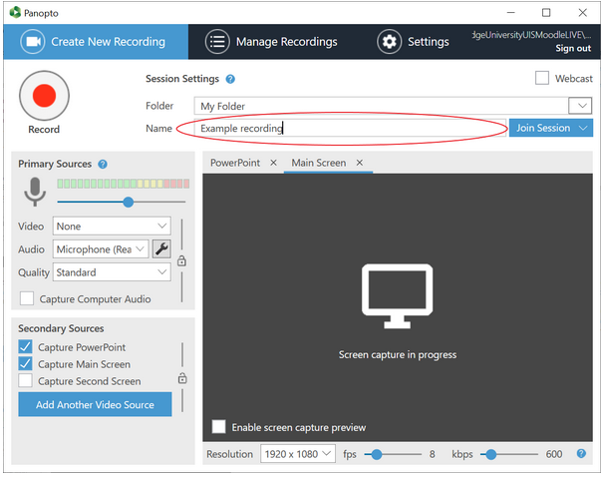
- Specify the sources you want to record: Panopto will always record the Primary source, and you can add your PowerPoint slides or Computer Screen as secondary sources. When viewing a recording via Moodle, students can display the primary source video alongside one secondary source video or view a single video in full screen mode. Students can switch between secondary source videos, but they cannot display multiple secondary source videos at the same time.
  - The Primary Sources include the single audio source and one video camera source. If you do not wish to record from your video camera (if connected) then set the Video source to [none].
  - The option Capture Computer Audio should not be ticked unless you specifically need to capture computer (not microphone) audio. Note that all computer audio, such as notification sounds, will be recorded when this option is selected.
  - You can add multiple secondary video sources, including a PowerPoint or Keynote presentation, one or more screens, and one or more cameras (depending on what is connected to your computer).
Note that Capture PowerPoint means that that any slides containing text (excluding images of text) will be indexed to create chapters and their content will be searchable, but that any cursor movements or animations are NOT captured. To include cursor movements or animations, use Capture Screen instead or in addition to capturing the PowerPoint.
  - Recording can be linked to PowerPoint presenting, so that recording automatically starts when you open the PowerPoint, so presenting mode starts when record is pressed.
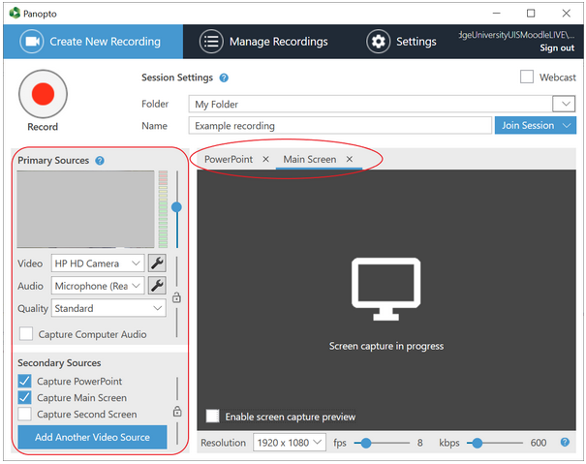
- Click the red record button to start the recording.
- You can pause the recording as needed. Panopto desktop recorder continues to capture the selected sources while the recording is paused but marks the content as a cut. When editing a recording, you can include content from the paused section in the published video.
- When you have finished, click Stop. After stopping the recording, you will see a summary of the recording. To save the recording and upload it to the Panopto folder you specified, click Done. If you weren't happy with it, you can delete the recording and start again.

Important note on Panopto folders
If you selected a course folder rather than My Folder to upload your video to on completion, the video will be made available to students via Moodle as follows:
- If the course folder is set to publish immediately the video will be available to students through the Moodle block straight away.
- If the course folder is set to be available when approved, this will require a teacher or 'publisher' from the course to approve the video.
To ensure the recording remains private until you are ready to share it with other teachers or students, ensure My Folder is selected.

Publishing a video to Moodle
Once you have reviewed and edited your video as needed you can publish it to Moodle so that the students enrolled on your course can access it. Publishing a video to a Moodle course involves moving the video to the Panopto folder for that course. Once added to the course folder, the recording will (subject to the folder's availability settings) be visible to students enrolled on that course from Moodle, but not to other Moodle users. If required, you can unpublish a video so that it is no longer visible to students enrolled in the course.
Note that a video can only be published to one Moodle course. To publish a video to multiple courses, create a copy of the video in each course folder.

Publishing a video
To publish a video, open Panopto:
- Find the video in Panopto. If you created the video using the Panopto desktop recorder, you can find the video from there. From the Panopto desktop recorder, open the Manage Recordings tab, and next to the video click View. The video is opened in the Panopto video player.
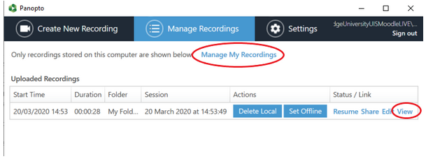
If you can't easily see the video in the Panopto desktop recorder, click Manage My Recordings. The Panopto web platform opens in your default web browser. Select My Folder, browse the folder structure or search for the video by name as required.
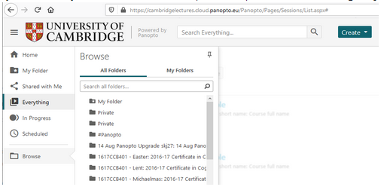
- If you have opened the video in the Panopto video player, click the cog icon at the top of the page. Alternatively, from the Panopto folder view, move your mouse over the video and click Settings. The settings for the video are displayed in a new window.
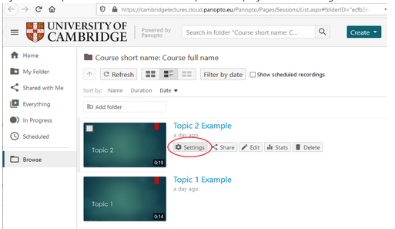
- In the Overview section, the folder in which the video is currently stored is displayed. Next to the folder name, click Edit.
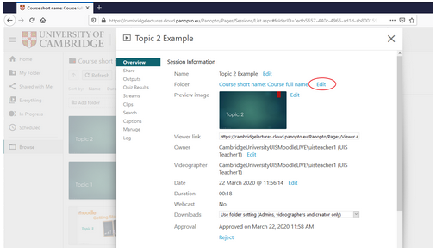
- A dropdown list of folders that you have permission to access is displayed. Select the folder of the same name as the Moodle course to which you want to publish the recording.
- Click Save. The video is moved to the course folder. The folder's availability settings determine whether the video is immediately visible to students enrolled on the course or not. If the video is moved to a course folder where the availability is set to immediate, the video will be available to students on the associated Moodle course.

Approving a video for publication
If the availability settings for a course folder are set to "When approved by publisher", all users with the publisher or creator role for that folder (Moodle participants with the teacher or coordinator roles) will receive an automated email from Panopto whenever a video is added to the folder. You can approve your own video. The email sent contains a brief message and two links: the first, shorter one is to view the video itself and the second link opens the settings where the clip can be approved for publication (also accessible from the course folder in Panopto).

Availability settings
All ‘Teacher’ and ‘Non-enrolling Teacher’ roles in Moodle are able to change the availability settings for all videos added to a course folder. The availability settings only impact students (i.e. users with the viewer role); Moodle coordinators and teachers can access all videos that have been published to Panopto course folders for their Moodle courses, regardless of these settings.
To check the availability settings for a course folder:
- Open the settings page for the Panopto course folder. From the Panopto interface, locate the folder and click the cog icon. Alternatively, from the Moodle course page, locate the Panopto block and click Course Settings.
- On the left-hand side of the settings window, select Settings.
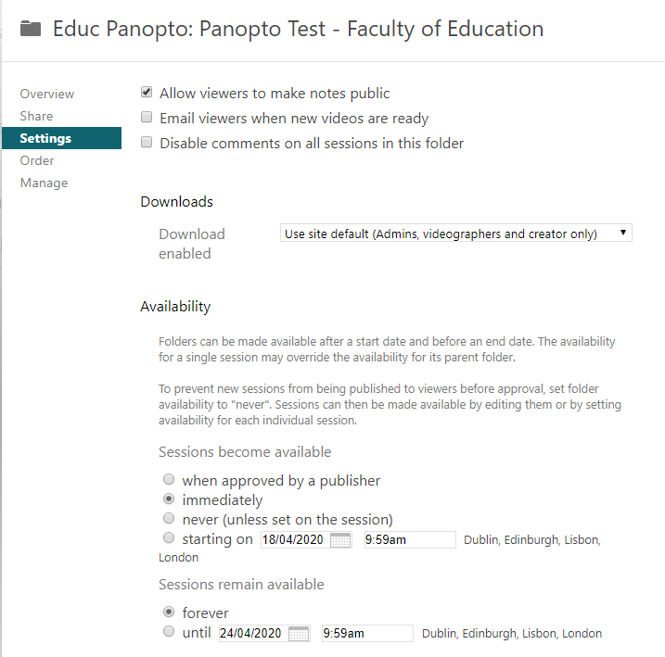
- Under Availability, ensure the appropriate option is selected:
  - Select When approved by publisher to make the video available only to users with the publisher or creator role until it has been approved by one of those users. (If you retrospectively change this setting for a course with previously published content, all content will revert to unpublished and requiring approval and multiple emails will be triggered at this point.)
  - Select Immediately to make any video in the course folder available to students without requiring an approval step.
  - Select Never (unless set on session) to make all videos in the folder unavailable by default. Individual videos can be made available by editing the individual video settings. This approach is much more labour-intensive than setting the availability at the folder level.
  - Select Starting on and select a date and time to make all videos in the folder available from a particular date.
You can also specify how long videos will remain available to students. Under Sessions remain available:
- Select Forever to make the videos available to students until the Moodle course is archived at the end of the academic year. When the Moodle course is archived, the videos will no longer be available to students via the Moodle Course History.
- Select Until and select a date and time to prevent students from having access to any of the videos in the folder from that point onwards.

Organising educational videos into subfolders
It is possible to create subfolders within a course folder in Panopto. While this may seem like a good way to organise videos for a particular course, it is important to note that students accessing the course from Moodle will only see videos in the course parent folder in the Panopto block.

Other sharing options
Both course folders and individual videos in Panopto include "Share" settings. These settings are separate from the option to publish a recording to a Moodle course described above. Publishing a recording to a Moodle course controls who has access to view, edit and manage a video, based on the course enrolment and permission settings. You do not need to modify the "Share" settings to achieve this.

More information
For more detailed help please see the Cambridge Panopto support pages:
Online Educational Videos with Panopto (Main Page)
https://www.vle.cam.ac.uk/course/view.php?id=180842
Conceptual Overview: Moodle and Panopto
https://www.vle.cam.ac.uk/mod/page/view.php?id=11992202
Creating a video using Panopto desktop recorder (Cambridge Specific - quick start)
https://www.vle.cam.ac.uk/mod/page/view.php?id=12004231
Uploading videos from another source
https://www.vle.cam.ac.uk/mod/page/view.php?id=12022441
Live streaming a video
https://www.vle.cam.ac.uk/mod/page/view.php?id=12062241
Reviewing and editing videos in Panopto
https://www.vle.cam.ac.uk/mod/page/view.php?id=12006201

(last edited by Anja Cessford 17-04-2020)

