Individual Staff Risk Assessment Checklist for COVID-19 (version 2)
For all individuals including Black, Asian and Minority Ethnic (BAME), pregnant and other staff groups that may be at greater risk

This risk assessment checklist is designed as a tool to facilitate joint understanding and decision making in relation to assessing the individual risk of occupational exposure to Covid-19 and measures needed to reduce this risk to as low as is reasonably practicable.

In line with Government and Public Health England (PHE) advice, (https://www.gov.uk/coronavirus) as much home working as possible should be facilitated and social distancing should be practised in order to minimise the exposure of staff to COVID-19 (whether they have risk factors or not).

This risk assessment checklist is an initial ‘screening’ tool. Please complete Part A of the following document and return this to your line manager who will make arrangements to complete B with you. Part C and D (Return to Workplace staff risk assessment, Red group including those shielding) will be completed depending on the outcome of the Part B assessment.

For individuals who might be at increased risk, based on the information provided, a more detailed discussion involving the Human Resources (HR) Schools Teams will take place. Following this review, a referral to Occupational Health (OH) for advice will be considered and made if necessary.

Should you require further advice or guidance on completing the document, please initially seek assistance from your line manager and / or HR Schools Team.

This version of the checklist has been written to reflect current evidence and guidance on risk factors. Please ensure you keep up to date with all University communications and revisions of this document, which will be updated to reflect changes in Government and PHE advice.

All staff are reminded to adhere to the following guidance and additional information, which is available at https://www.cam.ac.uk/coronavirus

- Follow the social distancing guidelines https://www.gov.uk/government/publications/staying-alert-and-safe-social-distancing at all times, whether in vehicles, on site, outside or inside. Advise colleagues politely if you see they are not maintaining social distancing; accept feedback about your social distancing from others.

- Where it is difficult to maintain social distancing of at least 2m, consider the use of face coverings when inside University buildings.

- Wash your hands more often than usual, using soap and hot water for at least 20 seconds, or use a hand sanitiser - when you get home, into work, and during the day, before and after you eat, or handle food, and after using the toilet. Hand sanitiser, soap, and hot water will be provided. Touching of the face should be avoided.

- Ensure that you are aware of the actions to take if you develop any COVID-19 symptoms and correct procedures are followed during resultant absence from work: https://www.cam.ac.uk/coronavirus/general-staff-advice/health-and-wellbeing#symptoms

- Ensure you are aware of how to access the testing service for symptomatic staff: https://www.cam.ac.uk/coronavirus/general-staff-advice/health-and-wellbeing#testing

- COVID-19 related absence (e.g. self- isolation for symptoms, isolation as a household member, and isolation in relation to shielding [where this is recommended by the government]) is supported by the University.

- Psychological support is available for any individual concerned about their mental health since the COVID-19 pandemic and/or their vulnerability to COVID-19. Staff support can be accessed through the University Staff Counselling Centre https://staff.counselling.cam.ac.uk/ and student support can be accessed through the University Student Counselling Service https://www.counselling.cam.ac.uk/

- Consider whether public transport / rush hour can be avoided through adjustments to work hours or accessing alternative travel arrangements.

Part A – to be completed by individual

Name
Job Title
Department
INDIVIDUAL HEALTH ASSESSMENT | Tick answer |  |  | Risk group details | Action required to control risks
 | Yes |  | No
Have you received a ‘shielding letter’ from the NHS Coronavirus Service or your GP or Specialist Unit informing you that you are ‘clinically extremely vulnerable’? |  |  |  | Individuals with shielding letters should comply with the shielding recommendations and only work from home whilst the shielding advice continues.  As the shielding advice is updated individual risk assessments will need to be undertaken in advance of staff in this risk group returning to the workplace and work from home should be continued where possible. | Individuals in this group should work from home whilst the shielding recommendation continues  Management action:  As the shielding advice is paused, individuals currently shielding, who are unable to work from home, will be able to go back to work so long as the work environment is COVID-safe. A further risk assessment will need to be undertaken for this group. Please complete Part B and D (Return to workplace risk assessment for red risk group / those shielding).  Ensure that individuals are aware that psychological support is available for any staff / student member concerned about the impact COVID-19 has had on their mental health or their vulnerability to COVID-19.
Do you have any of the ‘very high risk’ medical conditions listed below?  i.e. red risk category |  |  |  | If you are concerned that you should be in the clinically extremely vulnerable [red risk category] but have not received a shielding letter or text, please contact your GP or Specialist for further advice. | Individuals in this group should work from home whilst the shielding recommendation continues. As the shielding advice is paused, individuals currently shielding, who are unable to work from home, will be able to go back to work so long as the work environment is COVID-safe.  Management action:  As the shielding advice is paused, individuals currently shielding, who are unable to work from home, will be able to go back to work so long as the work environment is COVID-safe. A further risk assessment will need to be undertaken for this group. Please complete Part B and D (Return to workplace risk assessment for red risk group / those shielding).  Ensure that individuals are aware that psychological support is available for any staff / student member concerned about the impact COVID-19 has had on their mental health or their vulnerability to COVID-19.
VERY HIGH RISK (red)
- Solid organ transplant recipients
- People with specific cancers:
  - People with cancer and are having chemotherapy
  - People with lung cancer and are having radical radiotherapy
  - People with cancers of the blood or bone marrow such as leukaemia, lymphoma or myeloma who are at any stage of treatment
  - People having immunotherapy or other continuing antibody treatments for cancer
  - People having other targeted cancer treatments which can affect the immune system, such as protein kinase inhibitors or PARP inhibitors
- People who have had bone marrow or stem cell transplants in the last 6 months, or who are still taking immunosuppression drugs
- People with severe respiratory conditions including all cystic fibrosis, severe asthma and severe COPD.
- People with rare diseases and inborn errors of metabolism that significantly increase the risk of infections (such as SCID, homozygous sickle cell).
- People on immunosuppression therapies sufficient to significantly increase risk of infection.
- Women with significant heart disease, congenital or acquired who are pregnant (at any stage of pregnancy)
- People with severe diseases of body systems, such as severe kidney disease (dialysis), frequently relapsing nephrotic syndrome of those with a current nephrotic range proteinuria, etc.
- People with a neurological condition that has been identified as high risk as detailed in the guidance from the Association of British Neurologists Guidance on COVID-19 for people with neurological conditions, their doctors and carers available at the following link - https://cdn.ymaws.com/www.theabn.org/resource/collection/65C334C7-30FA-45DB-93AA-74B3A3A20293/ABN_Neurology_COVID-19_Guidance_v6_9.4.20_FP.pdf

Other groups not in the shielding group but considered clinically vulnerable and to be treated as very high risk:
- Those who are pregnant (after 28 weeks pregnant)
- Asthmatics who are on high dose inhaled steroids and have any of the identified risk factors detailed in the asthma flow chart – see Appendix 1

INDIVIDUAL HEALTH ASSESSMENT | Tick answer |  | Risk group details | Action required to control risk
 | Yes | No
Do you have any of the ‘high risk’ medical conditions / other risks listed below?  i.e. orange risk category |  |  | There is a wide spectrum of risk in the Orange risk category from individuals whose vulnerability to coronavirus is unlikely to be significantly higher than colleagues with no risk factors [green risk category], to those whose vulnerability is approaching that of colleagues in the red group.  Age, gender, ethnicity (BAME) and obesity are important factors that need to be taken into consideration when considering individual risk.  Individuals who have two or more risk factors in the orange risk category may have a higher level of vulnerability to COVID-19. This should be discussed with your HR Schools Team and a referral to OH considered.  Some individuals may fall into a yellow risk category (increased risk group e.g., asthma (see Appendix 1)). This group are likely to have well managed underlying health conditions or other risk factors. | Undertake local risk assessment (Part C) before any work in areas where there is a high risk of COVID-19 exposure.  Individual may work, but must complete a local risk assessment (Part C) and agree measures in place to reduce risk of exposure with their line manager  Management actions:  Complete (Part C) Individual checklist for Individual Local Risk Assessment for Orange / Yellow Risk Groups  OH does not need to be contacted if the individual and their manager have sufficient information on which to base an assessment. However, OH can advise when it is unclear which group an individual is in, and if this is orange, what is the stratification of risk. Please complete the COVID-19 OH referral.  Where referral to OH is not indicated:  Advise stringent social distancing.
HIGH RISK (orange)
- Aged 65 or older
- Aged 60 or older and EITHER male OR from a BAME background
- Aged 55 or older AND are male AND from a BAME background
- From a BAME background
See section on ‘other things that can affect your risk’: https://www.nhs.uk/conditions/coronavirus-covid-19/people-at-higher-risk/whos-at-higher-risk-from-coronavirus/
- Under 65 with an underlying health condition listed below (ie anyone advised to have a flu jab each year on medical grounds):
  - Chronic (long-term) respiratory diseases, such as asthma (see Appendix 1), chronic obstructive pulmonary disease (COPD), emphysema or chronic bronchitis
  - Chronic heart disease, such as heart failure
  - Chronic kidney disease
  - Chronic liver disease, such as hepatitis (see Appendix 2)
  - Chronic neurological conditions, such as Parkinson’s disease, motor neurone disease, multiple sclerosis (MS), a learning disability or cerebral palsy
  - Diabetes
  - A weakened immune system as the result of medical conditions or medication (contact OH if this applies to you but you are unsure whether you should be in the orange or red group)
  - Problems with your spleen – for example, sickle cell disease or if you have had your spleen removed – please contact occupational health
- Being seriously overweight (a body mass index (BMI) of 40 or above)
- Those who are pregnant (before 28 weeks) – we advise this risk assessment is undertaken with the New and Expectant Mothers risk assessment checklist, with an aim that the risk of exposure to Covid 19 in the work setting is no greater than the risk of exposure out of the work setting
- Those with poorly controlled hypertension, secondary hypertension or hypertension with an associated cardiac condition (see Appendix 2).

INCREASED RISK (yellow)
- Some individuals may fall into a yellow risk category. This group are likely to have well managed underlying health conditions, e.g., asthma – see appendix 1.

INDIVIDUAL HEALTH ASSESSMENT | Tick answer |  | Risk group details | Action required to control risk
 | Yes | No
Do you fall into neither the orange or red risk category above  i.e. Green risk category |  |  | If not highlighted by any of the criteria set out in either red or orange risk group then individuals are classified as - STANDARD RISK - green - social distancing group.  Workplace adjustments may need to be considered because of pre-existing health problems or disability, unrelated to a vulnerability to COVID-19 e.g. pre-existing anxiety aggravated by COVID-19 outbreak. Reasonable adjustments may be required. | No heightened risks identified  Standard risk group:  Social distancing  Able to work in all areas – follow University return to workplace protocol.  Management actions:  Discuss any concerns highlighted by individual  Ensure individuals are aware of the guidance on page 2; assess how best to implement it (with adjustments if required) and identify who they should inform of any associated difficulties or concerns.

Part B – to be completed by line manager

Risk assessment outcome and work placement | Red Orange / Yellow Green  + for orange risk group an individual risk assessment is required to determine appropriate activities
For those in the Red risk group please complete Part D (Return to workplace risk assessment for red risk group / those shielding) | Yes/No
For those in the Orange / Yellow risk group, confirm that a supplementary risk assessment proforma (Part C) has been completed and actions agreed | Yes/No
For those in the green risk category, please complete the date on which the assessment was undertaken (most recent) and completion of Part C is not required.
Name of Assessor
Date of Assessment
Signature of Assessor
Signature of Individual
Part C – to be completed in discussion with line manager

Supplementary Risk Assessment for Individuals in Orange Risk Group (and Yellow if appropriate) including Checklist

Name
Job Title
Department
Name of Assessor
Date of Assessment
Signature of Assessor
Signature of Individual

It is acknowledged that some individuals with well managed underlying health conditions, or other risk factors, may wish to continue to work without restrictions to their practice. This can be supported if a supplementary risk assessment has been completed to ensure the risk of exposure is reduced to as low as is reasonably practicable and that the individual is comfortable with the level of risk.

Where an individual wants to continue working, it is important that a local risk assessment is carried out to determine how risks can be best managed. It is important that the individual is content with the outcome of the risk assessment and is comfortable with the level of personal risk.

Advice is available to individuals and their managers if there are any questions or concerns about this. Depending on the nature of this, an enquiry could be directed to more senior management, HR Schools Teams, Occupational Health or Health and Safety.

If individuals wish to continue to work the following actions are required:

- Document measures to reduce exposures as far as reasonably practicable and any specific modifications required.
- Confirm that the individual and their line manager are comfortable with the control measures that are in place and know they can request to review the decision at any time.
- Review checklist to ensure all possible controls are considered and included if appropriate.

Details of agreed workplace adjustments/adjusted duties:

For all staff / students with an individual risk assessment a COVID-19 Risk Assessment Checklist must be completed with agreed actions – see overleaf

Tick those that apply | AGREED ACTION PLAN: (Please tick those that have been discussed/agreed)
 | Stringent social distancing - limit duration of close interaction with people as much as possible, when possible maintain >2m distance from people.
 | If risk assessment identifies the need, review PPE use to ensure availability, fit, correct donning and doffing and staff knowledge of the actions to take if PPE is not available / also consider the need for PPE for first aiders and security patrollers.
 | Ensure individuals are aware how to escalate any concerns about PPE availability
 | Where it is difficult to maintain social distancing of at least 2m, consider the use of face coverings when inside University buildings.
 | Ensure that individuals are aware of the actions to take if they feel unwell with Covid-19 symptoms
 | Ensure that individuals know about access to testing for symptomatic staff / students.
 | All individuals should be reassured that COVID-19 related absence (e.g. self- isolation for symptoms, isolation as a household member, and isolation in relation to shielding [where this is recommended by the government]) is supported by the University.
 | Ensure that individuals are aware that psychological support is available for any staff / student member concerned about the impact COVID-19 has had on their mental health or their vulnerability to COVID-19.
 | Consider whether public transport /rush hour can be avoided through adjustments to work hours
 | Review if any workplace adjustment are required due to an underlying health condition/disability, these should be discussed with management and a plan agreed
If work restrictions are not considered to be operationally practical or an individual risk assessment is not appropriate in the current role - consider temporary redeployment to an alternative work area within the division or wider University, where exposure risk is lower.

Escalate decisions within your departmental or divisional structures, if needed. If there are any concerns raised by the staff member or manager about the outcome of the risk assessment process please seek further support from your HR Schools team.

OH advice sought & outcome?
Further actions to be taken to reduce risks  (further actions needed only for “yes” answers in Part A) |  |  | By whom | By when | Date completed
The completed checklist should be filed in the staff members Personnel file. Review this risk assessment on a regular basis and close when no longer applicable.

Appendix 1
Stratification for Staff with Asthma
On inhaled steroid
C
GREEN
GREEN
ORANGE
YELLOW
Presence of ≥ 1 additional risk factor:
- Hospital admission in last year
- Intensive care treatment ever
- Steroid orally daily (prednisolone)
- Antibiotic orally weekly (azithromycin)
- ≥ 4 oral steroids / yr
- Smoker or vaper
Yes
No
No
Yes
Rescue inh < 3x /wk
AND
OCS < 2 /year
HIGH DOSE ICS with extra controller AND one of the following:

On maintenance prednisolone or frequent oral steroids

On a biologic therapy: Mepolizumab (Nucala) Benralizumab (Fasenra)
Reslizumab (Cinquero)
Omalizumab (Xolair)
RED
No
Yes
HIGH DOSE ICS + extra controller
MEDIUM DOSE ICS +/- extra controller
LOW DOSE ICS
Rescue inh < 3x /wk
AND
OCS < 2 /year
Yes
No
Rescue inh < 3x /wk
AND
OCS < 2 /year
No
RED and gov’t criteria for shielding
Asthmatics in the shielded group should have received correspondence from their GP
Yes: Consult BTS table to check if low / medium or high dose
Consider elevating one colour risk level level if smoker / vaper or age > 50
YELLOW
Recommend GP treatment review
YELLOW
Recommend GP treatment review

OCS / yr means the number of courses of high dose oral prednisolone (e.g. ≥ 0.5 mg / kg) for at least 3 days within the past one year.
ICS means inhaled steroid. INH means inhaler.
Additional controller refers to taking certain extra medicines as well as a preventer inhaler (for example, montelukast, salmeterol or formoterol, or you are on a combination inhaler such as Seretide, Fostair, Symbicort, Flutiform, Fobumix, DuoResp Spiromax, Combisal, Sereflo, Sirdupla, Aloflute, AirFluSal, Relvar, Ellipta, Fusacomb or Stalpex.
Asthma Inhaler Strength Classification:
https://www.brit-thoracic.org.uk/quality-improvement/guidelines/asthma/
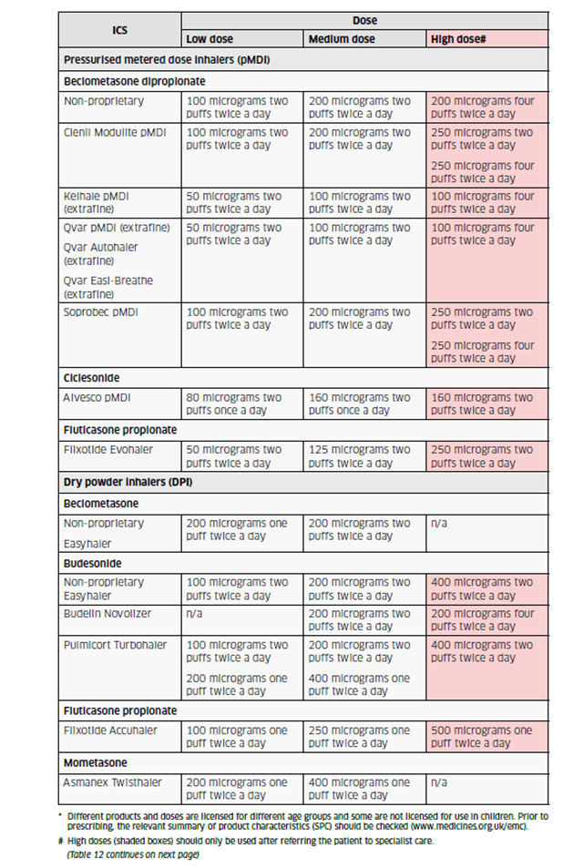
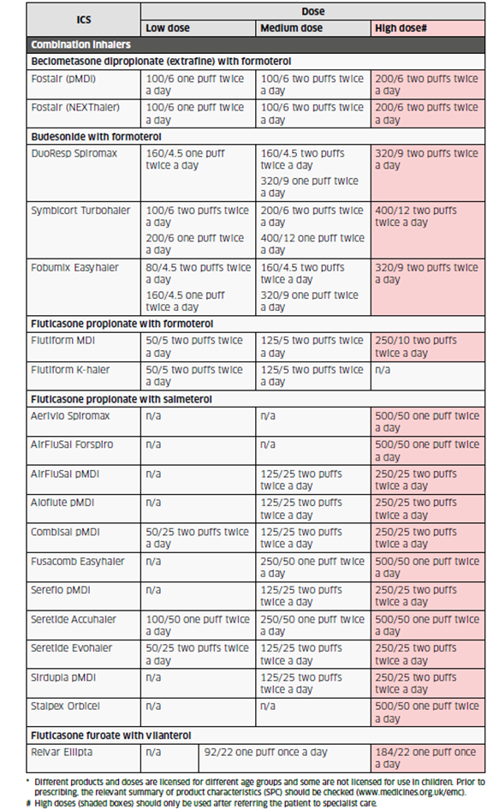

Appendix 2 -
Stratification for Orange Risk Group for Certain Health conditions
 | Respiratory | Cardiovascular |  |  | Other infections
 | TB | Hypertension | Asymptomatic heart valve disease | Atrial fibrillation | HIV | Hepatitis B or C
Standard risk  (Green) | Latent TB | Well controlled hypertension and no cardiac complications/ effects (eg left ventricular hypertrophy)  No other risk factors including those treated with ACE inhibitors or ARBs**** | Asymptomatic heart valve disease** |  | CD4 count ≥ 200 or above and undetectable viral load, on ART | Asymptomatic, with no treatment or comorbidity
Increased risk  (Yellow) | Past TB* |  |  | Controlled atrial fibrillation without reduced left ventricular function
Heightened risk  (Orange) |  | Poorly controlled hypertension or cardiac complications (e.g. left ventricular hypertrophy)  Other risk factors: MI, stroke, aneurysm, renal compromise, etc.)  Secondary hypertension,  arising from other underlying disease |  |  | CD4 count <200, detectable viral load or not on ART | Asymptomatic, with co-morbidities or on current treatment
Comments |  | Risk may be higher if there are other medical conditions  Consider increasing level if heart disease, BMI over 30. |  |  | Risk may be higher if there are other medical conditions
* Post-TB lung damage can leave individuals more vulnerable to chest infections and so at increased risk of secondary infections if they develop Covid-19
**Individuals with complex congenital heart disease are considered at higher risk, as are those with symptomatic heart valve disease and pregnant staff with cardiac conditions

*** The Medicines and Healthcare products Regulatory Agency states that “there is no evidence from clinical or epidemiological studies that treatment with angiotensin converting enzyme inhibitors (ACE inhibitors or ACE-I) or angiotensin receptor blockers (ARBs) might worsen Covid-19 infection” https://www.gov.uk/government/news/coronavirus-covid-19-and-high-blood-pressure-medication. This is currently being reviewed by NICE.

