epiSTEMe
Study Booklet
Probability

LAST NAME

FIRST NAME

May 2011 version
© epiSTEMe project, University of Cambridge Faculty of Education
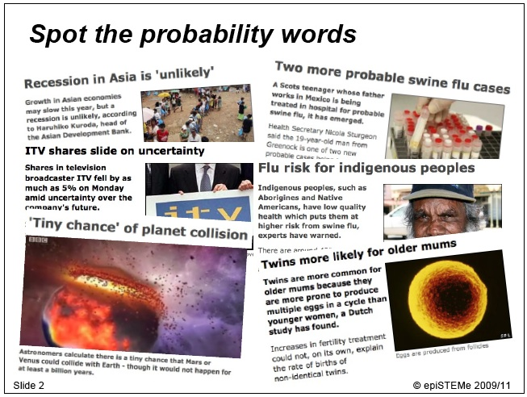
Mark the words that are related to probability.
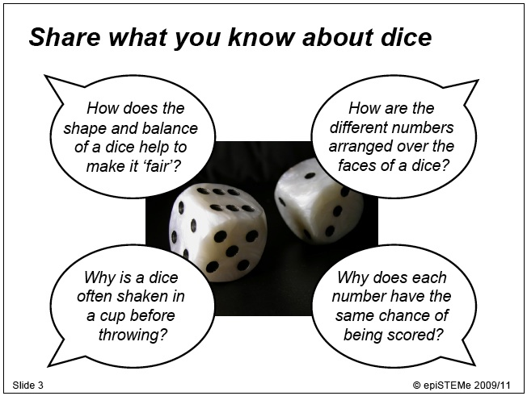
Note down ideas about each question.
How does the shape and balance of a dice help to make it ‘fair’?

How are the different numbers arranged over the faces of a dice?

Why is a dice often shaken in a cup before throwing?

Why does each number have the same chance of being scored?

Information about dice can be found at http://en.wikipedia.org/wiki/Dice.
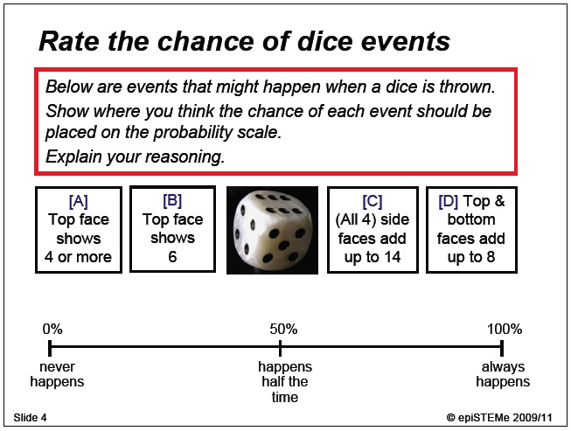
Show each chance on the probability scale.
Note down your reasoning below.
top face shows 4 or more

top face shows 6

(all four) side faces add up to 14

top and bottom faces add up to 8

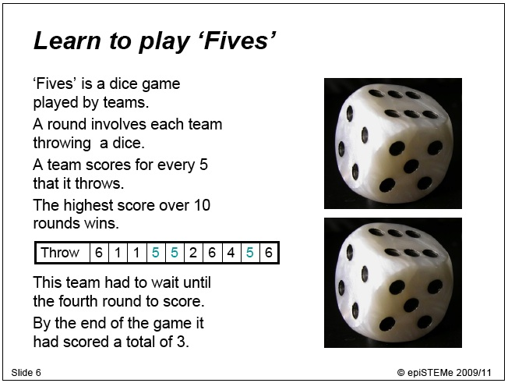
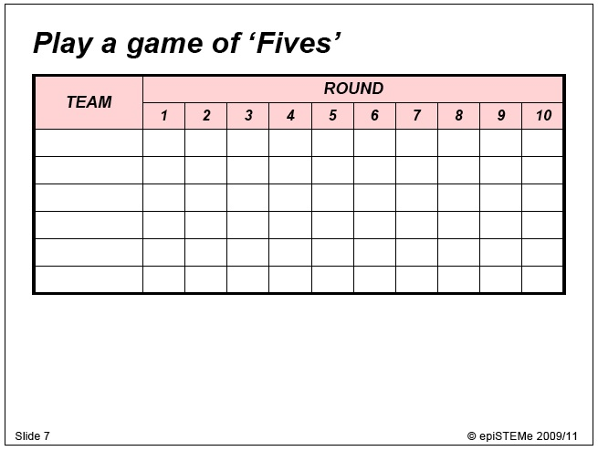
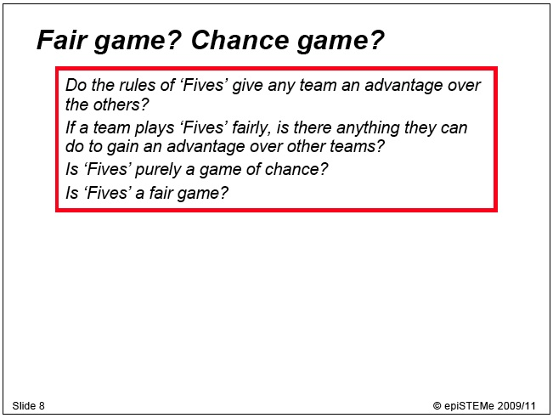
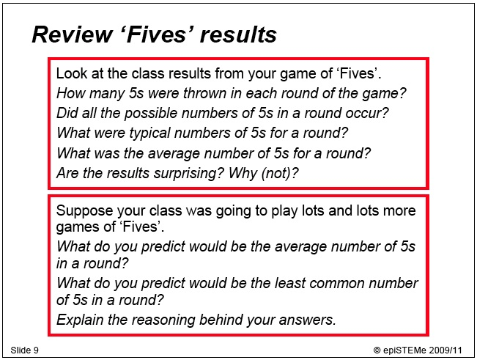
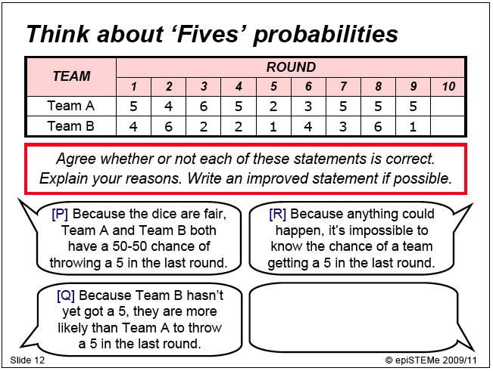
Before you discuss, decide whether you agree ✓ or disagree ✗ with each statement, and mark that to the left of each bubble.
After you have discussed, record whether your group agreed ✓ or disagreed ✗ with each statement, and mark that to the right of each bubble.
If your group has come up with an improved statement, note that down.
Note down whether the discussion has changed your mind about any of the statements and why.
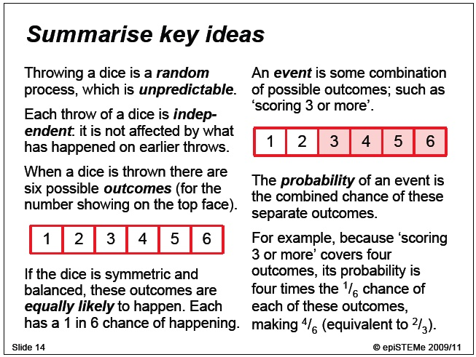
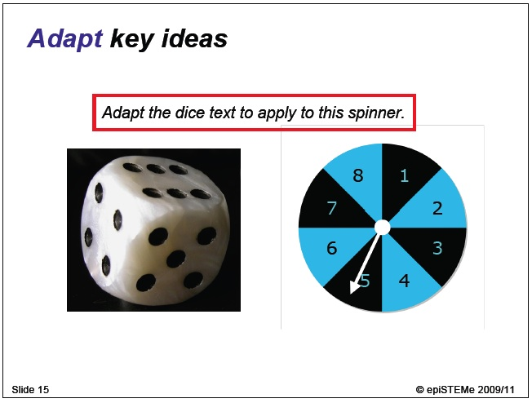
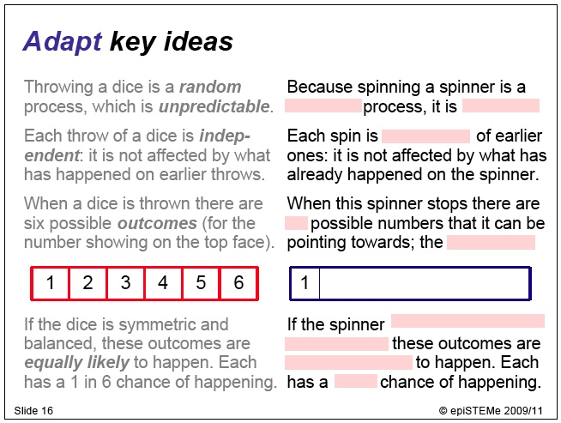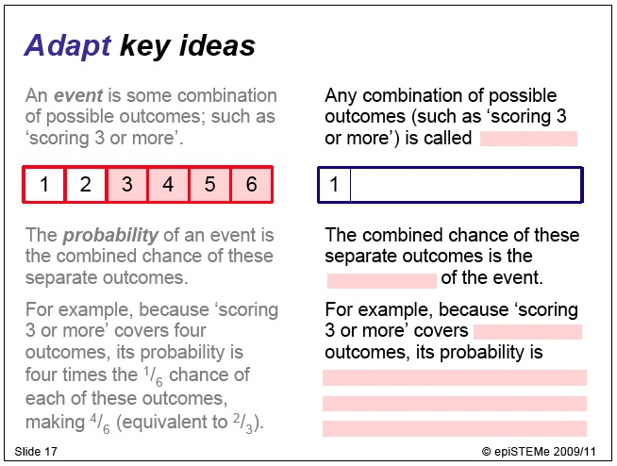Fill in the information missing from these slides
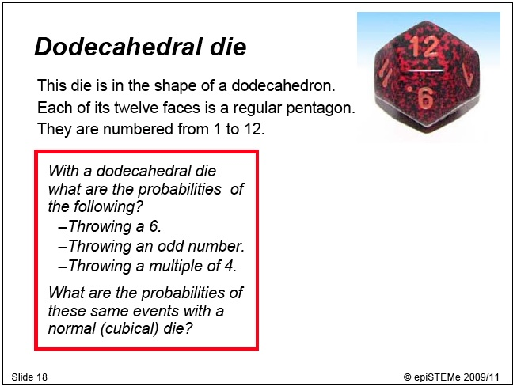
Write out your solutions to the problems
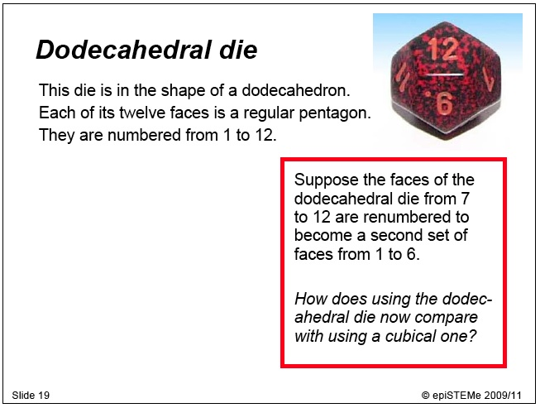
Write out your solutions to the problems
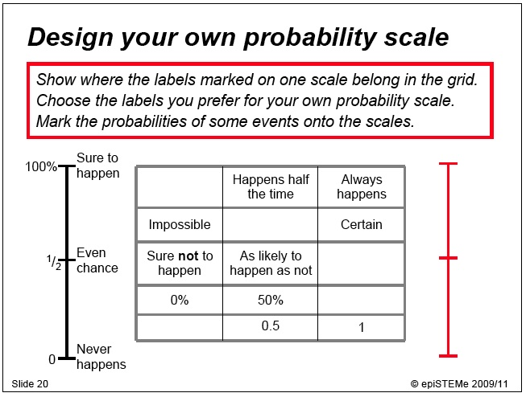
Show where each label marked on the scale on the left belongs in the grid in the centre.
Mark the labels you agreed in your group onto the probability scale on the right.
Mark some probabilities on your scales.
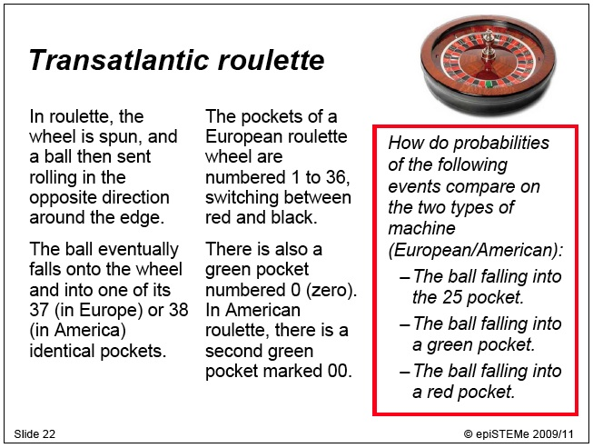
Write out your solutions to the problems.
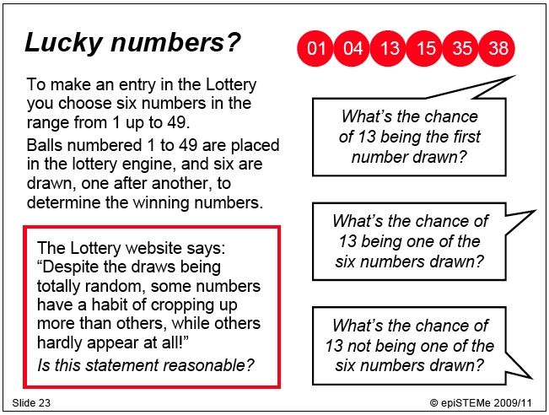
Write out your solutions to the problems.

Write what you think about whether the National Lottery statement is reasonable.
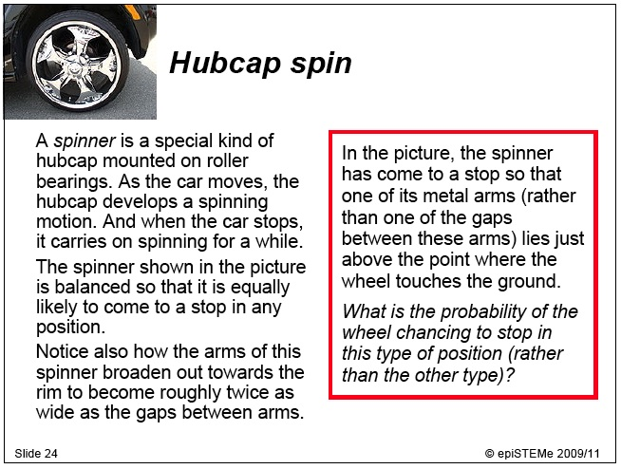
Write out your solution to the problem.
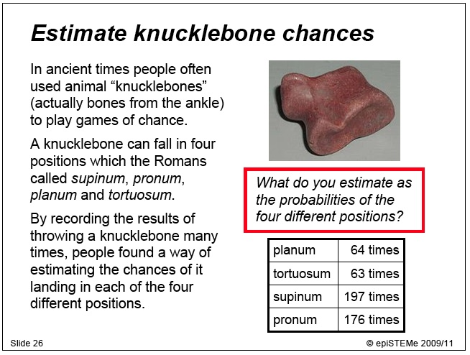
Note down your estimates for the probabilities of each position.

Position | Probability
planum
tortuosum
supinum
pronum

Explain your method for estimating probabilities in situations like this.
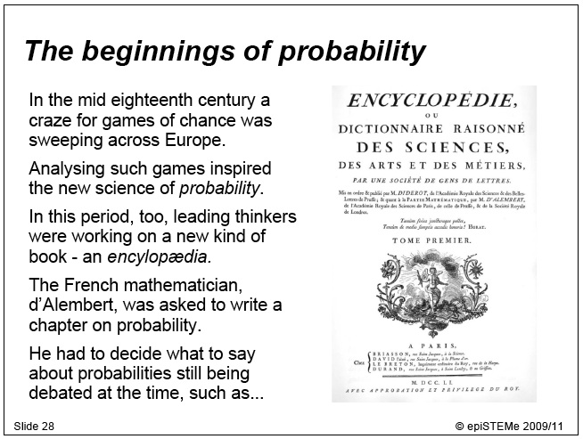

Information about d’Alembert can be found at http://en.wikipedia.org/wiki/D’Alembert, and about the Encyclopedia at http://en.wikipedia.org/wiki/Encyclopédie.
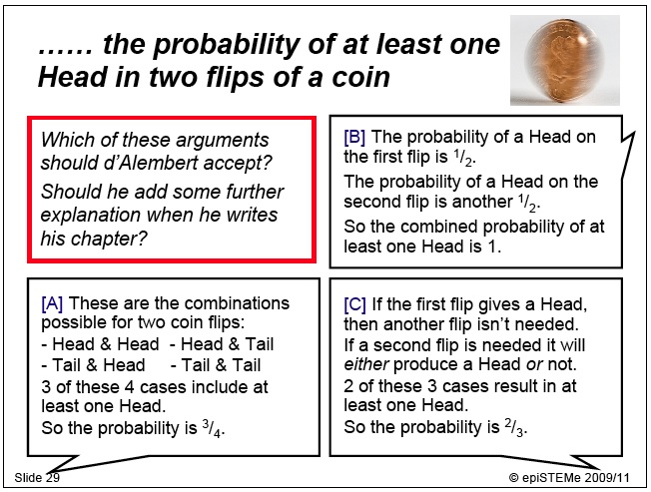
Mark whether your group agreed or disagreed with each solution, and record your reasons below.

Note down whether the discussion has changed your mind about any of the solutions.
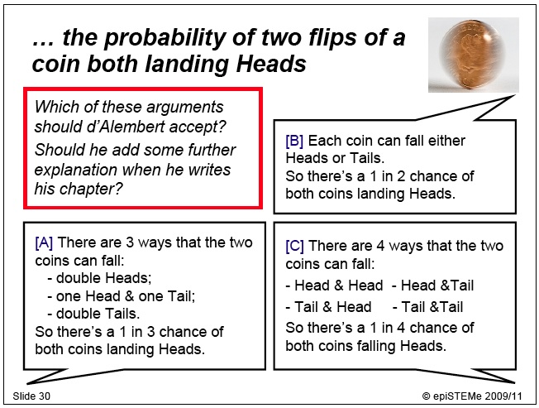
Decide whether you agree or disagree with each solution.
Note down your reasons below.
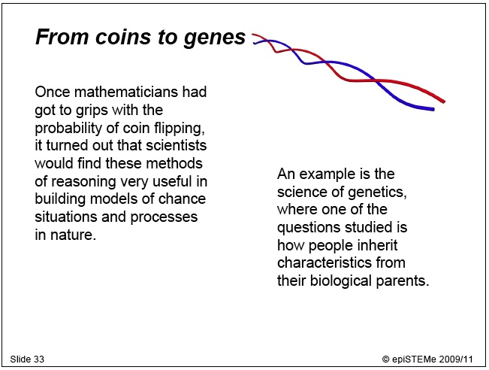
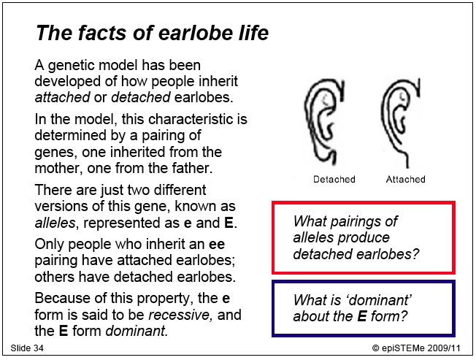
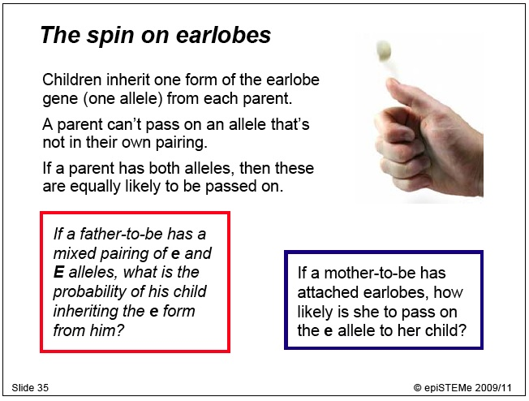
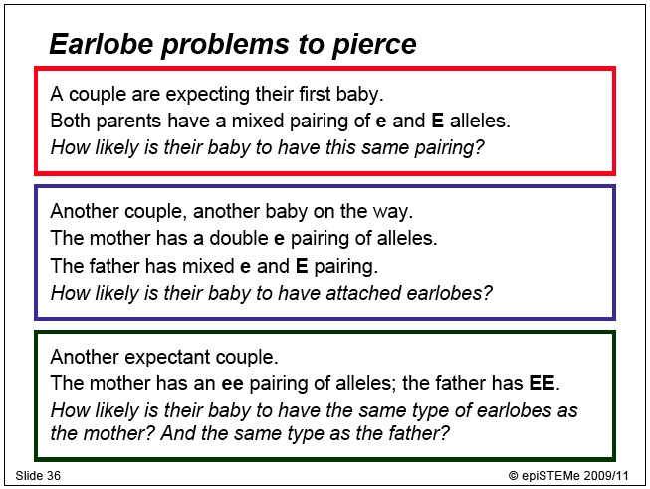
Note down your solutions to the problems here.
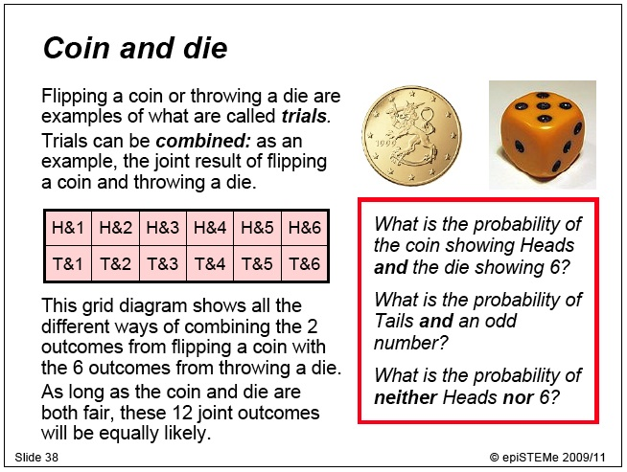
Note down your solutions to the problems here.
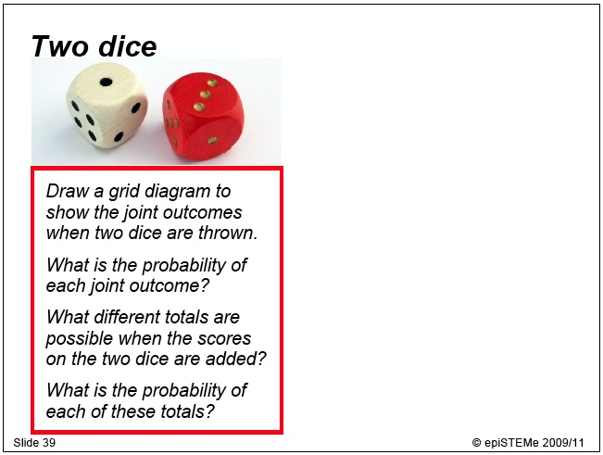
Note down your solutions to the problems here.
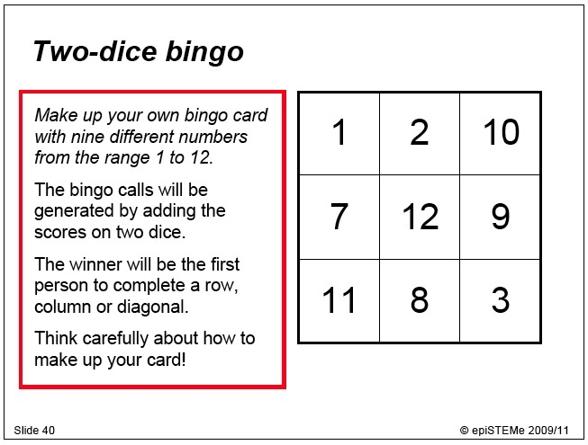
Fill out your bingo card here.

If you changed your card after the discussion, note down how you changed it and why.
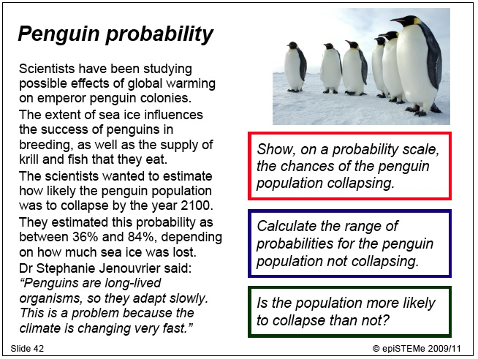
Note down your solutions to the problems here.

Penguin video clip is at http://news.bbc.co.uk/1/hi/uk/7852731.stm.
Further information about the penguin population study is at http://news.bbc.co.uk/1/hi/sci/tech/7851276.stm.
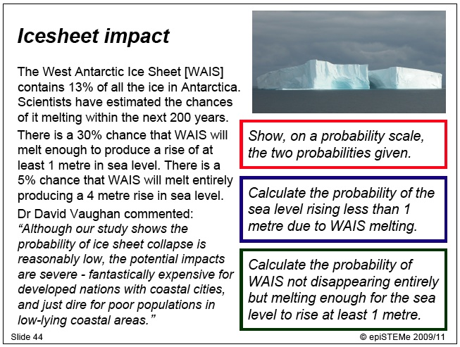
Note down your solutions to the problems here.

Further information on the icesheet melting study is at http://news.bbc.co.uk/1/hi/sci/tech/1731163.stm.
