TOOLKIT for SYSTEMATIC EDUCATIONAL DIALOGUE ANALYSIS (T-SEDA): A resource for inquiry into practice

ADDITIONAL RESOURCES

SECTION 3: Technical guidance for audio/video recording and transcribing
Part 1: Recording in your setting
Part 2: Transcribing
Part 3: Using the Smart Recorder on the Smartboard

SECTION 4: Case studies Illustrates teachers’ coding and interpretation of dialogue in different contexts; includes teachers’ findings and next steps.

SECTION 5: Resources and activities Ideas to implement dialogue in your classroom, references to other research on dialogue and links to related resources

A further set of templates to accompany the toolkit is available online at http://bit.ly/T-SEDA

SECTION 3: Technical guidance for recording and transcribing

How can I record video?
Your options include:
• tablet (with stand)
• phone (with stand)
• digital camera
• Camcorder
• sports cameras
• Classroom observation systems such as IRIS Connect (if your setting already has it)
• Microphones (individual or table top—can be used with video recording equipment)
How can I record audio?
Your options include:
• phone
• digital recorder/dictaphone
• tablet (some Apps offer a facility to sync notes with audio recording timecode)
• Interactive whiteboards (or interactive display panels): see instructions for use of the Smartboard recorder facility in Part 3 below
• microphones (individual / table top)
1. Recording in your setting
There are several possibilities for video and audio recording in your setting, depending on your inquiry focus and the classroom environment.
Guidance principles for recording in your setting:
• Don’t over-complicate things: existing equipment such as a smart phone or tablet could be good enough
• Be aware that using a device without an external microphone might not capture good enough sound quality in a noisy environment.
• It’s a good idea to test out your equipment in the classroom beforehand
• If you are using a tablet or smartphone to do video recording, use a stand so that the recording will be stable
• Find out what recording equipment your setting has available that you could use

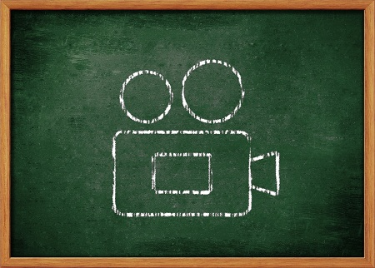
Where is the best place to put my recording device?
It is largely a matter or trial and error to find the best place to put your video or audio recording device. Ideally, you are looking for a location that:
• gives you good enough video and audio quality
• is near a power source and/or accessible to review battery life
• does not interfere with other classroom activities
• captures the events that are most relevant to the inquiry focus (whole class dialogue, peer talk, etc.). If you are recording whole class dialogue you’ll need it to be somewhere you can see and/or hear everyone. If you are recording small group work then you can place your device close to the group

Will my students act differently because they’re being recorded?
If they’re not used to it then they possibly will, at first. To help with this, you can try:
• Putting the device somewhere out of their direct line of sight
• Getting them used to the equipment by having some trial runs (and this will also help you test out your equipment)
• Setting it up before the students are in the room so you only have to press record
In our experience, after a short while students forget that equipment is there and act naturally, especially once they are engaged in a task.
Ethical considerations
(see also Part g of the main T-SEDA toolkit for general ethical principles)
It is essential to check whether students (and/or their guardians) and staff have given consent to be recorded and, perhaps, for the recordings to be shared beyond the classroom. The following should be considered:
• Is there already a policy in place in your setting for video and audio recording? What exactly does it cover?
• Have individual students or staff consented to be recorded?
• Will any personal details need to be removed for future use of the video or audio?
• What procedures are in place for handling sensitive or otherwise difficult incidents or situations?
• How can you ensure that recording does not interfere negatively with learning and teaching?

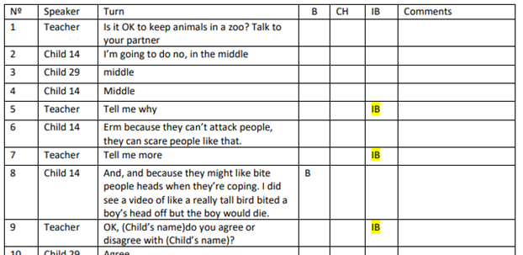
Guidance for transcribing:
• It is important to consider what you can practically do. Transcribing takes a long time, and if you are recording a noisy environment then you might have to listen several times or slow down the recording
• As a guide, 15 minutes of recording will take an hour to transcribe; an hour will take four hours.
• You might find that it takes longer at first as you get used to the process
2. Transcribing
You won’t necessarily need or want to transcribe your recording; your decision will depend on your inquiry focus and plan. Have a look at Section 2 of the main T-SEDA toolkit to decide if transcribing is the right approach for you.
What is transcribing?
Transcribing means writing down what you hear from recording in a systematic way to capture what has been said. You can decide how much detail you need to include in your transcription:
• Intelligent verbatim: if you are interested in the language the students are using, for example you want to identify one or more codes from the T-SEDA framework, you can transcribe the essence of what was said. You leave out unnecessary information such as pauses and repetitions. The transcript on this page is an example of an intelligent verbatim transcription
• Full verbatim: if you want to make a detailed record of exactly what was said, this might be more suitable. You transcribe more details about what was said and how it was said. For example, tone of voice, sounds such as laughter, pauses and perhaps gestures and body language.
Whichever type of transcription you use, it will be a representation of what actually took place. Researchers often find it useful to make an initial transcription and then add to this, while listening again to the recording - often several times - in order to build up the best possible understanding of the conversation that occurred. However, do be aware of the time that this will take and do what is practical for you.

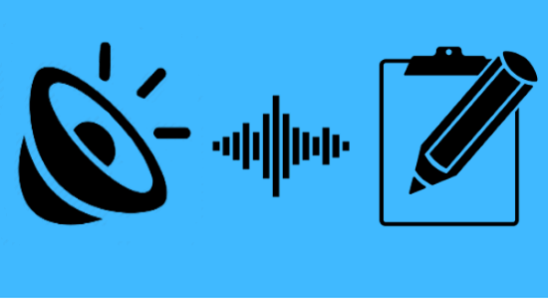
Tools for Transcribing
Office 365 online version of Word has an option, when using Google Chrome (using the microphone icon), allowing you to upload an audio file and auto-transcribe it. See this link.
https://app.trint.com (best for Spanish) or Otter.ai or https://transcribe.wreally.com/ or https://www.happyscribe.com/automatic-transcription-software: these transcribe very accurately in real time, for a modest fee
Google Docs: you can’t use this to transcribe a recording directly, but you can listen to what is said on a recording, pause it, speak the sentence out loud yourself, and then the Voice Typing function will write what you’ve said. There’s a guide on using this approach here.
• Inqscribe: free software that is useful to slow down recording. It runs on Apple or Windows. Note that transcripts cannot be exported from the free version but they can be cut and pasted. Download available here: https://www.inqscribe.com/
• Easytranscript: free software that runs on Apple or Windows and allows the user to export files. Download available here: http://www.e-werkzeug.eu/index.php/en/products/easytranscript

Transcribing notation
Researchers use some conventions to indicate important nonverbal events; you can choose how much of this to include in your own transcript.
On our ongoing project we use the following simple rules, adapted from Jefferson (1984)*:

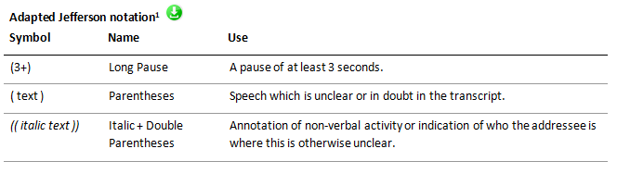

*Full Transcription Notation is described by G. Jefferson, “Transcription Notation,” in J. Maxwell Atkinson and J. Heritage (eds), Structures of Social Interaction, New York: Cambridge University Press, 1984.

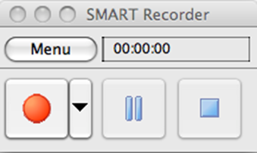
A teacher’s view of using the Smart Recorder
“[Smart Recorder] can be used to record anything you do on your computer. Once complete, you have an independent movie file that can be embedded in your class wiki or blog, or . . . yes, even a Notebook file. You can even upload your movie to YouTube or Teacher Tube, or any of the other video sites, so it is available for your students to view again and again if necessary. I really love having my students use this recorder to make movies showing how they solve math problems, for example. Not only do I get to watch what they do, I can hear their explanation, and save the video as an artefact for their portfolio, or for a parent conference.”
Adapted from a document authored by Megan Bowe, Teacher at Norwich High School for Girls, Norwich, UK

The Smart Recorder is an interactive whiteboard tool that can be used to audio record teacher narration and/or activity located at or near the board, or a whole class discussion. It can also capture everything that happens on the Smartboard screen.
It is accessible through the Smart Notebook application, and can be accessed independently of Notebook as well (check your Applications folder, or use the Spotlight Tool to search for "Recorder").
This YouTube link provides a guide to how to access and use the Smart Recorder: https://www.youtube.com/watch?v=ZNgyJn4_RTk

3. Using the Smart Recorder on the Smartboard

The Smart Recorder is an interactive whiteboard tool that can be used to audio record teacher narration and/or activity located at or near the board, or a whole class discussion. It can also capture everything that happens on the Smartboard screen.
It is accessible through the Smart Notebook application, and can be accessed independently of Notebook as well (check your Applications folder, or use the Spotlight Tool to search for "Recorder").
This YouTube link provides a guide to how to access and use the Smart Recorder: https://www.youtube.com/watch?v=ZNgyJn4_RTk

SECTION 4: Case studies

This section includes two worked examples of teachers’ use of T-SEDA written by members of the development team.
• The first one is based on a small project in which elements of T-SEDA were used to investigate the extent to which student participation in small group dialogue could be seen as equitable.
• The second one, focusing on teacher and pupil participation in whole-class dialogue, is based on the Masters research project of a teacher who is part of the T-SEDA development team.
Both examples include supporting notes (in the right-hand column) to show the key points and questions that underpinned each case ‘story’.
Note: both of these case studies have a lot of information and are quite long. This is to show detailed examples of the inquiry process: you may not need to add so much information to your own reports, depending on your purpose and potential audience.

A blank form is included in our online resources for developing your own worked examples. A concise worked example can also be a very effective way of sharing investigation findings with colleagues.

You can also read more examples of case studies here:
https://www.edudialogue.org/resources/inquiry-resources/

Case Study 1: Inquiring about equity in student participation in dialogue | Points and questions
Teacher: Michelle (Year 5) | Name of teacher, age group
Inquiry: I wanted to find out about children’s participation in reasoning in my science lessons. My students and I had previously established the ground rules for productive talk during groupwork, and my overall impression is that the children were responding well. My concern, however, was that I got the sense that some individual children were being marginalised or excluded from the group discussions, while others were talking a great deal without listening to other ideas. This is not what I intended and so I decided to find out whether the students participate equitably in the dialogue during science groupwork. I also wanted to see if there were any clear obstacles to the equitable participation, and any opportunities to intervene and enhance this.  I decided to focus on just two aspects of dialogue to make things manageable. I selected RE (reasoning) because it was relevant to the science learning objectives; and BI (building on ideas) because I wanted to see how the children responded to each other and took account of different ideas in their discussion. | General investigative purpose  Existing dialogic conditions, previous actions and general evaluation of the starting point  Specific concerns and investigative focus, and inquiry question(s)  Intended/hoped for outcomes  Focusing and managing the investigation  Which aspects of dialogue and why?  Practical issues
Method: I decided to use the T-SEDA time sampling tool. I did have some previous experience in systematic classroom observation, so I felt that using time sampling reasonably well was possible and I could take advantage of the more rigorous system to pick up more subtle aspects of talk that I could otherwise overlook. Because I had a student teacher assisting me in the classroom in two forthcoming science lessons, I knew I would have the chance to devote some of my own time to detailed ‘live’ observation.  The lessons focused on the anatomy of the flower, with associated group tasks. For instance, one task involved the children working together to label the parts of a flower. They dissected real flowers as well as working on the interactive whiteboard following a sequence of guided questioning.  I chose two 10-minute slots when I could be observing students during the lesson and I printed a copy of the time sampling scheme and set up a timer on my phone. During the chosen time-slots, I sat close to the student group at a separate table. Following the instructions, I used i.e. observation ‘windows’ of 1 minute and 40 seconds for close observation and simultaneous coding, followed by 20 seconds for resting. For each window I ticked the box when the identified student used Reasoning (R) or Build on ideas (B) in his/her contributions to the dialogue. I decided just to tick once in each window rather than tallying the number of contributions, since this would be practically manageable and sufficient to provide an initial overview of each child’s participation. When I had completed the time-sampling, I used the T-SEDA checklist for individual students to rate each child’s participation as ‘high’, ‘medium’ and ‘low’, judging this in relation to the general participation levels in this activity (i.e. not the typical or expected participation of individual students as judged from previous impressions I had about students). | Decision about observation approach (with reference to the T-SEDA tools  Previous experience and confidence to proceed  Specific goals  Practical considerations  Focus of lesson and student activity  Decisions about when and how much observation time  Technical tools and physical arrangements  Observation and recording details (following or adapted from relevant T-SEDA tool)  Reasons for observation and recording decisions  Stages of investigation (with reference to T-SEDA tools in use)

Case Study 1: Page 2
Findings: my ratings showed clear differences between the children’s participation in both lessons: One child was rated as consistently ‘high’ in (R) ‘reasoning’, but not (B) ‘build on ideas’, and one child was rated as consistently ‘low’ in both. Two other children gave me a more ambiguous impression, with mixed ratings that differed between the two lessons. One of the children who received mixed ratings had contributed a lot to reasoning in one lesson, but did very little to build on others’ ideas. In the next lesson this child then did much less reasoning and generally contributed less. On reflection, I realised that this child’s high level of reasoning in the first lesson occurred when the child was leading the written response on the IWB, while in the next lesson this child was watching others in this role. With regard to the child who was rated consistently low in both lessons, I was concerned to note at the bottom of the time sample record that none of the others responded to any of his suggestions; they just seemed to talk over him and continuing their own conversation. | Broad findings in relation to inquiry questions  Sample observations relevant to the inquiry, particularly potentially calling for further investigation  Reflective comment drawing on teacher’s wider knowledge of the children and classroom  Identification of potentially serious concerns not previously evident (learning; social; etc)
Evaluation: I found this to be a manageable short inquiry. Through these 10-minute observations I could confirm and extended my understanding of the children’s participation in science groupwork. For once, I confirmed that indeed not all students were participating equally in the group. I also noticed aspects of the children’s interactions and activity that I had missed before. On reflection, I think that when referring just to the actual amount of contributions from each child, there was not equitable participation in dialogue. However, the children did seem to share different elements of the task between them, so were they taking collective responsibility for ‘dividing the labour’ and completing the task as group? This made me think about what I understood and expected of the children’s participation in groupwork and what I tell the children is expected of them. Maybe we could refine this, particularly in terms of how individual contributions to talk, activity and social relations might vary over time. | Overall evaluation of findings and manageability  Specific points noticed  Reflective summary and conclusions relating to the inquiry question(s)  Wider critical reflections on classroom dialogue and learning
Where Next? Having now tuned in to the question of equitable participation in groupwork, I decided to continue my investigation in two ways: (1) as a priority, observing the child who was consistently rated ‘low’ (using an open narrative style), and also to talk to him individually about his feelings about learning in the class; (2) to find further opportunities to observe groups systematically to develop my ability to capture children’s interactions, to ensure that I’m not relying too much on my assumptions about the children. To do this, what I intend to do is using Part B of the T-SEDA scheme, adapting the format to create a tally chart for the whole of each observation period. This could help me tackle my new goals without having to repeat the intensive time-sampling from Part A. Ultimately, I still intend to identify obstacles to the participation of students in groups, so that I can support them and enhance the children’s inclusion in classroom dialogue and learning. | Identifying next steps in the investigation  Priorities (e.g. in relation to any serious concerns emerging) and general development  Potential use of other investigative tools (e.g. interviews)  Further use of T-SEDA tools (including rationale for any adaptations)  Ultimate aims in relation to educational values and priorities for the students

Case study 2: Inquiry into the level and nature of teacher and pupil participation in whole class dialogue | Details to include
Teacher: Lisa (Year 5) | Teacher name (or pseudonym), year group
Inquiry: I was teaching a single lesson on photosynthesis and wanted to find out how much guiding I might do during an initial discussion, and how much the students would be able to express their ideas from prior learning. I decided to focus on G (Guide direction of dialogue or activity) in relation to my own role, and E (Express or invite ideas) in relation to the students. | What is the lesson subject and focus?  What is the reason for the investigation?  Is there any prior learning which is relevant?  What will the dialogic focus be? (chosen codes)
Method: I decided to use part D (whole class overview) of the T-SEDA. This was in part because I did not have any other adults to call upon during the lesson. I wanted to conduct a whole class dialogue in which I would be involved, therefore observing and coding dialogue ‘live’ would not be possible, so I decided to audio record the introductory discussion of the lesson and listen to it later. With this method, I could reflect on the dialogue after the lesson in order to identify occurrences of G and E. The nature of the discussion was to elicit and draw upon the students’ prior knowledge of photosynthesis and to guide their discussion to a fuller understanding of the processes involved in plants synthesising glucose. | How will the T-SEDA be used?  Why will T-SEDA be used in this way?  Will any equipment be used to aid the use of T-SEDA, and why?  What is the nature of the dialogue to be coded?
Findings: when listening to the audio I noticed that I seemed to make more contributions during the discussion than my students did. This was not what I expected so I decided to count how many contributions I made, and how many were made by the class. I found that during the discussion she made 95 contributions, whilst the students made 46 contributions. Having counted the total number of contributions made, I decided to calculate the percentage incidence of G and E contributions made during the discussion and use these to assess the level of contributions as defined by the T-SEDA. The percentage of teacher’s contributions coded as G was 54% of the total, a rating of 3, whilst the percentage incidence of students’ contributions coded as E was 70% of the total, a rating of 4. | What was noticed during the dialogue?  Were any actions taken as a result of these observations?

Case study 2: Page 2
Evaluation: I was really surprised that the number of contributions I made (95) during the discussion was relatively high compared to the number made by the class (46). My thinking is that this may indicate that the students’ prior knowledge of the subject of photosynthesis was less clear than I had anticipated. However, since 70% of those 46 contributions were coded as E, this indicates that the students did have ideas to express on the subject, even if in the moment I thought they needed quite a lot of guidance to structure those ideas and reach conclusions. | Where there any unexpected observations during the dialogue?  What conclusions can be drawn from the observations about the nature of the dialogue?  What conclusions can be drawn about the learning scenario?
Next Steps: I found that I made a relatively high number of contributions during the discussion, which I did not intend. Thus, I think that when approaching a subject for the first time with the year group, even when they had met the subject in previous years, it could be useful to present a refresher of their prior learning before asking them to hold a discussion and share their knowledge. That way, they would be more prepared to take part in the discussion. I also wonder if whole class dialogue could be structured in such a way that my own input could be reduced, and so I decided to investigate this with further inquiry. | What reflections can be made about teaching practice from this evaluation?  What reflections can be made about children’s participation in dialogue from this evaluation?  What might be done differently in a similar situation in the future?

SECTION 5: Ideas to implement dialogue in your classroom, references to other research on dialogue, and links to other related resources and activities

Other activity designs and contexts that can support engagement in authentic dialogue:
• assigning students talking partners to discuss ideas with;
• giving students time to work in small groups to rehearse expressing and discussing their ideas, which might be a less threatening environment than a whole-class discussion;
• giving small groups the responsibility for ensuring that all members participate and are listened to;
• giving small groups the responsibility for ensuring that all members come to an understanding of the topic;
• designing more open tasks or questions that stimulate thinking and do not have one right answer (talking points are an example).

This website has a number of suggestions for structuring and focusing small-group activities
General introduction to educational dialogue http://21stcenturylearners.org.uk/wp-content/uploads/2020/07/A-Teachers-Guide-to-Dialogic-Pedagogy.pdf
Accountable Talk Developed in the US, this website offers suggestions for classroom activities that promote dialogue, as well as a series of free podcasts about dialogue, particularly in maths teaching.
DIALLS…. Bloomsbury book…. PPD site
Ideas to implement dialogue in your classroom
As well as the catch all term ‘group work’, there are a number of pedagogical approaches to encourage productive dialogue. Many teachers will already be familiar with some of these:
• Talking Points
• Talking Partners
• Think, Pair, Share
• Circle Time
• Student Presentations with Q&A (‘hot seating’)
There are also deeper pedagogical practices that facilitate high quality educational dialogue.
• Thinking Together
• Philosophy for Children
• Dialogic Literary Gatherings
• Dialogic Halaqah
Lesson Study can be used by teachers working together to develop dialogic practice by developing pupils’ learning.

Talking Points
The talking point resources were developed by the Thinking Together team
Reflecting on group work This links to a number of statements which can be used to start a discussion about classroom talk and group work with students.
Curriculum-linked talking points This has ideas for talking points related to a number of specific curriculum areas, and give an idea of how they could be adapted for any curriculum topic, subject or age group.

Subject-specific resources
Thinking Science Free resources for science teachers designed to promote thinking and discussion. Aimed at children aged 11-14.
We are multilingual Free resources for languages teachers, promoting a dialogic approach to language learning. Aimed at children and young people of any age.
RE-searchers Free resources for religious education (RE) teachers, taking a dialogic approach to different forms of inquiry in RE. Aimed at children aged 5-11
Transforming Primary Maths Mike Askew’s free maths resources for promoting collaboration. Aimed at children aged 5-11

Philosophy with Children
This approach facilitates dialogue as students discuss age-appropriate philosophical questions. The focus is not on ‘learning philosophy’ but rather the process of inquiry – formulating and expressing ideas, and building on or challenging other’s point of view to advance understanding
Center for Philosophy with Children, University of Washington A selection of lesson plans and stimulus materials for children aged 5-16
Philosopher’s Backpack This has a page with a large collections of links to Philosophy for Children ideas and resources
The Philosophy Man Teachers can sign up for free weekly emails which have a stimulus story and questions, as well as ideas for thinking games

Using the interactive whiteboard to support classroom dialogue

A school-based professional development programme which resulted in several resources for teachers:
• Developing Interactive Teaching and Learning Using the Interactive Whiteboard: A Resource for Teachers A printed resource book co-authored with participating teachers and including their own case stories of developing dialogic practice is also available:
Reference: Hennessy, S., Warwick, P., Brown, L., Rawlins, D., & Neale, C. (Eds.). (2014). Developing Interactive Teaching and Learning Using the Interactive Whiteboard: A Resource for Teachers. Maidenhead: Open University Press.
• An outline of face-to-face workshop activities guiding teachers through the professional development process is downloadable at http://dialogueiwb.educ.cam.ac.uk/evaluate/
• Online resources including an open digital resource bank of annotated screenshots, links to video clips of dialogic classroom practice and interactive whiteboard flipchart templates for creating activities, are at http://dialogueiwb.educ.cam.ac.uk/resources/
• Online resources also include teachers’ own classroom materials developed to support dialogue in contexts using digital technology in the UK and Mexico. A set of downloadable resources for teachers of students of all ages. Includes interactive whiteboard flip charts that can be re-used or modified that cover a range of subject areas and teaching aims. http://dialogueiwb.educ.cam.ac.uk/evaluate/teachersmaterials/

Links to related research-informed resources for practitioners

The following resources were all produced by academics at the University of Cambridge and their collaborators:

OER4Schools – an extensive set of open, multimedia professional learning resources for primary teachers in sub-Saharan Africa which contains units on whole class dialogue and groupwork, drawing on Thinking Together and a range of other relevant resources, and illustrated with video clips. www.oer4schools.org

Video clips: Downloadable video clips of dialogic teaching in UK (primary, middle and secondary) classrooms deriving from several research projects are available at https://sms.cam.ac.uk/collection/2827689. Critique and discussion of other teachers’ practices can offer a powerful stimulus for trying out new approaches oneself. (Prompts for such discussion are included.)

Reflective teaching: There are many resources to support reflective teaching in general, including this comprehensive one produced by Andrew Pollard and colleagues: http://reflectiveteaching.co.uk/

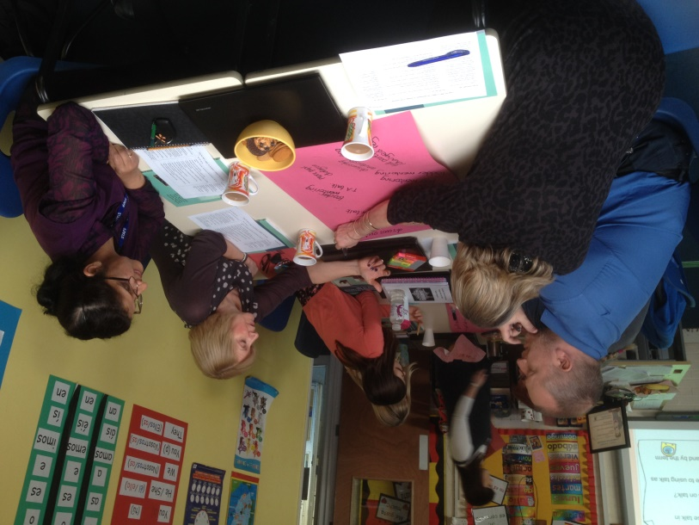
References
Dudley, P., Warwick, P., Vrikki, M., Vermunt, J., van Halem, N & Karlsen, A. (2018) Implementing a new mathematics curriculum in England: district Research Lesson Study as a driver for student learning, teacher learning and professional dialogue in Theory and practices of Lesson Study in mathematics, an international perspective, Springer, New York.
Norwich, B., Dudley, P. & Ylonen, A. (2014) Using lesson studies to assess students’ learning. International Journal of Lesson and Learning Studies, 3(3) 192-207
See also Pete Dudley’s September 2018 blog: https://oracycambridge.org/blog/

Lesson study (LS)
Lesson Study is a model of teacher-led research in which practitioners work together to target an identified area for development in their students’ learning. It originated in Japan and is now used in over 75 countries worldwide.
Teacher Practice Knowledge: LS involves groups of teachers identifying an improvement focus for their pupils by studying their curriculum, progress expectations and current teaching materials and researching alternatives that might help improve learning. Group members may be peers or it may include one member with expertise in the area of study. They then collaboratively plan a ‘research lesson’ (RL) that introduces the innovation they decide to try out or develop. One member of the group teaches while the others observe the pupils’ learning (NOT the teacher’s teaching). After the RL they reflect together on what they have observed and on the pupils’ work and they decide on adjustments and improvements to the next RL. Teachers from other schools might even come along to observe when a refined RL is then taught, and the cycle continues
You could use LS to identify your students’ and your own dialogic practices.
For a step-by-step guide to how to conduct and lead a research lesson study, download the free handbook from www.lessonstudy.co.uk/handbook

Mercer, N., & Littleton, K. (2007). Dialogue and the Development of Children’s Thinking. London: Routledge. [A book proposing a new sociocultural account of the relationship between dialogue and children’s intellectual development, relating research findings to real-life classrooms]
Taber, K. (2013) Classroom-based research and evidence-based practice: An introduction (2nd ed.). London: Sage. [A basic research methods textbook aimed at teachers in schools]
Vrikki, M., Kershner, R., Calcagni, E., Hennessy, S., Lee, L., Estrada, N., Hernández, F., and Ahmed, F. (2018). The Teacher Scheme for Educational Dialogue Analysis (T-SEDA): Developing a research-based observation tool for supporting teacher inquiry into pupils' participation in classroom dialogue. International Journal of Research and Methods in Education. https://doi.org/10.1080/1743727X.2018.1467890.
Wilson, E. (2009/2013) ‘Action research’, in Wilson, E. (Ed.) School-based research: A guide for education students. London: Sage. [A basic research methods textbook aimed at teachers in schools]

References and further reading
Alexander, R. (2011). Towards dialogic teaching: Rethinking classroom talk. Cambridge: Dialogos. [A very accessibly written booklet outlining the key principles of classroom dialogue]
Dawes, L., Mercer, N., & Wegerif, R. (2003). Thinking Together: A programme of activities for developing thinking skills at KS2. Birmingham: Imaginative Minds Ltd. [A book of practical classroom activities for developing the talk, reasoning and curriculum learning of children aged 8-11].
Hennessy, S., Mercer, N., & Warwick, P. (2011). A dialogic inquiry approach to working with teachers in developing classroom dialogue. Teachers College Record, 113(9), 1906–1959. [A journal article describing the process and issues involved in academics working with teachers as co-researchers of dialogic practices]
Hennessy, S., Rojas-Drummond, S., Higham, R., Márquez, A. M., Maine, F., Ríos, R. M., García-Carrión, R., Torreblanca, O., & Barrera, M. J. (2016). Developing a coding scheme for analysing classroom dialogue across educational contexts. Learning, Culture and Social Interaction. 9, 16-44. [A journal article describing development of SEDA, the precursor coding scheme to T-SEDA, and the methodological issues encountered]
Howe, C., & Abedin, M. (2013). Classroom dialogue: A systematic review across four decades of research. Cambridge Journal of Education, 43(3), 325-356. [A journal article summarising the research on the impact of classroom dialogue]
Littleton, K., & Howe, C. (Eds.). (2010). Educational dialogues: Understanding and promoting productive interaction. Abingdon, Oxon: Routledge. [An edited book containing chapters by experts in the field on the importance of dialogue and its significance for learning and teaching]
Littleton, K., & Mercer, N. (2013). Interthinking: Putting talk to work. Routledge. [An accessibly written book describing how people think creatively and productively together through talk, and how to promote more effective talk in the classroom]

