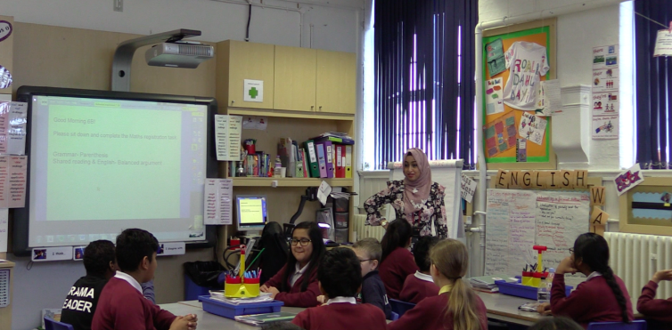
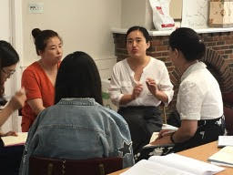
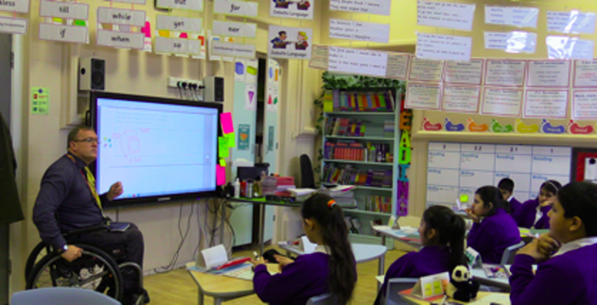
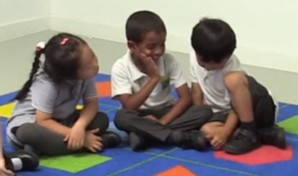
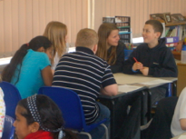
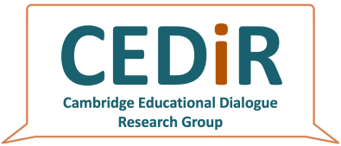
TEACHER SCHEME FOR EDUCATIONAL DIALOGUE ANALYSIS
(T-SEDA v.8a)
T-SEDA@educ.cam.ac.uk http://bit.ly/T-SEDA
Written, researched and compiled by The T-SEDA Collective

The T-SEDA Collective

Development of T-SEDA has been very much a team effort, including: Ruth Kershner, Sara Hennessy, Elisa Calcagni, Farah Ahmed, Victoria Cook, Laura Kerslake, Lisa Lee and Maria Vrikki of the University of Cambridge Faculty of Education, and Nube Estrada and Flora Hernández of the National Autonomous University of Mexico. We are very grateful to the numerous colleagues who have contributed in some way or other to T-SEDA development over the last few years. This includes those who assisted with translation into Spanish, Chinese, French and Hebrew (Ana Laura Trigo Clapés, Elisa de Padua, Elisa Izquierdo, Qian Liu, Yun Long, Ji Ying, Chih Ching Chang, Delphine Cestonaro and Benzi Slakmon).

Acknowledgements

The original work on T-SEDA (and its precursor SEDA) was supported by the British Academy (International Partnership and Mobility Scheme) through the 3-year project entitled “A Tool for Analysing Dialogic Interactions in Classrooms” (2013-2015), led by Sara Hennessy and Sylvia Rojas-Drummond at the University of Cambridge, UK, and the National Autonomous University of Mexico: http://tinyurl.com/BAdialogue. The Mexican work was supported by the Dirección General de Asuntos del Personal Académico of the National Autonomous University of Mexico (DGAPA-UNAM) (PAPIIT Project Number: IN303313 and PAPIME Number: PE305814). We appreciate the support of the Economic and Social Research Council (RES063270081; RES000230825), sponsor of most of the UK team's preceding work in this area. Our most recent ESRC project (ES/M007103/1) entitled ‘Classroom Dialogue: Does it Make a Difference for Student Learning? (Christine Howe, Sara Hennessy, Neil Mercer, Maria Vrikki & Lisa Wheatley, 2015-17: http://tinyurl.com/ESRCdialogue) drew on SEDA to develop CDAS, a new 12-category scheme and rating scales, testing them extensively with a large sample of 72 teachers of children aged 10-11. Statistical analyses of the relationships between dialogic teaching and student attainment and attitudes produced the findings that have shaped this version of the pack. An ESRC Impact Acceleration grant supported further development of the pack and trials across diverse educational contexts in seven countries in 2018-19.
T-SEDA is used globally by practitioners from pre-school years to higher education. We thank all of the facilitators, teachers and students who participated in our research and testing across several countries from which examples in this pack have been taken with their kind permission. Some names have been changed where teachers wished to remain anonymous. Photographs appearing in the pack are derived from our research studies; permissions have been received to use them for educational purposes.
To cite the T-SEDA pack: T-SEDA Collective (2021). Teacher Scheme for Educational Dialogue Analysis (T-SEDA) v.8a resource pack. University of Cambridge. http://bit.ly/T-SEDA.

T-SEDA pack contents
T-SEDA: Users’ Guide
Information about educational dialogue and a step-by-step guide through the inquiry process. Introduces the inquiry cycle, which is at the heart of classroom inquiry. Also contains the self-audit for you to reflect on your practice.

T-SEDA: Core Resources
SECTION 1: Coding framework A list and explanation of categories for analysing dialogue illustrated with sample prompts and contributions, plus more general dialogic classroom practices.
SECTION 2: Templates for scales observing and coding dialogue Time-sampling; checklists; rating scales
This pack contains information and resources for educators to carry out a dialogue-focussed inquiry into their practice.
T-SEDA: Supporting Resources
These additional resources are available online at http://bit.ly/T-SEDA
SECTION 3: Technical guidance for recording and transcribing
SECTION 4: Case studies. Illustrative examples of teachers’ coding and interpretation of dialogue in different contexts; includes teachers’ findings and next steps
SECTION 5: Ideas to implement dialogue in your classroom. Includes references to other research on dialogue and links to related resources
BLANK TEMPLATES: Reflective cycle, observation templates, self-reflection, inquiry reporting template

The entire pack is available online, including separately downloadable templates for printing or editing; look out for the icon.

Video 1: What is educational dialogue? | Video 10: Using the coding scheme (part 1)
Video 2: How does dialogue support learning? | Video 11: Using the coding scheme (part 2)
Video 3: Practical tips for supporting classroom dialogue: ground rules | Video 12: Recording dialogue and coding in your classroom
Video 4: Practical tips for supporting classroom dialogue: talking points | Video 13: Identifying productive dialogue: ‘building on’ and ‘challenging’ ideas
Video 5: The T-SEDA pack welcome guide | Video 14: Practising coding: whole class dialogue
Video 6: Completing your self audit | Video 15: The value of group dialogue
Video 7: Completing your reflective cycle | Video 16: Coding and rating the quality of small group dialogue
Video 8: Ethics in educational inquiry | Video 17: Promoting student participation in dialogue
Video 9: The impact of T-SEDA inquiry
The T-SEDA video guides
The T-SEDA Users’ Guide and Core Resources described on the previous page have accompanying video guides. These videos provide bite-sized introductions to using the T-SEDA pack, as well as additional activities to practise coding dialogue.
Look out for the symbol throughout the pack.

Videos are all available at: https://www.edudialogue.org/tools-resources/introductory-video-series/
T-SEDA Users’ Guide
Contents
a. Introduction to T-SEDA | 1
b. What is educational dialogue? | 5
c. Educational dialogue and learning in diverse contexts | 7
Evidence that teacher-student dialogue promotes learning | 7
Peer group dialogue | 8
Dialogue in different contexts | 9
Dialogue with young children | 10
Higher education and adult learners | 11
Dialogue in curriculum subjects | 12
Equity and participation of all learners | 13
Promoting a positive classroom culture for educational dialogue | 14
d. How productive is the dialogue in my classroom? A self-audit for teachers | 15
e. Reflective cycle of classroom inquiry | 17
f. Choosing an inquiry focus | 20
g. Research ethics | 25
h. Analysing classroom talk: systematic observation and coding | 26
i. Possible uses of the T-SEDA pack | 30

Part a. Introduction
Introduction: About T-SEDA
What is T-SEDA?
T-SEDA stands for Teacher Scheme for Educational Dialogue. It’s a collection of tools and resources that will support you in promoting high quality dialogue in your learning setting. It will help you to carry out an inquiry to find out more about the dialogue in your setting and to make the changes that you want to see.
Who is T-SEDA for?
T-SEDA can be used by teachers of students in any age group, from early years to adult learners. It can be used in formal face-to-face or online learning settings such as school classrooms and university seminars, or in informal settings such as children’s clubs. You’ll see examples of how T-SEDA has been used throughout this resource pack.
How does T-SEDA work?
You can use T-SEDA to carry out an inquiry into dialogue in your learning setting. During this inquiry, you’ll become more aware of what dialogue is like at the moment, find out what good quality dialogue is and how to listen for it, and decide what you want to find out about dialogue in your classroom. The T-SEDA pack has been designed to be both supportive and flexible. It’s a step-by-step guide, but you can also adapt and add to any of the materials according to your own needs and interests.
What do I need to know?
You can find everything you need in this pack and on the T-SEDA website: http://bit.ly/T-SEDA. There is a wealth of other resources to support you on this website: www.edudialogue.org. Throughout the pack, there will be signposts to where you can find the information that you need.

Video 5: The T-SEDA pack—welcome guide is a useful overview of how to use the pack

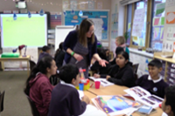
Good inquiries start off by identifying problematic, puzzling or interesting aspects of practice in your setting. Your self-audit will help you to do this and find out what you want to focus your inquiry on
This guide will take you through the process of setting up an inquiry into dialogue in your setting
The coding scheme identifies the kinds of things that you might hear that are examples of high quality dialogue. These will provide a focus for your classroom inquiry
The T-SEDA Core Tools
There are three tools that will enable you to carry out your inquiry so that you can systematically identify what your students’ dialogue and your own practice is currently like (Tool 1), how to use this as a starting point to develop an inquiry (Tool 2), and a dialogue coding scheme to help you to carry out an inquiry (Tool 3). The pack explains how you can use each of these tools. There is a range of observation tools and tips in Section 2-5 to aid with your inquiry.

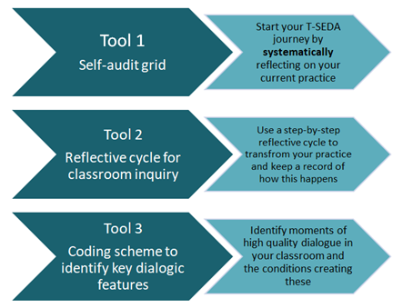

The Inquiry Cycle
The inquiry cycle is at the heart of T-SEDA. Each section of the users’ guide will help you to complete the phases of the inquiry cycle, providing you with useful information about classroom dialogue.

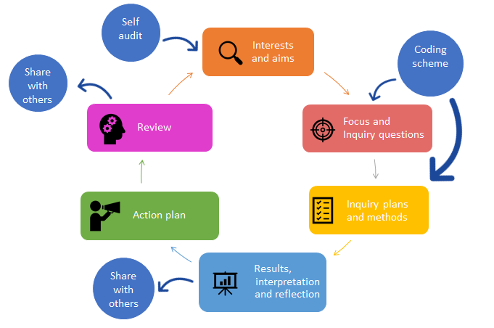

Video 7: Completing your reflective cycle gives more information about the reflective cycle and how to complete it

Examples of teachers’ inquiries
Here are some examples of the ways in which teachers have used the T-SEDA pack to carry out their own classroom inquiries.
Gary’s Inquiry:
Building dialogue in role play
I’m a teacher of 4-5 year old children, and the role play area is an important part of the Early Years Foundation Stage (EYFS) classroom because we always link the activities in the role play area to the EYFS development framework. When I used the self-audit tool, I realised that because the class in in free-flow, I needed to find out exactly how children were using the area and particularly how they responded to each other.
I decided to observe children playing in the role play area to see how they built on each other’s ideas as the foundation of dialogue between them. I used templates 2C and 2D to live code, and discovered that some children developed their creative expression in their talk with others, incorporating new ideas into their play. However, other children mostly played on their own and didn’t listen or respond to other children.
After this, I decided to ask children if they wanted to play in the role play area in pairs, and to share ideas about how to play. I found that children would only respond to each other’s ideas if they were excited about them—but also that children did become aware of a wider circle of play partners that their usual few friends. This meant that they were hearing a range of different ideas.
Kiran’s Inquiry:
Interrogating each other’s ideas in history
I’m a secondary history teacher (of children aged 11-16) and, using the self-audit tool, I wondered if my students understood how to interrogate each other’s ideas about sources. I decided to observe how much challenging of each other’s ideas was happening when the students were looking at sources in pairs. Not only this, I wanted the students themselves to become aware of how important it is to challenge each other’s ideas—because some sources can be deliberately misleading.
While some students were working in pairs, I asked others to make a tally of how many times each student in the pair queried or challenged over a period of 10 minutes. Afterwards, these students gave feedback to the class about their observations. This led to a really productive class discussion about challenging each other’s ideas and the source itself, so that students were reflecting on their learning as well as gaining a deeper understanding of using sources in history.
Lily’s Inquiry:
Developing reasoning in science group work
I’m a year 5 teacher (of children aged 9-10) and I was concerned that there wasn’t enough reasoning happening in my classroom, after using the self-audit tool. I felt that this was particularly the case in science, where not all children were demonstrating their reasoning, for example by applying their knowledge to make predictions, etc.
I decided to use the T-SEDA coding scheme to find out how often reasoning took place in children’s group work during a unit of science lessons. I did live observations of certain groups using the time sampling tool, template 2B, and recorded instances of reasoning. I found that some children contributed their reasoning quite often, but others didn’t reason at all (at least not verbally).
Having completed these observations, I realised that I needed to structure group work activities so that all children were encouraged and given the opportunity to share their reasoning within the group.

What is educational dialogue?

In dialogue, participants listen to each other, they contribute by sharing their ideas, justifying their contributions and engaging with others’ views.
In particular they explore and evaluate different perspectives and reasons. Relevant questions and contributions are linked between speakers, allowing knowledge to be built collectively within a lesson or over a series of interconnected lessons.
Although verbal interactions are central, dialogue can be supported with non-verbal communication (e.g. gestures, facial expression and eye contact) and by using visual or technology resources. Silence, physical movement, classroom routines and ethos can also be important aspects of dialogue, framing and supporting (or sometimes hindering) the spoken conversation that is the main focus of this pack.

Some features of productive educational dialogue already appear in many classrooms but sustaining productive educational dialogue takes time. It might also challenge participants, especially if they are not used to expressing their views at length or having them examined publicly.

Video 1: What is educational dialogue?
Provides more information about educational dialogue
Educational dialogue

Part b. What is educational dialogue?
What’s the difference between dialogue and talk?

Students and teachers, of course, talk a great deal during the course of the day. This talk can have many purposes: giving instructions, students chatting together, or sharing information. However, these examples are not what we mean by educational dialogue. Even when students talk together during learning situations, they may not be engaging in educational dialogue. Take this example from a teacher who has used the T-SEDA resources:

Some students let their learning partner do all the talking, or they would state their thoughts without listening to what their learning partner said. Some pairs either did not talk at all or their talk was off topic. The children were not able to structure their discussions and they did not understand the purpose of their talk. (Natalie)

Although students were talking together, they were not taking part in dialogue because they were not engaging with each other, listening to each other, and their talk was not part of their learning.

The table overleaf indicates the sort of talk that you might hear when students are taking part in educational dialogue.

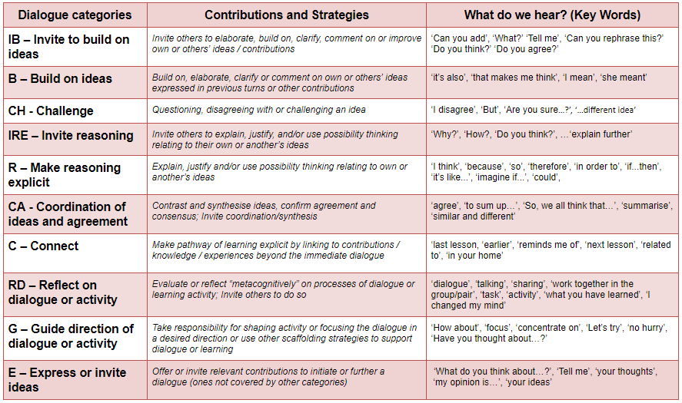
T-SEDA dialogue coding scheme

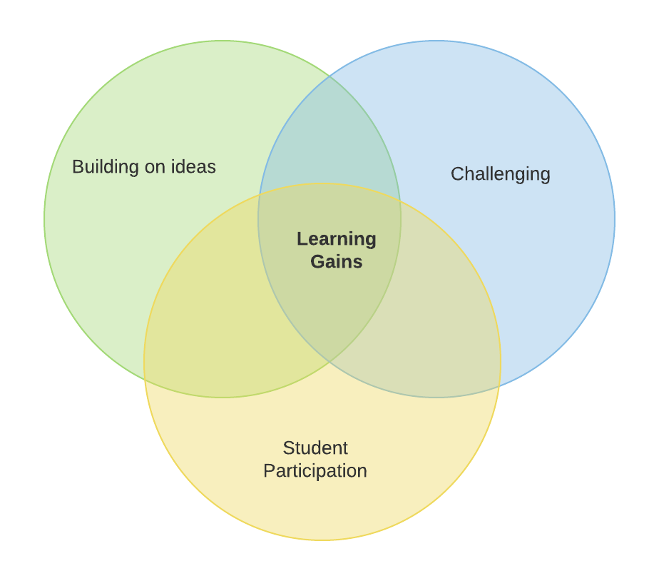
Part c. Educational dialogue and student learning in diverse contexts
There is a growing base of international research that supports the idea that dialogic teaching is beneficial for students’ learning and other personal development outcomes. Findings from evaluating professional development programmes include:

- UK primary students’ improved academic attainment (see Alexander, 2018)

- increased learning motivation, perceived autonomy and interest in STEM subjects among secondary students in Germany linked to increased teacher constructive feedback (Kiemer et al., 2015).

Other studies focus on the impact of ‘natural variations’ in classroom dialogue. Findings include:

- students that speak more using high-quality reasoning in language arts achieve better outcomes (see Šeďová et al., 2019 in the Czech Republic).
- studies of primary mathematics in the US found that providing detailed and correct explanations backed up with evidence relates to higher achievement. Students can also benefit from engaging with others’ ideas in detail and having their ideas commented upon in detail (Webb et al., 2008, 2009, 2014).
Evidence that teacher-student dialogue promotes learning
Recently, a team at the University of Cambridge produced compelling evidence about the impact of teacher-student dialogue. The data came from detailed analyses of 144 lessons by 72 teachers in 48 English primary schools (http://tinyurl.com/ESRCdialogue).
Which talk moves are strongly associated with learning gains?
· building on ideas is particularly important
· invitations to build on ideas
· challenging and questioning others’ views respectfully*
These talk moves need to happen in the context of a supportive classroom, in which these elements are found:
· active student participation – multiple students give extended contributions and engage with others’ ideas
· explicit use of ground rules for talk – supporting dialogic practices, negotiated with students

*Too much challenging without the other supportive elements can even have a negative effect!
Recently, a team at the University of Cambridge produced compelling evidence about the impact of teacher-student dialogue. The data came from detailed analyses of 144 lessons by 72 teachers in 48 English primary schools (http://tinyurl.com/ESRCdialogue).
Which talk moves are strongly associated with learning gains?
• building on ideas is particularly important
• invitations to build on ideas
• challenging and questioning others’ views respectfully*
These talk moves need to happen in the context of a supportive classroom, in which these elements are found:
• active student participation – multiple students give extended contributions and engage with others’ ideas
• explicit use of ground rules for talk – supporting dialogic practices, negotiated with students

*Too much challenging without the other supportive elements can even have a negative effect!

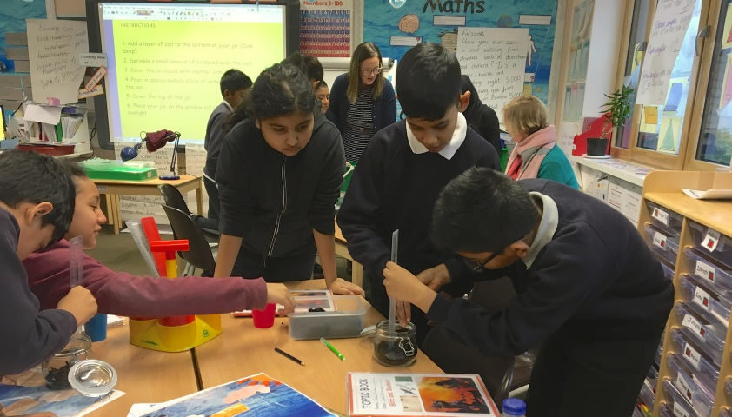
Peer group dialogue
What is the value of group work?

• High quality group work is strongly linked with learning gains (e.g. Howe et al., 2019) especially when participants have different views (Bennett et al., 2009).

• Students can learn from each other

• Learners can practise using talk for learning, reasoning and problem solving without a teacher

• They can rehearse ideas in a less stressful environment before sharing their progress with students in other groups / the whole class arena – “making thinking visible” to others; this promotes learning gains (Howe 2020)

• Other students can reflect on and evaluate the new ideas, including using formal rubrics; going beyond passive listening
How can you make group work effective?
Children need to learn to talk and work effectively together in groups; often they are not skilled at this. ‘Ground rules’ and sentence stems can get learners in the habit of listening, referencing others, expressing agreement and respectfully challenging, giving reasons.
Support for dialogue in which students engage with each other’s ideas needs to be built into activity design, for example requiring students to work together in order to succeed, and aiming to stimulate reasoned debate. Talking points are a great activity for this—see the box below.
How can you know if groupwork is supporting learning?
Tool 2G provides a rating scale for the quality of groupwork; there are versions for observing younger and older students and one for learners’ self-assessment. High scores on these scales are strongly linked with learning outcomes (e.g. Howe et al., 2019).
What are talking points?

• Statements – not questions – that students are asked to agree/ disagree (respectfully) with during discussion
• Provocative, curious, interesting, true, false
• May be used to generate factual or imaginative responses
• Like ground rules, they can be used in group work or whole class discussion

Video 4 Practical tips for supporting classroom dialogue: talking points

Dialogue in different contexts
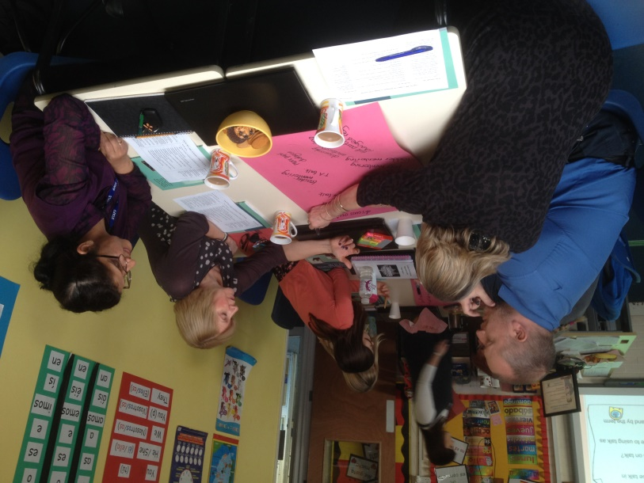
Educational dialogue can be practised with diverse groups of learners from, in groups from all ages and across subjects and contents. This is why the T-SEDA pack is designed to be versatile and adaptable, and it has already been used by practitioners in varied contexts. The next pages will help you to think about dialogue in your setting: have a look for the ones that are relevant to you.

 | Younger students: you might hear simpler language, and building or challenges might be expressed through these kinds of phrases | Older students: you might hear more formal sentence starters or more sophisticated language
Build on Ideas | ‘And…’; ‘So then…’; ‘Oh yeah…’; | ‘I agree that…’; ‘That’s a good point’; ‘We started off thinking…, and then…’
Challenge | ‘No!’; ’But…’; ‘It can’t be…’; | ‘I disagree that…’; That doesn’t seem right ‘; ‘ That isn’t possible, because…’; ‘I think that’s half right’; ‘That’s not possible’
Reasoning | ‘Because…’ ‘

Reflection point: Have a look at the dialogue codes in Part B, with the examples of what you might hear, and look at the examples below. How do you think the students in your setting would verbalise the different dialogue codes? What might you hear in your classroom?

Dialogue with young children
Dialogue is at the centre of education in the pre-school years (ages 2-5). There are several ways in which carrying out a T-SEDA inquiry will help to identify the kinds of dialogue that children are using at this stage. The table below shows speaking and listening skills taken from one national curriculum (England). Could you apply these in your own national context?
Listening, Attention and Understanding.  Children at the expected level of development will: | Possible T-SEDA dialogue code | What you might hear
Listen attentively and respond to what they hear with relevant questions, comments and actions when being read to and during whole class discussions and small group interactions | Build on Ideas (B): build on, elaborate, clarify or comment on own or other’s ideas expressed in previous turns or contributions | I’m glad I didn’t see a Gruffalo. The mouse was brave.  Yeah, the mouse was brave, and sneaky
Make comments about what they have heard and ask questions to clarify their understanding; | Build on Ideas (B): build on, elaborate, clarify or comment on own or other’s ideas expressed in previous turns or contributions  Challenge (CH): Question, disagree with or challenge an idea. | Where did the skeletons come from then?  No, I’m not scared of the skeletons, they look friendly
Hold conversation when engaged in back-and-forth exchanges with their teacher and peers. | Connect (C): Link to contributions/knowledge/experiences beyond the immediate dialogue | We went to the woods, we went stumble, trip, stumble, trip
Speaking.
Children at the expected level of development will:
Participate in small group, class and one-to-one discussions, offering their own ideas, using recently introduced vocabulary; | Guide Direction of Dialogue or Activity (G): Take responsibility for shaping the activity or focussing the dialogue in a desired direction | Get that big bowl then you can be daddy bear. I’ll be mummy bear.
Offer explanations for why things might happen, making use of recently introduced vocabulary from stories, non-fiction, rhymes and poems when appropriate; | Make Reasoning Explicit (R): explain, justify or use possibility thinking relating to their own or others ideas | I think if I made a giant jam sandwich the bread would get too squishy

Dialogue in Higher Education and with adult learners
Educational dialogue also has a valuable role to play in higher education (HE) and adult learning. Lecturers in several countries have conducted successful T-SEDA inquiries in their universities where they believed that more dialogue would be valuable for student learning. Here are some examples from HE contexts.
Steven is a law lecturer who has used the T-SEDA resources to carry out his own inquiry. He noted that the value of dialogic education is that it helps to promote the self-led learning skills that are important in HE contexts .
Steven also realised that the different types of learning setting in HE could promote different forms of dialogic interaction. In a larger lecture-style situation, he found that asking open questions was a way to encourage students to engage in dialogue
For example, when he asked the question in a lecture ‘Should International Investment Law be involved in any way with Anti Money Laundering/Counter Terror Finance efforts, or should they be mutually exclusive?’, he was not looking for a predefined answer. Instead, he wanted students to ‘begin to explore, analyse and evaluate the question using their internal dialogue’. Then they could discuss the question in a smaller seminar group at a later point in time and consider how others had thought about the question.
Steven concluded that the dialogic practices suggested in the T-SEDA pack could be used in conjunction with HE subject content to enable students to discuss issues in greater depth and to develop greater criticality of the subject matter.
Kathren teaches English as a Second Language (ESL) to adult students. She carried out a T-SEDA inquiry in order to create a supportive classroom environment to heighten engagement and allow the students to explore the content of their lessons more creatively. She was particularly interested in the use of ground rules for talk.
Kathren found that the inquiry enabled her to pay more attention to aspects of her own teaching, such as types of questions that she was asking. Her students spoke a great deal during her classes, demonstrating challenge to each other’s ideas and expanding on what others had said.
I think that once teachers realise the power of just changing the way you maybe ask questions, or changing the way that students ask questions, it could be really quite a wow moment.

In England, the National Curriculum document¹ for ages 5-16 states that students should become proficient in Spoken Language during their time at school:

6.2 Pupils should be taught to speak clearly and convey ideas confidently using Standard English. They should learn to justify ideas with reasons; ask questions to check understanding; develop vocabulary and build knowledge; negotiate; evaluate and build on the ideas of others; and select the appropriate register for effective communication. They should be taught to give well-structured descriptions and explanations and develop their understanding through speculating, hypothesising and exploring ideas. This will enable them to clarify their thinking as well as organise their ideas for writing.

The highlighted phrases in the above statement show the similarities between the Spoken Language aims and the dialogue that is key for learning shown in Part B. Of course, what you will hear in your classroom depends on the age and stage of your students.
Dialogue in curriculum subjects
1. https://www.gov.uk/government/publications/national-curriculum-in-england-english-programmes-of-study
T-SEDA inquiries can be carried out across all subjects with students of any age. Helping students to improve their dialogue can aid learning from the earliest years of primary/elementary school to school-leaving age students.
Teachers have used the T-SEDA pack in many ways: primary maths; physics classes with 16-year-olds; psychology classes with 16-year-olds; in secondary history and English classes. These are just a few examples.
A typical response from these teachers is that dialogic practices “really help to develop [students] knowledge in that topic, and that “having their ideas challenged made them think about them in a different perspective” (Jacob)
Other teachers have wanted to observe and improve their students’ dialogue as part of the classroom culture rather than for a specific subject. For example, Nadia wanted to investigate if children could build on each other’s ideas across a range of subjects such as English, maths, geography and history. Another teacher, Lucy, found that the students in her class used talk rules and listening cues to build on each other’s ideas during class discussion.

Dialogic principles for equitable participation

• the notion of dialogue is intrinsically inclusive of people’s diverse views and knowledge

• all have rights to be heard

• all need to participate to promote everyone’s learning

• inclusion of diverse voices and perspectives will add to the understanding of what dialogue means in practice
BUT barriers to dialogic participation for all learners may exist in:

• ways of communicating

• Lack of confidence to participate

• understanding of different perspectives and ways of thinking

• acceptance and valuing of diverse views

• contrasting perceptions and motivations for participation

• preconceived ideas about ‘ability’ and capacity to participate

• cognitive challenge
SO, it’s important to consider factors relating to the people taking part and the context, such as:

• individual differences in communication, including non-verbal

• cultural differences and commonalities

• classroom structures, routines, activities and environment (physical and social)

PRACTICAL MEASURES could include:

• discussing the value of listening to other voices in your setting
• adapting and extending the observation templates in the T-SEDA pack to answer specific questions about inclusion
• Developing new structures support for group interaction and cultural awareness
Equity and participation of all learners
Educational dialogue can help create space for all students’ voices and a more inclusive classroom ethos.

Engaging students on the autistic spectrum in dialogue
For example, Ana Laura Trigo Clapés has devised ways of adjusting the T-SEDA coding scheme to the communication characteristics associated with autism. Some of the strategies were enriched, adding suggestions of how they could be implemented to support students’ understanding of the content and structure of dialogue and what is expected from their participation. Six main features were added, including incorporating visual or physical representations, being explicit, breaking down information into steps, providing options, mediating dialogue with peers and providing 1-to-1 support. Other new strategies related to configuring the physical classroom environment and planning friendlier activities that open up opportunities for different forms of contribution. Contact t-seda@educ.cam.ac.uk for more information on the free resources available.

Getting a class to engage in productive educational dialogue can take time. Students might not be used to publicly sharing their ideas or having other students disagree with them.
In most settings, some students will be very keen to share their ideas and others will not like speaking at all. Some students may prefer speaking to writing, while others find it more difficult to explain themselves to others.
Ground rules, or talk rules are a good way of creating a classroom culture where all students feel comfortable to share and challenge ideas.
These rules let all students know what’s expected of them and others during discussions. They should be created with the students; for example you could ask the students to share their ideas about what they think talk rules should be. Then, it is important to remind students, for instance, repeating them at the start of lessons and encourage reflection and monitoring over time. (See scale 2F for rating student participation levels and measuring students’ input into creating talk rules)

Video 3: Practical tips for supporting classroom dialogue: ground rules can give you more information about how to set them up in your classroom
You can also find a set of talk rules for setting up dialogue here. This website will also help you to think about dialogue in your setting; have a look for the pages that are relevant to you:
https://thinkingtogether.educ.cam.ac.uk/resources/
Promoting a positive classroom culture for educational dialogue
Examples of talk rules

Don’t interrupt when others are speaking
We give reasons for our ideas
We listen to what others are saying
Taking part means thinking and listening, not just talking
It’s ok to disagree with someone
We ask each other questions

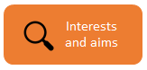
Part d. How productive is the dialogue in my classroom? A self-audit for teachers
Your Self-Audit
1. This self-audit builds on an original table authored by Diane Rawlins, one of our teacher co-researchers in Cambridge. (Economic and Social Research Council grant no. RES063270081).
2. This distinction between the three different layers and elements of classroom dialogue was highlighted in a large-scale mixed methods intervention study on classroom dialogue in teaching science and mathematics (www.educ.cam.ac.uk/research/projects/episteme/).
Section of inquiry cycle

You may want to begin by conducting a self-audit¹. But, remember that sometimes we understand audit statements differently. For example, a ground rule, such as ‘we all trust and listen to each other’, has different possible meanings, such as²:
- fostering interpersonal relationships
- hearing everyone’s ideas
- learning from each other’s thinking

Your self-audit will help you to identify the characteristics of your current classroom practice. It will also help you to:
- start your reflective cycle by focusing on your interests and aims to start thinking about your inquiry.
- reflect and monitor what happens as you go along.
- see how dialogue in your classroom has changed by repeating the audit after your inquiry

You’ll find the self-audit on the next page, and a downloadable version is available on the T-SEDA website for you to complete.
Tool 2H, Dialogic Teaching Questionnaire—Assessment of their practice also offers you the opportunity to reflect on your practice. You could do this at different points as you carry out an inquiry to record how your practice might be changing.

Video 6: Completing your self-audit

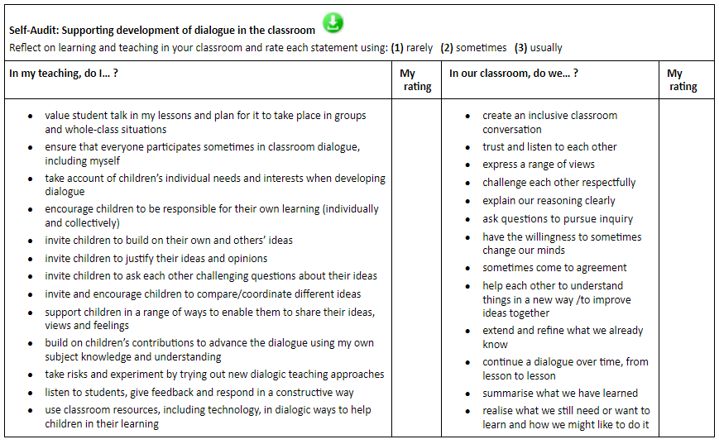
Reflection point: In looking the self-audit, ask yourself:
• What do these mean in my practice and how do I know they are actually happening?
• To what extent is the ethos in my classroom supportive of dialogue for learning?
• What is the difference between the ‘I’ and the ‘we’ columns? Is there a difference between your planning and what happens in practice?

Part e. Reflective cycle of classroom inquiry
T-SEDA is particularly suited to situations when teachers have identified a particular interest in or concern about classroom talk and learning. At this point, you might have identified from your self-audit that you have a particular aim or goal for your setting, or you might have identified this during conversations with colleagues or even your students.

The approaches outlined in the T-SEDA pack are grounded in the belief that reflective inquiry lies at the heart of teaching. Focusing inquiry questions and conducting a short classroom investigation can help to target attention, sharpen awareness and build understanding of what is actually happening in the fast-paced classroom setting. Reflecting on observational evidence and further discussion with colleagues supports subsequent decision making about setting priorities and deciding whether and how to intervene. This inquiry process resembles school-based action research, in which knowledge and understanding are developed through iterative cycles of planning, classroom trialling, observation, evaluation, and reflection and modification.
Focusing on educational dialogue
Reflection points:
1. Now that you’ve completed your self-audit, what are the things that you’re most interested in carrying out an inquiry about? What do you want to find out or change about dialogue in your setting? Jot down some ideas for potential inquiry.
2. Go back and have a look at the T-SEDA coding scheme in Part b. Which of the codes do you think are most relevant for you? Write down the codes next to your ideas for potential inquiry.
3. You may also be interested in the other aspects of dialogue, such as the talk rules and/or overall levels of participation in a session (template 2F) or students' self-assessment of group work quality (template 2G)
4. Now look at the inquiry cycle on the next page. You’ve been working on the top section, Interests and Aims, for which you identified points of interest and possible goals. You’ve also started to think about the relevant T-SEDA codes from the scheme. The next section of the pack will help you to narrow down your focus so that you can plan your inquiry.

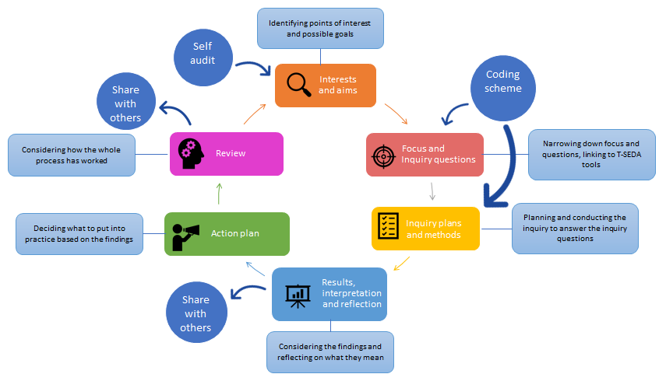
This page shows the inquiry cycle with additional information about each stage in order to help you to fill out your own inquiry cycle

Here is an example of a completed inquiry cycle
Interest and aims
When I try to encourage children of different levels to work together, the higher attaining child tends to just tell those that are struggling the answer.

Focus and inquiry questions
Are students building on ideas?
Do all students contribute?
Are quiet students engaged?
Are ideas respectfully challenged?
Are ideas built upon?
Inquiry plan and methods

Observe children working in mixed ability pairs using 2A and 2C to identify participation and quality of dialogue.
Results, interpretation & reflection
Children rarely building on ideas, HA children explaining or stating answers.
Very little participation from LA children, all led by HA children either performative or engaging minimally
Action plan
Create ground rules together
Talk about how dialogue can help all learners.
Introduce stem sentences.
Develop meta awareness of benefits of dialogue
Review
Substantial improvement in quantity and quality of dialogue - explaining reasoning and building on ideas
Does this impact on learning?
Would the results be different for similarly attaining pairs?

Reflective Cycle of Inquiry Name: Julia Monks

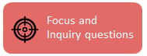
The following pages offer guidance for different ways to generate an inquiry question, and it’s good to remember that there’s no one right way to do it. However, there are some principles to keep in mind when coming up with an inquiry question:

• It should be based on a real issue that you have noticed in your classroom so that the inquiry is meaningful to you.
• Discussing your thoughts with other colleagues can really help you to come up with a question – for example, you might realise that all of the teachers in your team have noticed the same issue
• It should be manageable for you in your classroom (based on the time you have and if there are other adults to help, for example)
• It should lead to understanding practice, taking an action, trying something out, and/or to improving a teaching/learning situation
• It should not lead to a simple ‘yes’ or ‘no’ answer. Good research questions start with words like ‘How..’; ‘What happens when…’. They are genuinely open to different answers emerging.
When thinking about what you can do, it can help to ask yourself ‘How am I going to investigate my inquiry question?’ in order to come up with an inquiry question that is manageable. Sections 1 and 2 of this pack give you examples of T-SEDA codes, observation techniques and templates: it’s worth having a look through these as you plan your inquiry. You can also watch these videos:

Video 7: Completing your reflective cycle

Video 10: Using the coding scheme (part 1)

Video 11: Using the coding scheme (part 2)
The following pages offer guidance for different ways to generate an inquiry question, and it’s good to remember that there’s no one right way to do it. However, there are some principles to keep in mind when coming up with an inquiry question:

· It should be based on a real issue that you have noticed in your classroom so that the inquiry is meaningful to you.

· Discussing your thoughts with other colleagues can really help you to come up with a question – for example, you might realise that all of the teachers in your team have noticed the same issue

· It should be manageable for you in your classroom (based on the time you have and if there are other adults to help, for example)

· It should lead to understanding practice, taking an action, trying something out, and/or to improving a teaching/learning situation

· It should not lead to a simple ‘yes’ or ‘no’ answer. Good research questions start with words like ‘How..’; ‘What happens when…’. They are genuinely open to different answers emerging.
Section of inquiry cycle
Generating an inquiry question
Generating an inquiry question can be challenging because there is so much that you could do: a general rule of thumb for inquiry questions is to narrow your thinking down to something that you can do. You might have the overall aim that the students in your class will all participate, build on each other’s ideas, and challenge each other, but that’s a lot to focus on!
Part f. Choosing an inquiry focus

Funnelling your thoughts into an inquiry question

One way of generating an inquiry question is to think of it as a funnelling process in which you start off with a problem and then narrow down your focus, until you get to an inquiry question.

Example inquiry question: Does the use of sentence stems improve students’ reasoning (R) in maths? How?
I want to see what happens when I use sentence starters with the students
I’ve noticed that students don’t give reasons for their answers during class discussions
I want to focus on reasoning during maths lessons
What have you noticed that’s problematic, interesting or challenging in your classroom?
What can you do to help bring about the changes that you want to see?
What aspects of the T-SEDA pack will you use?
Other details
I want all children to be able to give reasons when they share their opinions
I’m going to look at dialogue code Reasoning (R).
What do you want to see happen or change in your classroom?
Funnelling questions to ask yourself
An example of funnelling to generate an inquiry question

The diagrams on these pages might give you some more ideas about what you want to focus on and how to shape your question

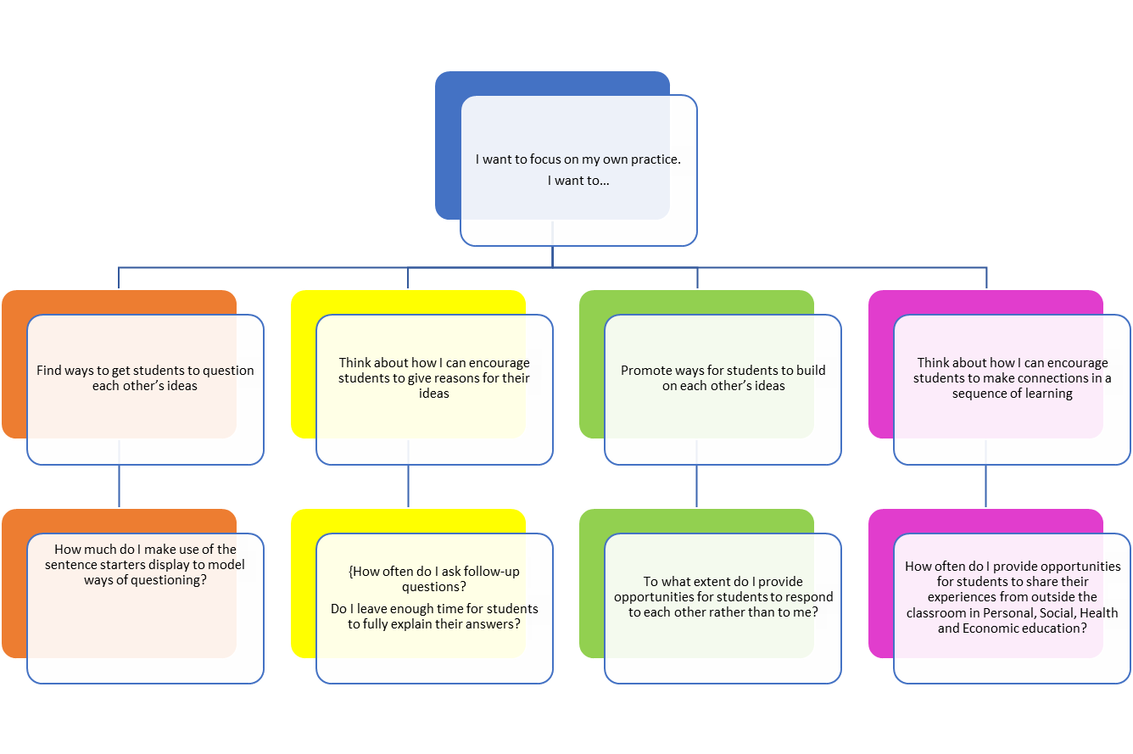

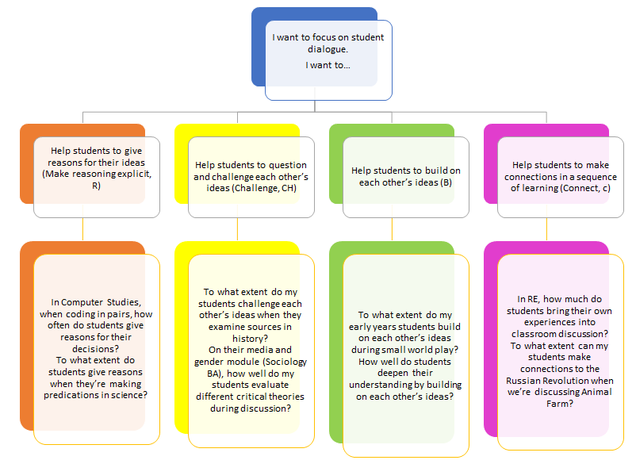

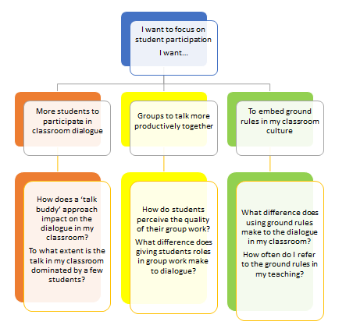
Reflection point: At this point, you should have an idea about what you want your research question(s) to be. If not, have another look at your self-audit and the guidance on generating a research question. You could also look for inspiration in Part H, which explains how to code and analyse dialogue in your classroom. Or you could discuss your thoughts with a colleague to help your thinking.

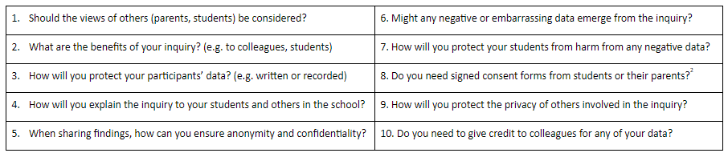
Making sure you carry out an ethical inquiry
Part g. Research ethics
The T-SEDA professional learning pack is intended to support teachers' reflective inquiry, with the aim of enhancing classroom dialogue. As in any form of professional activity there are some general ethical considerations for using T-SEDA to investigate dialogue. Note that educational researchers in Britain are expected to abide by ethical guidelines issued by the British Educational Research Association and these offer useful guidance for others too: http://bit.ly/BERAethics2018.
The Principles of Research Ethics:
• Minimising the risk of harm and maximising benefits
• Obtaining informed consent
• Protecting anonymity and confidentiality
• Avoiding deceptive practices
• Providing the right to withdraw from research
What does the risk of harm mean?
• Physical harm or discomfort to participants
• Psychological distress and discomfort, including participants feeling pressure to participate
• Social or educational disadvantage
• Lack of privacy and anonymity
To follow the principles of research ethics, it is important to consider these points before, during and after your inquiry. You might choose to discuss these issues with colleagues or to make your own notes on any of these points:
Video 8: Ethics in educational inquiry

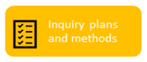
Section of inquiry cycle
About coding and rating
Part h. Analysing classroom talk: systematic observation and coding
When you plan your inquiry, you need to think about how you will actually carry out the inquiry in your setting in order to be able to answer your research question. Consider how much observation you want to do and when; how feasible is it to repeat your observations over time in order to look at change? This section gives an introduction to coding in educational settings, and there is more information, as well as coding templates, to help you in Sections 1 and 2.
There are a number of T-SEDA video guides that can provide useful guidance on this as you start to think about the planning and methods stage. This video will give you an overview of how to carry out coding and the positive and negative aspects of different types of coding:

Video 12: Recording dialogue and coding in your classroom

What is coding?
Coding means breaking down classroom dialogue into chunks and systematically putting each chunk into a category. This is often done by ‘turn’ (Person A...Person B...etc).
Why is coding important?
It’s easy to miss dialogue in a busy classroom or to assume that it’s happening when it might not be. Coding is a way of focusing in on particular types of dialogue and recording it in some way. This allows you to go back over the dialogue and spot patterns or missed opportunities to probe students. It also helps you notice change over time
How do I code?
The T-SEDA pack offers several resources to support your coding: there is more information about this on the following page about this
What is rating?
In addition to coding dialogue, you might want to rate student participation. For example, you could rate students who took part a lot as a ‘1’, who took part less as a ‘2’ and who didn’t take part much as a ‘3’. There are also resources to help you rate aspects of classroom dialogue (see templates 2C and 2D for group work and 2E and 2F for whole-class participation)

About coding: planning your inquiry
Reflection point: Coding can seem tricky if you are new to it. Here are some tips to help you plan your coding for your inquiry:
• Decide on one or two dialogue codes to look at for any one inquiry, then you won’t be trying to focus on too much in the classroom
• Look at the templates in Section 2. Think about how you could use them in your classroom to record dialogue
• Consider the way that you will record dialogue, and what this entails. Will you have to source recording equipment? Do you have other adults in your setting to help out while you are coding in person (live coding)?
Using Sections 1 and 2 and the video guides to help you, jot down some of your ideas to these questions. These noes will help you to decide on a plan for your inquiry.
One key tip for coding during your inquiry is to get some practice at it beforehand. The T-SEDA videos on coding have activities so that you can practise coding some recorded dialogue.

Video 13: Identifying productive dialogue: ‘building on’ and ‘challenging’ ideas
Video 14: Practising coding: whole class dialogue

Video 16: Coding and rating the quality of small group dialogue

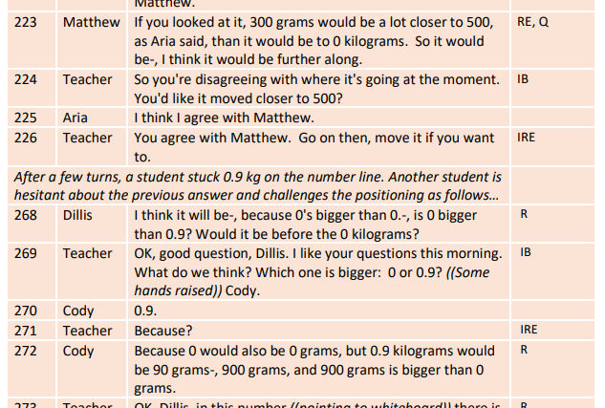
Here you can see an example of a section of dialogue that has been coded by ‘turn’: each time a different person speaks, look at the coding framework to see if one (or more than one) of the codes could be applied to what has been said. In this example, the dialogue has been recorded and then transcribed.
Each different turn is given a different number for easy identification
The name of each speaker is recorded
Each turn is added in a separate line
You can identify the code by checking what has been said against the coding framework in Section 1.

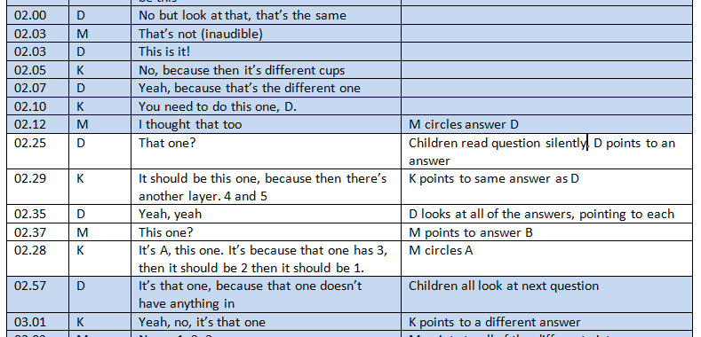
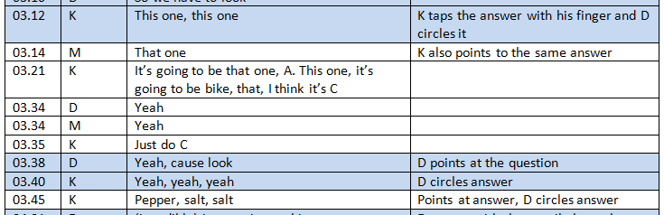
Gathering data in your inquiries: baseline data
What is baseline data?
Baseline data means making observations and gathering information before you make any changes in your learning setting.
Why should I collect baseline data?
Knowing what sort of dialogue is taking place in your classroom at the start of your inquiry can:
• Give you more information about your assumptions (students might be better or worse than you think)
• Help you to understand changes over time. You can compare your baseline data with data that you gather later to see if anything changes
• Give you an indication if any interventions that you are putting in place are making a positive difference
Consider the two sections of dialogue on the right. They are the same group of children before and after an intervention. The children are taking part in a group activity where they are solving multiple choice non-verbal reasoning problems. In the first example, you can see that there is not a lot of reasoning taking place: children aren’t spending much time discussing the activity or giving reasons to others. In the second example, interactions are longer and there is much more reasoning (the word ‘because’ is used often).
This indicates that children are engaging in dialogue more following the intervention, particularly showing reasoning.
Example 1: Baseline data before the intervention
Example 2: Data gathered after the intervention showing positive changes

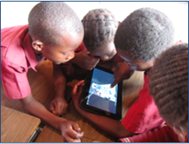
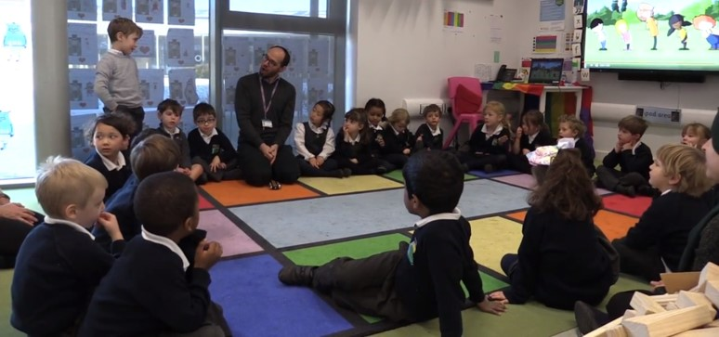
Part i. Possible uses of the T-SEDA pack
How you use the pack will depend on what you’re interested in, but it will also depend on what kind of opportunities you have as well. Here are some suggestions about extended ways in which you could use these resources:
• If you have a teaching assistant in your setting you could ask for help in videoing or doing live observations. Or you could ask them to video you if you wanted to focus on your own practice
• If there are several teachers doing T-SEDA inquiries in your school you could collaborate to share your findings and consider how you could embed whole-school practices
• You could ask other colleagues to observe you, or you could observe them, having learning conversations together
• Depending on the age of your students, you could get their input as you’re planning your inquiry and sharing your findings with them, or involve them in formulating your action plan
• You could consider how to integrate technology into your inquiry and how this impacts on dialogue
• Sections 1-5 of the pack will give you some more ideas about what you could do

TEACHER SCHEME FOR EDUCATIONAL DIALOGUE ANALYSIS
(T-SEDA): Supporting Resources

• SECTION 1: Detailed Coding framework A list and explanation of dialogue categories illustrated with sample prompts and contributions, plus more general dialogic classroom practices.

• SECTION 2: Templates for observing and coding Includes lesson observation (time-sampling; checklist; rating scales).

The following resources are available online (http://bit.ly/T-SEDA), including separately downloadable templates for printing or editing; look out for the icon

• SECTION 3: Technical guidance for recording and transcribing

• SECTION 4: Case studies Illustrates teachers’ coding and interpretation of dialogue in different contexts; includes teachers’ findings and next steps.

• SECTION 5: Resources and activities: Ideas to implement dialogue in your classroom, references to other research on dialogue and links to related resources

Section 1: Detailed coding framework
This coding scheme is a more detailed version of the one that you saw in Part B. These codes will help you to identify the dialogue that is taking place in your learning setting. You can apply a dialogue code to each ‘turn’ by a different speaker, whether you record and transcribe what is said or you do live coding as students are talking. Guidance about how the framework can be used follows in the next sections of this resource.
CODING CATEGORIES | CONTRIBUTIONS AND STRATEGIES | WHAT DO WE HEAR?
B – Build on ideas  build on, elaborate, clarify or comment on own or others’ ideas expressed on previous turns or other contributions to the learning activity (oral/written/other) | • build on own or another’s previous ideas /contributions by adding something new  • clarify, elaborate, extend, reformulate own or another’s previous ideas / contributions  • comment on previous ideas / contributions | Possible Key Words to look for:  ‘it’s also’, ‘that makes me think’, ‘I mean’, ‘she meant’  Examples:  Kate’s idea made me think about why the character would do that.  I’ve got an idea that no-one has mentioned yet…  What I meant earlier was…  Ahmed’s story had a lot of detailed description  My idea was similar to Jose, I wrote that flowers would make the best present
IB – Invite to build on ideas  Invite building on, elaboration, clarifying or commenting on own or others’ ideas / contributions to learning activity (oral / written / other) | • invite others to build on own or others’ ideas  • invite others to clarify a contribution  • invite others to comment on others’ ideas or views (including invitations to agree/disagree or evaluate)  • invite others to refine/improve ideas | Possible Key Words to look for:  ‘What?’ ‘Tell me’, ‘Can you rephrase this?’ ‘Do you think?’ ‘Do you agree?’ Can you add to…?’  Examples:  What do you mean? Tell me more…  Can anyone add to that? Can you give an example of what you said?  Is your idea similar to Manuel’s? What do you think about Maria’s idea? Do you agree with what Chris just said?  What other information do we need?  How can you improve Sanjay’s group’s poster/concept map?

CODING CATEGORIES | CONTRIBUTIONS AND STRATEGIES | WHAT DO WE HEAR?
CH – Challenge  Questioning, disagreeing with or challenging an idea | • Stating full or partial disagreement  • Doubting an idea  • Challenging an idea  • Rejecting an idea  • Indicating that two or more ideas that have been expressed are in disagreement | Possible Key Words to look for:  ‘I disagree’, ‘No’, ‘But’, ‘Are you sure…?’ ‘…different idea’  Examples:  I’m not sure it will float actually  I don’t think that’s right, I think.... or ‘I have a different idea…’  Are you sure these angles are the same?  But then that wouldn’t happen if…  That’s partially true, but not when…  I don’t agree with that at all  It’s not Victorian London though  No, I think that other one
R – Make reasoning explicit  Explain, justify and/or use possibility thinking relating to own or another’s ideas | • explain, justify, draw on evidence, make analogies, make distinctions  • predict, hypothesise  • speculate, explore different possibilities | Possible Key Words to look for:  ‘I think’, ‘because’, ‘so’, ‘therefore’, ‘thus,’ ‘in order to’, ‘if...then’, ‘not...unless’, ‘it’s like...’, ‘imagine if...’, ‘would’, ‘could’ or ‘might’  Examples:  I think the wood will float but not the metal.  The ice caps melting by 10% supports the global warming theory.  If children don’t have to go to school, they wouldn’t learn maths properly.  If I chose the first alternative I would be safer, but if I choose the second one I could eventually have greater gains.  I think the author might be referring to feelings when he writes about water.

CODING CATEGORIES | CONTRIBUTIONS AND STRATEGIES | WHAT DO WE HEAR?
IRE – Invite reasoning  Invite explaining, justifying, and/or using possibility thinking relating to their own or another’s ideas | • invite others to explain, justify, draw on evidence, make analogies, make distinctions  • invite others to predict, hypothesise  • invite others to speculate, explore different possibilities | Possible Key Words to look for:  ‘Why?’, ‘How?, ‘Do you think?’, ‘explain further’  Examples:  How did you arrive at that solution/conclusion/evaluation?  I don’t quite understand. Can you explain further?  Group X/Classmate Y said that it is because of... what do you think about their explanation?  What would/could/might happen if...?  Which objects do you think might float?  Why do you think that was? (in relation to a statement/observation)  Why do you think that would be? (in relation to a statement/observation)  How do you know that?
CA - Coordination of ideas and agreement  Contrast and synthesise ideas, express agreement and consensus, or invite others to do this | • come to a consensus view  • evaluate at least two different ideas by comparing / contrasting / critiquing them  • judge the value of an idea / artefact  • confirm agreement/consensus  • propose to resolve differences and/or agree a solution  • synthesise, generalise  • invite consensus, evaluation, summary | Possible Key Words to look for:  ‘I agree’, ‘to sum up…’, ‘So, we all think that…’, ‘summarise’, ‘similar and different’  Examples:  So we agree with Jason… because…  Elaine came up with more evidence than Tim, she was more convincing.  I think all we agree that a suspension bridge would work best.  I agree with Maria and not with Andy because the pebble is too heavy to float  We agree that these ideas can’t be reconciled.  I see what you mean, Option C is probably right, not B.  They are both saying the same thing because…

CODING CATEGORIES | CONTRIBUTIONS AND STRATEGIES | WHAT DO WE HEAR?
RD – Reflect on dialogue or activity  Evaluate or reflect “metacognitively” on processes of dialogue or learning activity; invite others to do so | • talk about talk rules / ground rules  • reflect (or invite to reflect) about the processes/ value/ impact of dialogue  • reflect (or invite to reflect) on value/ impact of learning activity  • explicitly acknowledge a shift of position | Possible Key Words to look for:  ‘dialogue’, ‘talking’, ‘sharing’, ‘work together in the group/pair, ‘task’, ‘activity’, ‘what you have learned’, ‘I changed my mind’, changed your mind’, ‘listening’, ‘talk rules’  Examples:  I like sharing ideas because it can give us new ideas for our writing.  They (talking and listening) kind of go together, don’t they?  It (dialogue) works when everyone is talking about the right thing  So, thinking about our ground rules for talking in the classroom...  In your group can you think about what makes dialogue work?  Do you think we need new talk rules for next time?  I can see you were listening to each other carefully; did that help your learning?  What have you learned in today’s lesson? Have you changed what you think?  What / whose argument helped you change your mind, and why?  How did you feel about being a group leader today?  As the ‘note-taker’ in your group did you feel you participated in the dialogue?

CODING CATEGORIES | CONTRIBUTIONS AND STRATEGIES | WHAT DO WE HEAR?
C – Connect  Make pathway of learning explicit by linking to contributions / knowledge / experiences beyond the immediate dialogue | • refer back to earlier contributions or flag up forthcoming requests  • refer forward or back to relevant activity or artefacts  • refer to wider contexts beyond the classroom or to prior knowledge / experiences | Possible Key Words to look for:  ‘last lesson, ‘earlier’, ‘reminds me of’, ‘next lesson’ ‘related to’, ‘in your home’  Examples:  It’s like when we did/learnt…  How is today’s lesson related to last lesson?  Who remembers the experiment we did with keeping plants in the dark?  At the end of the lesson I'm going to ask you to write down what you think happened and why.  Who has visited the science museum and can tell us what they’ve seen?  I know a lot about horse riding because I have my own horse.  Do you think you might find similar creatures in the soil in your own garden?  Have you seen anything on the news that refers to weather or climate?  Is there any information in earlier chapters that is useful?
G – Guide direction of dialogue or activity  Take responsibility for shaping activity or focusing the dialogue in a desired direction or use other scaffolding strategies to support dialogue or learning  (This general category captures contributions that support the flow of dialogue and may enhance student participation) | • encourage student-student dialogue  • offer thinking time  • propose possible courses of action or inquiry | Possible Key Words to look for:  ‘How about’, ‘focus’, ‘concentrate on’, ‘Let’s try’, ‘no hurry’  Examples:  So, in answer to the question, what have you found out?  Are you thinking about...?  Don’t worry, have a go...  Let’s try adding up instead!  Take your time and let me know when you’ve thought of anything.  Why don’t you explain to Kelly what we are doing?  In pairs can you discuss which of these sources you think is the most reliable account of the battle?  What would Newton say?

CODING CATEGORIES | CONTRIBUTIONS AND STRATEGIES | WHAT DO WE HEAR?
E – Express or invite ideas  Offer or invite relevant contributions to initiate or further a dialogue (ones not covered by other categories) | • invite opinions, ideas, beliefs or examples without referring back or building on prior contributions, typically by open, general questions, or by drawing more people into the exchange without explicitly inviting them to build/reason/coordinate/query  • make a relevant contribution, including short responses to closed questions; plenary reporting; extended ideas not explicitly linked to previous contributions | Possible Key Words to look for:  ‘What do you think about…?’, ‘Tell me’, ‘your thoughts’, ‘my opinion is…’, ‘your ideas’  Examples:  What do you think, Maria?  What do you think is really important in this text? Can you identify some key words and underline them on the board?  Are there any more ideas on that?  How many four-legged animals can you name?  What do you know about how electricity works?  Let’s brainstorm…

Section 2: Systematically observing and coding dialogue
This section covers two important aspects of carrying out your inquiry: which sort of observations you will make and which template you will use to record your observation. These observation fact files provide more information about different types of observation
Type of observation: Live Coding
What is it? You can live code in your learning setting, for example by sitting with a group and recording their dialogue onto one of the coding templates.
What are the advantages?
• You can see how the group is interacting and pick up on non-verbal clues such as body language
• It is more practical, and doesn’t need any special equipment, so it can be used more often
• It’s easier to capture normal behaviour because you’re not filming students

What are the disadvantages?
• As you’re not recording the dialogue, if you miss anything you can’t go back and check what was said
• It can be demanding as you have to listen, think and code at the same time
• Your focus has to be on only one or two codes so it is manageable

Best for: Capturing dialogue in group work; rating students participation or dialogue; short and/or multiple periods of observation,

Can be used with templates: 2B; 2C; 2D
Type of observation: Audio recording with transcribing
What is it? You record what is said in your learning setting (audio only) and then later on transcribe it so that you can code the transcription. See Part H for an example of a coding transcript.
What are the advantages?
• You can code in more detail and with more precision
• You can make more connections between the dialogue ‘turns’ because you can revisit the transcript and recording
• It gives you more thinking time
• It’s a more subtle way of recording than with a video camera
What are the disadvantages?
• It’s more time consuming as you have to take the time to transcribe the recording
• You have no visual observation so you cant pick up on non-verbal aspects of dialogue and interaction
• You need to obtain consent from guardians to record, so it requires advance planning
Best for: If you want to examine one episode of dialogue in more detail; if you want to look at several codes at once
Can be used with templates: 2A; 2C; 2E

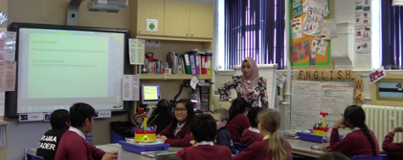
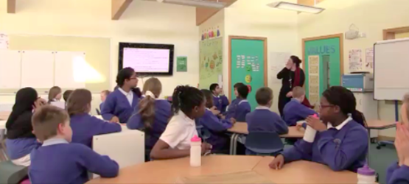
Type of observation: Video recording with transcription
What is it? You record what it said in your learning setting and then transcribe it later

What are the advantages?
• You can code in a greater level of detail and with more precision
• It gives a more accurate representation of classroom events because you have audio and visual data
• You can make connections between ‘turns’ because you can revisit the data
• You can record student interaction and non-verbal dialogue
What are the disadvantages?
• It might take time for students to get used to being video recorded and their behaviour might be different in the presence of a camera
• You need to get consent from guardians so you need to plan in advance
• Transcribing is time consuming so you need to make sure that the amount of dialogue you plan to transcribe is manageable
Best for: If you want to examine one longer episode of dialogue in a lot of detail; if you want to look at non-verbal interaction; if you want to look at several codes at once
Can be used with templates: 2A; 2C; 2E

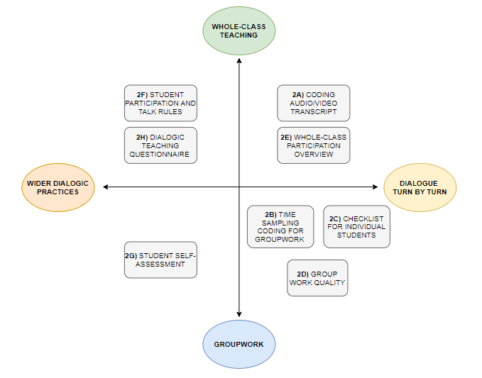
When to use the different coding and rating templates
This diagram shows when particular templates that you will find on the following pages are particularly useful.
Some tools are more suited to whole class teaching and others to group work. You can also use different tools depending on whether you want to focus on turns in dialogue or on wider practices such as participation and classroom cultures of dialogue.
Looking at these templates can help you to decide how you will carry out your inquiry.

2A: Template for coding an audio/video transcript
You can use this template to apply T-SEDA codes to individual speaker’s turns.
Guidance notes:
• Create your transcript into a table like this one, adding as many rows as you need
• Numbering the terms makes them easily identifiable
• You can choose one or two codes to look for, or use many categories, depending on what the focus of your inquiry is
• Some turns might be left uncoded because none of the categories apply
• Alternatively, some speakers’ turns might have more than one code applied to them
• You could also add a comments category to each row to record your thoughts about how the dialogue is unfolding

A downloadable transcript coding template is available from our website.

On the next page you can see an example of a completed template

Line no. | Speaker | Turn | Code

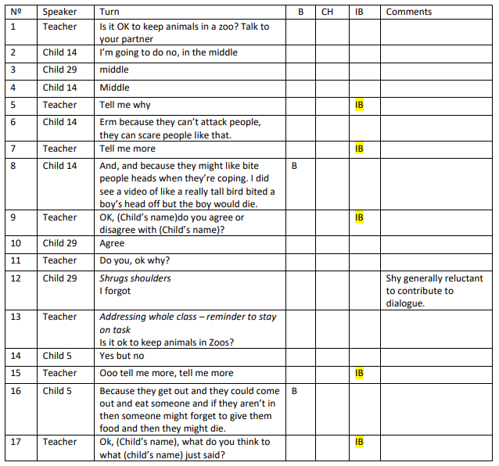
Here is an example of a section of completed transcript from Lucy’s investigation in a primary school.
As you can see, she’s decided to focus on three codes: Build on (B), Challenge (CH) and Invite to Build (IB).
She’s also added a comments section to record any points of note during the dialogue

2B: Time-sampling coding for groupwork
‘Time sampling’ is a common technique used by researchers to sample events at regular time intervals during an episode or whole lesson. You don’t note down everything, but it will give you a general picture of what is going on. It also reduces the demand of live coding as your observation windows are short
Guidance notes:
• Observations have an ‘active’ and a ‘resting’ phase. Each active phase is the time window when you note down the codes that you hear
• You can decide how long you want the observation window to be, but they should be short to make sure that the observation isn’t too demanding
• Tick the relevant coding box if the student uses that code during the observation window
• Instead of ticking, you could choose to tally each time the student uses the code, but be aware this is harder to do
• You could choose to video the interaction as a ‘back up’ to watch later

A downloadable time-sampling template is available from our website.
On the next page you can see an example of a completed template

Decide how long you want your observation windows to be, for example, observe for 1 minute, rest for 1 minute and so on
Decide which codes you want to focus on: CH and B are given as examples but you can use any one or two codes
Write down the name of each student, adding as many columns as you need. Observing 3-6 students in groups is ideal
If a teacher or teaching assistant interacts with the students during this time put a tick in this box
Time window | Teacher present | Student 1:  [name] |  | Student 2:  [name]
 |  | CH | B | CH | B
1
2
3

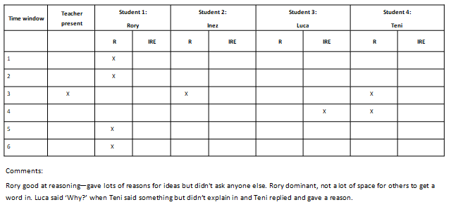
Example of completed time-sampling template
This teacher, Huseyin, had observed and live coded group work with four students. He was looking for Reasoning and Invite Reasoning. He observed for one minute at a time and then rested for 30 seconds, recording when he heard examples of R and IRE. He has also recorded some brief notes of aspects of the dialogue that seemed important.

2C: Checklist for individual students (groupwork)
This checklist can be used in two ways. Firstly, it can serve as a summary of 2B: you can record the results of students from multiple groups in this checklist, adding a rating of overall participation. Secondly, if it isn’t possible for you to carry out time sampling, you can use this instead: observing dialogue and ticking when you hear the categories you’re interested in. Again, you can give each student an overall rating.
Checklists of this type can’t capture everything, but they’re not designed to. However, it’s a manageable way of paying closer attention to students’ dialogue and identifying trends over time.
Guidance notes:
• You can choose one or two categories that you’re interested in
• Tick the code boxes if you hear those codes in a student’s dialogue at any point in their discussion contributions
• If a student participates a lot in the discussion then they will have an overall rating or (3), a medium amount would be (2) an low participation would be a rating of (1)

A downloadable template is available from our website.

Students’ names | CH | B | Rating of overall participation
Add as many rows as you need for your students’ names
You can give each student an overall participation rating between 1 (low) and 3 (high)
Add the dialogue categories into the middle sections, ticking if you hear them

Dialogue code | Rating (1-3) | Comments
CA
C
2D: Group rating (groupwork)
This group rating tool is slightly different from 2B and 2C because it does not rate individual students’ contributions but the group as a whole. You can select different categories of dialogue to focus on (in this case Coordination of Ideas and Agreement (CA) and Connect (C).
Guidance notes:
• Use a three-point rating scale for the frequency of each dialogue category within the conversation as a whole: 1 = low, 2 = medium, 3 = high
• Use the ‘Comments’ column to add any relevant information to the rating, such as whether the results are typical, or if they show progress
• You could repeat this to see if groups change their dialogue patterns over time

A downloadable template is available from our website.

• Use the following rating scale:

5 = all the time/as many students as possible
4 = most of the time/most of the students
3 = some of the time/some of the students
2 = occasionally/a few students
1 = never/none of the students

A downloadable template is available from our website.
2E: Whole-class participation overview (rating scale)
This whole-class rating scale extends 2D to focus on whole-class talk. It will allow you to understand more about how students are taking part in dialogue. You can focus on different aspects of student participation such as the length of contributions and how often students are taking part. You can do this during different types of whole class activities to build up a bigger picture of dialogue in your learning setting.
Guidance notes:
• Choose one or two categories that you want to focus on for your inquiry
• Decide which types of activity you want to focus your observations on, such as lesson introductions, whole-class discussions or plenaries

Activity type | Category | How often are students doing this? | How many students are taking part in this? | Are the contributions extended or short?
1) | B
 | CH
2) | B
 | CH

Guidance notes:
• This tool can be used across whole lessons or for different activities
• You could use it in your own classroom or when observing a colleague
• Read through the descriptors for each category and decide which best applies to the lesson you have just observed
2F: Student participation and talk rules rating scales
This is another tool with which you can measure student participation. It also offers a way of assessing whether or not talk rules are being used.
A downloadable template is available from our website.

Dimension | 0: Not Evident | 1: Teacher-led | 2: Teacher-led with student involvement
Talk rules | No explicit focus on ground rules for dialogue or dialogic practices is apparent | The teacher introduces, models or reminds students of target dialogic practices, e.g. ground rules to be followed, inclusive turn taking. | Teacher and students or students themselves negotiate target dialogic practices, e.g. ground rules, perhaps along with reminders / modelling.  It may also include students being given or taking responsibility for managing the dialogue, as well as students being involved in evaluating effectiveness of dialogic practices.
Student participation | Public exchanges in whole-class situation or group work consist in teacher questioning and succinct students' contributions  or  Students don't have opportunities to discuss their ideas publicly | Students express their ideas publicly at length in whole-class situation and group work, but they don't engage with each other’s ideas | Multiple students express their ideas publicly at length in whole-class situation and group work  AND  In doing so, they engage with each other’s ideas, for example by referring back to their contributions, challenging or building on them (e.g. ‘It’s a bit like what Shootle said but….’, ‘Sam had such a great idea, look [demonstrates]’). This includes spontaneous or teacher-prompted participation.
Guidance notes:
• The rating scale is: 1 = Not true; 2 = Partly true and 3 = Very true
• Students can either complete one per group or one each. This can be an interesting activity as different members of the group might have very different perceptions and this can lead to good discussion
• The example on this page is for older students including adults . On the T-SEDA website there is a version for younger children so you can choose the most appropriate

2G: Student group work self-assessment
(Older student/adult example)

This template is for a group of students to rate their own dialogue. It can help students to understand more about their own participation in dialogue. It can also help you to understand what students are thinking about their own dialogue. You might also find that you have different perceptions of their dialogue and group work than they do.
Downloadable templates are available from our website.

Criteria | Rating
G1 – Everyone in the group participated
G2 – We worked as a single group and didn’t split up
G3 – Most or all of our talk was about the task we were doing
G4 - We shared our own ideas and built on each other's
G5 - We listened carefully when others were speaking and took on board what they were saying
G6 – We enjoyed working together in a group
G7 – When we made suggestions or agreed/disagreed with others, we gave reasons
G8 – We challenged or commented each other’s ideas in a respectful and constructive way
G9 – We tried to reach consensus or compromise if there was disagreement
G10 – Our discussions and disagreements helped us learn from each other

Guidance notes:
• There are three sections: : creating an Openness for Dialogue (A - Items 1-5), inviting Students’ Contributions (B - Items 6-9) and fostering Dialogic Participation (C - Items 10-18, on the next page).
• For each item, tick the box that is most relevant, and give yourself a score.
2H: Dialogic Teaching Questionnaire: Self-assessment of practice
This template is for you to assess your own practice. You could do this at different points during your inquiry to identify how your practice has changed. Downloadable templates are available from our website.

Consider the following statements with regards to your practice and mark your level of agreement from (1) “completely disagree” to (6) “completely agree”.  In my teaching, I... | (1)  Completely disagree | (2) | (3) | (4) | (5) | (6)  Completely agree
A. Openness for Dialogue
build purposeful conversations as part of my lessons through my lesson planning.
offer time for questions so that students can understand the learning objective(s).
allow enough time for students to contribute at length.
pose open questions and wait for students to respond.
listen appreciatively to students and respond in a constructive way, including giving formative feedback.
Aggregated rating Dimension A: Openness for Dialogue (add up your ratings) | / 30
B. Inviting Students’ Contributions
invite students to share their ideas, views, thoughts, interests or feelings.
invite students to elaborate and build on their own and others’ ideas.
invite students to justify their ideas and opinions explicitly including giving extended explanations, offering arguments, counter-arguments and/or evidence.
invite students to respectfully challenge, question and critically evaluate each other’s ideas.
Aggregated rating B. Inviting Students’ Contributions (add up your ratings) | / 24

Dimension C: Dialogic Participation
 | (1) | (2) | (3) | (4) | (5) | (6)
emphasise the importance of purposeful dialogue for my students’ learning (e.g. by commenting on how students can collaboratively solve a problem by talking productively, or through reflection about the dialogue at the end of a lesson).
demonstrate openness to change my mind when students bring in new ideas or arguments.
create an atmosphere of trust, so students feel comfortable enough to take risks or try something new.
engage students in both jointly creating and using ground rules for talk.
include productive dialogue across the different phases of the lesson.
develop dialogue cumulatively over time (between lessons).
invite students to reflect on the quality and success of the dialogue.
invite students to show they are listening carefully to others’ contributions.
explicitly encourage students to ask their own questions.
Aggregated rating C. Dialogic Participation (add up your ratings) | / 54
There are two other Dialogic Teaching Questionnaires:
• Teacher’s overview of their lesson
• Students’ overview of a lesson (for students age 13-18)
These focus on your, and your students, perspectives of a particular lesson.
They are available as downloadable templates on our website as part of Tool 2H

